
浙江省严州中学高三年级第二次模拟考试
英语学科试题
第I卷
第一部分：英语知识运用（共两节，满分30分）
第一节：单项填空（共20小题；每小题0. 5分，满分10分）[来源:Z,xx,k.Com]
从A、B、C和D四个选项中，选出可以填入空白处的最佳选项，并在答题纸上将该选项标号涂黑。
1. — I’ve got something weighing on my mind at the moment. Could you give me some advice?
— ______. Tell me all about it and I’ll do what I can.
A. Never mind B. No way
C. No problem D. Forget it
2. The company needs to improve its communication system to show that it ______ all its staff.
A. consults B. values C. educates D. attaches
3. We’ve got a general idea of what we want, but nothing ______ at the moment.
A. concrete B. ordinary C. standard D. abstract
4. Linda acts as if she were the boss, ______ people around.
A. ordered B. ordering C. to order D. having ordered
5. We have our bad times but on the whole we’re ______ happy.
A. rarely B. merely C. fairly D. chiefly
6. Two of my friends are having their weddings on the same day, and I’m in a real ______ about which one to go to.
A. situation B. choice C. trick D. dilemma
7. Cynthia is not ashamed of what she does, ______ she ends up doing something wrong.
A. as though B. in case C. even if D. for fear
8. When you reach the other end of the bridge, I ______ right there to show you the way.
A. wait B. have waited C. was waiting D. will be waiting
9. — Hello, I’m calling to complain about one of your sales staff.
— Oh dear, ______
A. you must be kidding! B. what a shock!
C. why not? D. what happened?
10. Most companies’ marketing effort is focused on getting customers, with little attention ______ to keeping them.
A. paying B. to pay C. paid D. having paid
11. ______ is surprising is that there are so many Chinese restaurants in Toronto.
A. It B. That C. Such D. What
12. Human history is rich ______ examples of our ability to overcome and rise above difficulties.
A. with B. of C. on D. by
13. She would always be an outsider here, no matter how much she ______ try.
A. could B. must C. might D. need
14. I’ve had enough of my neighbor. I’m going to ______ their noisy parties right now.
A. put an end to B. give way to C. look up to D. come up to
15. We should ______ for possible delays on the motorway and leave an hour earlier.
A. apologize B. allow C. account D. ask
16. ______ how mirrors produce image, we need to know what light does.
A. Understanding B. Understood C. To understand D. Having understood
17. The rise in consumer spending is an encouraging ______ that the economy may be recovering.
A. symptom B. solution C. subject D. sign[来源:学科网ZXXK]
18. — Have you read the newly-published novel by J. K. Rowling?
— Yes. I ______ recommend this book to anyone who is sick of the same old stories.
A. briefly B. instantly C. fully D. awfully
19. Not ______ with the quality of your goods, I will certainly not advise others to buy them.[来源:学.科.网]
A. to impress B. impressing C. having impressed D. impressed
20. There are a couple of matters which I want to ______ today for discussion.
A. bring up B. set up C. make up D. put up

第二节：完形填空（共20小题，每小题1分，满分20分）
阅读下面短文，掌握其大意，然后从 21～40 各题所给的四个选项（A、B、C和D）中，选出最佳选项，并在答题纸上将该选项标号涂黑。
It was a cold, wet day on June 6, when 14-year-old Wasana arrived at school. Waiting outside his classroom for his classmates to arrive, Wasana 21 aimlessly at the pouring rain. Then his 22 fell upon the hill that rose at the back of the classroom.
He noticed huge amounts of rainwater 23 down the hill, and water was also bubbling at the base of a large rock on the hill. For a few 24 , Wasana looked at the water, wondering 25 it looked so familiar.
Then it 26 him – the scene was surprisingly 27 to the pictures he was shown during Disaster Management classes. 28 a disaster was about to happen, Wasana waved 29 at students, shouting “Run, run, don’t stay here! The rocks on the hill are going to 30 on us!”
All the students and teachers ran to the open area that had been 31 as an emergency gathering point. 32 , they heard screams as the huge rock rolled down the hill, bringing sand, rock and mud. There was 33 they could do as they watched the earth bury an entire school block.
Thanks to Wasana’s quick action and sharp 34 , no one was hurt in the incident. The landslide 35 two classrooms and caused heavy damage to six 36 . “The financial damage is nothing compared to 37 would have happened had there been children in the classrooms,” says the schoolmaster.
Wasana later received a Gold Star from the Foundation for Civilian Bravery, Sri Lanka. 38 at the incident, he says, “I feel disaster management 39 are important for everyone. We’ll never know when the 40 will come in handy.”
21. A. stared B. nodded C. shouted D. pointed
22. A. thoughts B. eyes C. words D. voices
23. A. pulling B. jumping C. sliding D. flowing
24. A. times B. minutes C. hours D. periods
25. A. how B. where C. why D. when
26. A. hit B. drove C. pushed D. stopped
27. A. strange B. rare C. terrible D. similar
28. A. Rejecting B. Fearing C. Scaring D. Avoiding
29. A. angrily B. sadly C. excitedly D. wildly
30. A. beat B. move C. fall D. dive
31. A. put away B. set aside C. brought forth D. taken apart
32. A. Just then B. In short C. In good time D. As a result
33. A. something B. much C. anything D. little
34. A. discovery B. movement C. observation D. idea
35. A. destroyed B. tore C. injured D. overcame
36. A. another B. other C. others D. ones
37. A. those B. which C. that D. what
38. A. Looking back B. Looking around C. Looking through D. Looking forward
39. A. exhibitions B. lessons C. units D. examinations
40. A. concept B. image C. knowledge D. situation

第二部分：阅读理解（第一节20小题，第二节5小题；每小题2分，满分50分）
第一节：阅读下列材料，从每题所给的四个选项（A、B、C和D）中，选出最佳选项，并在答题纸上将该选项标号涂黑。
A
Until I was twelve years old, I thought everyone in the world knew about the grinnies, if I thought about the term at all — which is unlikely. After all, everyone in my family used the word quite naturally, and we understood each other. So far as I knew, it was a word like any other word — like bath, or chocolate, or homework. But it was my homework which led to my discovery that grinnies was a word not known outside my family.
My last report card had said that I was a “C” student in English, and my parents, both teachers, decided that no child of theirs would be just an average student of anything. So nightly I spelled words aloud and answered questions about the fine points of grammar. I wrote and rewrote and rewrote every composition until I convinced my mother that I could make no more improvements. And the hard work paid off. One day the teacher returned compositions, and there it was — a big fat, bright red “A” on the top of my paper. Naturally, I was delighted, but I didn’t know I was attracting attention until the teacher spoke sharply, “Helen, what are you doing?”
Called suddenly out of my happy thoughts, I said “Oh, I’ve got the grinnies!” The teacher and my classmates burst into laughter, and then I understood that grinnies were used inside my family. Other people were not so lucky.
And it is really lucky to have the grinnies, an uncontrollable, natural state of great pleasure. Grinnies are shown on the outside by sparkling eyes and a wide, wide smile — not just any smile, but one that shows the teeth and stretches the mouth to its limits. A person experiencing the grinnies appears to be all mouth. On the inside grinnies are characterized by a feeling of joyful anxiety. Grinnies usually last just a few seconds, but they can come and go. Sometimes, when life seems just perfect, I have occasional attacks of the grinnies for a whole day.
The term originated in my mother’s family. Her younger sister, Rose, who had deep dimples (酒窝), often expressed her pleasure with such a grin that the dimples appeared to become permanent. When Rose was about four, she started explaining her funny look by saying, “I have the grinnies”. The term caught on, and it has been an important word in our family now for two generations.
The occasion doesn’t matter. Anything can bring on the grinnies — just so long as one feels great delight. When my brother finally rode his bicycle — without training wheels — from our house to the corner and back, he came home with the grinnies. When I was little, my mother’s announcement that we would have homemade ice cream for dessert always gave me the grinnies. My father had the grinnies when I was chosen to make a speech at the end-of-school-year ceremony. Grinnies can be brought on by a good meal, a sense of pride, a new friend, a telephone call from someone special, an achievement. Or sometimes one gets the grinnies for no reason at all: just a sudden sense of happiness can bring on a case. Whatever brings them on, an attack of the grinnies is among life’s greatest pleasures.
In fact, now that I look back on the experience, I feel sorry for my seventh-grade teacher. I think it’s a pity that she didn’t know the word grinnies. It’s such a useful term for saying, “I’m really, really pleased!”

41. After the writer was twelve years old, she ______.
A. thought everyone knew the meaning of “grinnies”
B. equaled “grinnies” to bath or chocolate in meaning
C. got to know “grinnies” was used only inside her family
D. discovered the word “grinnies” through her mother
42. When her English teacher called her name, the writer was ______.
A. looking at the big “A” on the top of her paper
B. listening to her English teacher attentively
C. too happy to notice what’s happening around her
D. busy rewriting and improving her compositions
43. According to the writer, the word “grinnies” originates from______.
A. her mother B. her aunt
C. her brother D. her father
44. The writer feels sorry for her seventh-grade teacher because the teacher______.
A. has no pity on her students
B. should not have laughed at her
C. doesn’t have any luck to meet her parent
D. has no idea of what “grinnies” is
45. What method does the writer use to explain “grinnies”?
A. Cause and effect. B. Examples.
C. Comparison and contrast. D. Process.

B
Below is a page from The World Almanac（年鉴）and Book of Facts 2008.

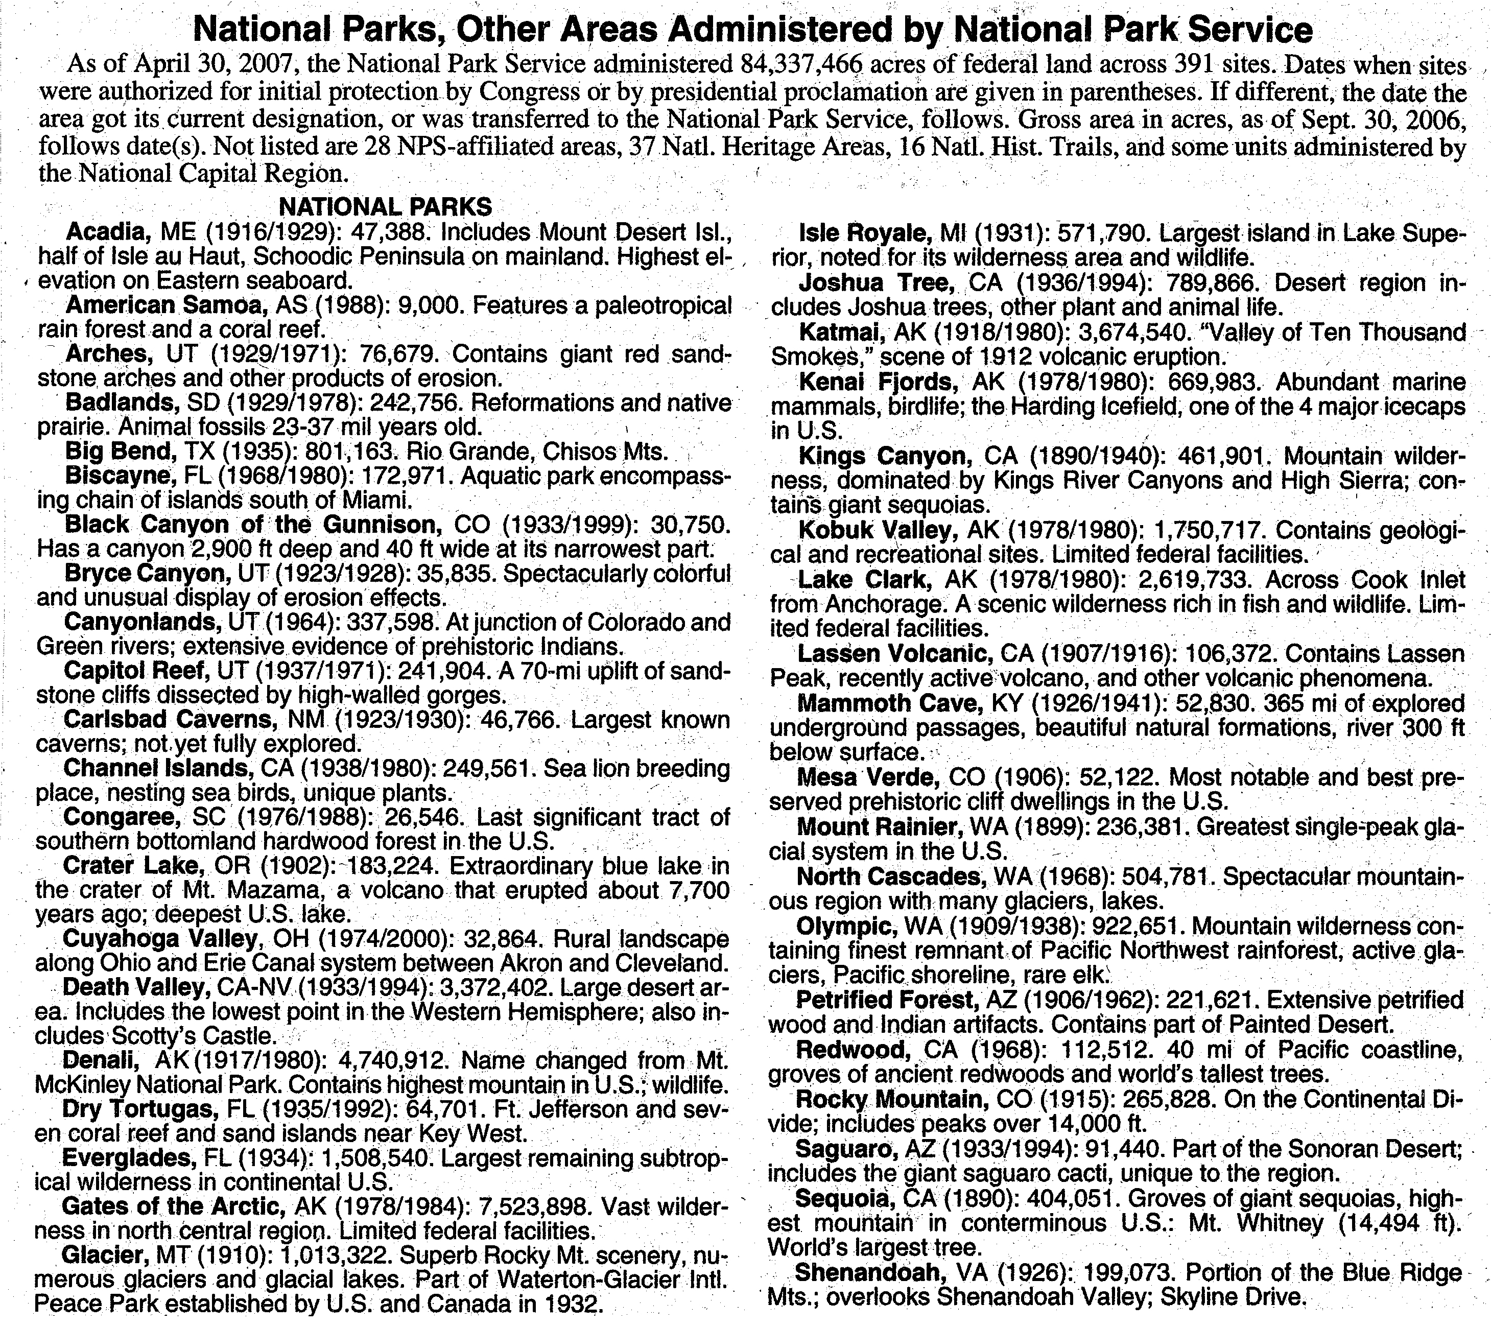
46. Which park has 365 miles of explored underground passages?
A. Arches, UT . B. Cuyahoga Valley, OH.
C. Acadia, ME. D. Mammoth Cave, KY.
47. In which year was Channel Islands first authorized as a protection site for sea lions, sea birds and unique plants?
A. 1929. B. 1938. C. 1978. D. 1980.
48. The world’s tallest trees are found in _______.
A. Redwood, CA B. Gates of the Arctic, AK
C. Canyonlands, UT D. Kings Canyon, CA
49. In 1917, the national park Denali was named as _______.
A. Black Canyon of the Gunnison B. Mount Desert Isl.
C. Mt. McKinley National Park D. Rocky Mountain

C
Bonus（奖金） culture has become the subject of many studies nowadays. Many people have been angered by the way some bankers and high officials seem to have been rewarded for failure. Others find the idea of offering many-million-dollar bonuses morally disgusting.
But few have asked whether performance-related bonuses really do improve performance. The answer seems so obvious that even to ask the question can appear ridiculous. Indeed, in spite of all the complaints about them, financial encouragements continue to be introduced in more and more areas, from healthcare and public services to teaching and universities.
So it may come as a shock to many to learn that paying for results can actually make people perform badly in many circumstances, and that the more you pay, the worse they perform.
No one is arguing that bonuses can help companies and institutions attract and keep the best staff. Nor does anyone argue against the idea that you can encourage people to do specific tasks by linking payments to those tasks. Rather, the point is about how to get the best out of people. Do employees really perform better if you promise to pay them more for getting results?
There are some obvious reasons why such payments can fail. It has been argued, for instance, that cash bonuses contributed to the financial crash, because traders had little enthusiasm to make sure that their companies enjoyed long-term survival.
Most bonus projects are poorly designed, says Professor Malcolm Higgs. He thinks the reason is that organisations try to keep bonus arrangements simple. Nevertheless, he thinks bonus projects can work as long as they link the interests of individual employees with the long-term goals of a business.
Bonuses can also encourage cheating. “Once you start making people’s rewards dependent on outcomes rather than behaviours, the evidence is people will do whatever they can to get those outcomes,” says Professor Edward Deci. “In many cases the high officials simply lied and cheated to make the stock (股票) price go up so they got huge bonuses.”
But the work of Deci and others suggests the problem with bonuses runs far deeper than poor design or cheating. In 1971, he asked students to solve puzzles, with some receiving cash prizes for doing well and others getting nothing. Deci found those offered cash were less likely to keep working on puzzles after they had done enough to get paid.
These studies suggest that offering rewards can stop people doing things for the pure joy of it. This was the basis for a series of books by Kohn in which he argues that rewarding children, students and workers with grades, scholarships and other “bribes” (贿赂) leads to low-quality work in the long run.
Those who believe in the power of bonuses fail to distinguish between inner drive and outside pressure — wanting to do something because you like it for itself in contrast to doing something because you want the reward, Kohn says. “It’s not just that these two are different, it’s often that the more you reward people for doing something, the more their inner drive tends to decline.”
A “do this and get that” approach might improve performance in the short term, but over longer periods it will always fail, Kohn says. People who receive bonus will naturally play safe, become less creative, cooperate less and feel less valued, he adds. What’s more, the studies also suggest that offering rewards can also stop people taking responsibility.

50. The effect of performance-related bonuses has not been well studied because people _______.
A. take the function of bonuses for granted
B. see that bonus offering is done everywhere
C. think financial encouragement is disgusting
D. are shocked by the practice of rewarding for failures
51. According to Malcolm Higgs, designs that _________ are the good ones.
A. drive people to finish short-term tasks
B. help to attract and keep good employees
C. link financial rewards with the quality of the outcomes
D. connect individual interests with long-term business goals
52. If a person plays safe to get a bonus, he is probably being ________.
A. more enthusiastic B. more risk-taking
C. less daring D. less responsible
53. Which of the following do you think the author would most probably agree with?
A. Companies should make their bonus projects simple.
B. The benefit of bonus helps to get the best out of people.
C. The biggest problem with bonus is it creates cheating.
D. Bonus offering can stop people doing things for pure joy.
54. Which do you think is the best title of the passage?
A. What Is Bonus? B. Does Bonus Work?
C. Why Bonus Offered? D. How Bonus Works?

D
Which is sillier: denying we ever went to the moon or trying to convince the true nonbelievers?
Once upon a time – July 20, 1969, to be specific – two men got out of their little spaceship and wandered around on the moon for a while. Ten more men walked on the moon over the next three and a half years. The end.
Unfortunately, not quite. A fair number of Americans think that this whole business of moon landings really is a fairy tale. They believe that the landings were a big hoax (骗局) staged in the Mojave Desert, to convince everyone that U.S. technology was the “bestest” in the whole wide world.
Which is the harder thing to do: Send men to the moon or make believe we did? The fact is the physics behind sending people to the moon is simple. You can do it with computers whose entire memory capacities can now fit on chips the size of postage stamps and that cost about as much as, well, a postage stamp. I know you can because we did.
However, last fall NASA considered spending $15,000 on a public-relations campaign to convince the unimpressed that Americans had in fact gone to the moon. That idea was mostly a reaction to a Fox television program, first aired in February 2001, that claimed to expose the hoax. The show’s creator is a publicity hound (猎狗) who has lived up to the name in more ways than one by hounding Buzz Aldrin, the second man on the moon. Mr. X (as I will call him, thereby denying him the joyous sight of his name in print) recently followed Buzz Aldrin around and called him “a thief, liar and coward” until the 72-year-old astronaut finally lost it and hit the 37-year-old Mr. X in the face.
Anyway, NASA’s publicity campaign began to slow down. The nonbelievers took the campaign as NASA’s effort to hide something while the believers said that $15,000 to convince people that the world was round — I mean, that we had gone to the moon — was simply a waste of money. (Actually, the $15,000 was supposed to pay for an article by James E. Oberg, an astronomy writer who, with Aldrin, has contributed to Scientific American.)
If NASA’s not paying Oberg, perhaps it could put the money to good use by hiring two big guys to drag Neil Armstrong out of the house. Armstrong is an extremely private man, but he is also the first man on the moon, so maybe he has a duty to be a bit more outspoken about the experience. Or NASA could just buy Aldrin a commemorate plaque (纪念匾) for his recent touch on the face of Mr. X.

55. We can learn from Paragraphs 2 and 3 that some Americans believe _______.
A. moon landings were invented
B. U.S. technology was the best
C. moon landing ended successfully
D. the Mojave Desert was the launching base
56. According to the writer, which of the following is to blame for the story about the hoax?
A. NASA’s publicity campaign. B. The Fox television program.
C. Buzz Aldrin. D. James E. Oberg.
57. According to the writer, Mr. X _______.
A. told a faithful story B. was not treated properly
C. was a talented creator D. had a bad reputation
58. The believers think that NASA’s publicity campaign is ________.
A. proof to hide the truth
B. stupid and unnecessary
C. needed to convince the non-believers
D. important to develop space technology
59. What is implied in the last paragraph?
A. NASA should not bother with the non-believers.
B. Armstrong was a very private and determined person.
C. Armstrong should be as outspoken as Buzz Aldrin.
D. NASA should send more astronauts to outer space.
60. The tone of the article is _______.
A. angry B. conversational C. humorous D. matter-of-fact

第二节：加拿大运动鞋设计专家Benno Nigg曾为当今众多运动明星设计过多款著名运动鞋，如Masai MBT运动鞋。在接受采访时，Nigg回答了记者的5个问题（第61～65题）。请从下列提问（A、B、C、D、E和F）中选出与他的回答相匹配的问题，并在答题纸上将相应选项的标号涂黑。选项中有一项是多余选项。

Questions:
- What kind of technology might we see in sports shoes of the future?
- What should people look out for when buying a new pair of sports shoes?
- Will a more expensive shoe make me run faster or jump higher, as the ads suggest?
- When you say that expensive shoes are no better at preventing injury than cheap ones, is it true?
- Some people say we should run just as well without shoes. What’s your opinion of that?
- You helped develop the unstable Masai MBT shoes. Does this design actually work?

61．____________________________________________
Nigg’s Answer: That is a little bit overstated. But the relative frequency of running injuries doesn’t seem to have changed much in the past 30 years, in spite of all the developments in sports shoe design. The literature shows that shoes are a minor player in injury development. If you take a group of people and want to injure them, send them out every day for a 20-kilometre run. A lot of them will be injured in three weeks. The major factors are the distance run, the intensity and recovery time, not the shoes.

62．___________________________________________
Nigg’s Answer: The problem is that if you go to a store and want to find your best shoes, you don’t know what to do. Things that are sometimes done, like video analysis of your rear foot movement, may not help. The only way to assess whether a shoe is right for you is how it feels. If you feel comfortable in a shoe, it’s likely to be good for you. We did a study with soldiers where we gave them six different inserts, and they chose the one they liked best. In four months those with inserts had 53 per cent fewer injuries than those without.

63．__________________________________________
Nigg’s Answer: A shoe may act as a training device, making some muscles to function more effectively for a majority of users. Or it may use materials that last longer. That may have something to do with its price. However, for the average runner it is difficult to distinguish between actual functional designs and unnecessary features. Generally, the more a shoe controls movement, the more it acts like a cast, which means you have some muscles that don’t work any more. This may mean that you lose some muscle strength, and your feet are more likely to be injured.

64．_________________________________________
Nigg’s Answer: Yes, for about 80 per cent of people. The major benefits are training the small muscles crossing the ankle joint, and a reduction of knee and lower back pain. However, some claims for these unstable shoes are overstated, such as the general muscle strengthening that they are claimed to produce.

65．_________________________________________
Nigg’s Answer: There are claims that there are fewer injuries when you run barefoot, but there is not yet enough evidence, or enough research, to prove that. If you look at performance, most papers suggest an advantage of 3 to 4 per cent. With a few exceptions — Abebe Bikila in 1960 and Zola Budd in the 1980s — people don’t run barefoot, so it may be that it’s not an advantage, or it may be that we’re just not used to it.

第II卷
第三部分：写作（共两节，满分40分）
第一节：短文改错（共10小题；每小题1分，满分10分）
下面短文中有10处语言错误。请在有错误的地方增加、删除或修改某个单词。
增加：在缺词处加一个漏字符号(∧)，并在其下面写上该加的词。
删除：把多余的词用斜线（＼）划掉。
修改：在错的词下划一横线，并在该词下面写上修改后的词。

注意：1.每处错误及其修改均仅限一词；
2.只允许修改10处，多者（从第11处起）不计分。

例如：
It was very nice to get your invitation to spend ∧weekend with you. Luckily
the
I was completely free then, so I’ll to say “yes”. I’ll arrive in Bristol at around 8:00 p.m. in
am on
Friday evening.

After our final examinations, my brother and me thought we would give ourselves a treat
[来源:学&科&网Z&X&X&K]
at restaurant. While waiting for our food, we emptied all our small changes from our wallets

on the table and counted it out. Soon, our food arrived with a note. It reads, “Your lunch has been

paid for. Have a lovely meal!” It was a wonderfully surprise as nothing like that had ever been

happened to us. I remembered an old man sitting nearby. He should have thought we didn’t have

enough money to the bill. We looked around to thank him, and he was not there. His kindness

meant so many to us.

第二节：书面表达（满分30分）
美国已故大演说家罗曼。文森特。皮尔有一句名言：Attitude is everything. 请你结合自己的亲身经历，谈谈拥有正确的人生态度的重要性。
要求：1.对上述名言的理解；
2.结合自己的亲身经历，谈谈对此名言的看法。
注意：词数100-120
_____________________________________________________________________________ _____________________________________________________________________________ _____________________________________________________________________________ _____________________________________________________________________________ _____________________________________________________________________________ _____________________________________________________________________________ _____________________________________________________________________________
_____________________________________________________________________________
英语测试卷参考答案
第一部分
第一节 （10分，每小题0.5分）
1. C 2. B 3. A 4. B 5. C 6. D 7. C 8. D 9. D 10.C
11. D 12. A 13. C 14. A 15. B 16. C 17. D 18. C 19. D 20. A
第二节 （20分，每小题1分）
21. A 22. B 23. D 24. B 25. C 26. A 27. D 28. B 29. D 30.C
31. B 32. A 33. D 34. C 35. A 36. C 37. D 38. A 39. B 40. C
第二部分 （50分，每小题2分）
41. C 42. C 43. B 44. D 45. B 46. D 47. B 48. A 49. C 50. A
51. D 52. C 53. D 54. B 55. A 56. B 57. D 58. B 59. A 60. C
61. D 62. B 63. C 64. F 65. E
第三部分
第一节 （10分，每小题1分）

After our final examinations, my brother and me thought we would give ourselves a treat
I [来源:学科网]
at ∧ restaurant. While waiting for our food, we emptied all our small changes from our wallets
a change
on the table and counted it out. Soon, our food arrived with a note. It reads, “Your lunch has been
read
paid for. Have a lovely meal!” It was a wonderfully surprise as nothing like that had ever been
wonderful
happened to us. I remembered an old man sitting nearby. He should have thought we didn’t have
must
enough money to the bill. We looked around to thank him, and he was not there. His kindness
for but
meant so many to us.
much

第二节（30分）
One possible student version
As a saying goes, “Attitude is everything.” It means that our attitude will decide whether we will succeed or not in the future. If we take a positive attitude and keep on trying, we will achieve our goals in the end.
I can’t agree more with this view. At one time I was not good at English, which made me very depressed. Then my parents told me I had to make all my efforts to go to my favourite university. I talked with my teacher about my problem, who offered some valuable advice to me. With my teacher’s help, I improved my English gradually.
My story shows that if we have a good attitude and keep on trying, we will be able to overcome difficulty and move on. It is our attitude that plays a key role in our life.

