
第一部分：听力测试（本题有2节，共30分）
第一节（共5小题；每小题1.5分，满分7.5分）
听下面5段对话, 每段对话后有一个小题， 从题中所给的A,B,C三个选项中选出最佳选项，并标在试卷的相应位置；听完每段对话后，你都有10秒钟的时间来回答有关小题和阅读下一小题。每段对话仅读一遍。
1. Where will the woman most probably go?
A. To the fourth floor. B. To the second floor. C. To the third floor.
2. How does the man look?
A. Very well. B. Very tired. C. Very excited.
3. Who has given up smoking?
A. Frank. B. Jack. C. The woman.
4. What does the man plan to do first?
A. To tour in a city. B. To go back home. C. To see his brother.
5. What does the woman feel scared of?
A. Attending an important party.
B. Missing an important party.
C. Hosting an important party.
第二节（共15小题；每小题1.5分，满分22.5分）
听下面5段对话或独白。每段对话或独白后有几个小题，从每题所给的A,B,C三个选项中选出最佳选项，并标在试卷的相应位置。听每段对话或独白前，你将有时间阅读各个小题，每小题5秒钟；听完后，各小题将给出5秒钟的作答时间。每段对话或独白读两遍。
听第6段材料，回答第6至8题。
6. What’s the man doing?
A. Eating in a restaurant. B. Reserving a table. C. Treating his friends.
7. What kind of dishes does the man order?
A. Chinese. B. Italian. C. Indian.
8. How much is the man going to pay?
A. $ 500. B. $ 400. C. $ 100.
听第7段材料，回答第9至11题。
9. What is the woman?
A. A teacher. B. A student. C. A doctor.
10. What can we learn about the woman?
A. She is always sick. B. She is always tired. C. She is always busy studying.
11. What will the woman do next?
A. Have a cup of coffee. B. Go home. C. Take an exam.
听第8段材料，回答第12至14题。
12. What is the probable relationship between the speakers?
A. Friends. B. Classmates. C. Co-workers
13. What does the man like to do?
A. To garden. B. To cycle. C. To swim.
14. What kind of books does the woman like to read?
A. Love stories. B. Science fiction. C. Crime stories.
听第9段材料，回答第15至17题。
15. What is wrong with the bedroom air conditioner?
A. It is old. B. It doesn’t cool. C. It is noisy.
16. Which of the following was fixed last year?
A. The washing machine. B. The refrigerator. C. The TV set.
17. Who probably is the man?
A. The woman’s father. B. The house owner. C. The woman’s husband.
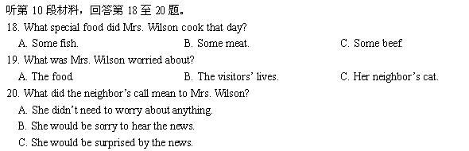
第二部分：英语知识运用（共两节，满分30分）
第一节：单项填空(共20小题；每小题0.5分，满分10分)
从A、B、C和D四个选项中，选出可以填入空白处的最佳选项
21. Of the two brothers, Bill is ______ younger one, and he is a quiet boy, ______ that most adults like very much.
A. the; one B. a; the one C. a; one D. the; the one
22. Tropical Storm Fitow on July 7, 2013 has caused serious _______ to Wenzhou’s economy.
A. damage B. injury C. wound D. ruin
23. You _______ call him if you want to, but you _______, for he’ll surely come here soon.
A. may; mustn’t B. can; needn’t C. have to; needn’t D. can; doesn’t need
24. Parents should pay attention to the cases _______ their children have difficulty adapting to new surroundings.
A. where B. as C. why D. when
25. — It’s getting dark, but Mr. Chen is till at his office.
— No surprise. Who else can _______ he does.
A. do less work than B. work as hardly as
C. work as hard as D. be working hardly like
26. Words don’t have the power to hurt you, _______ the person who said them means a lot to you.
A. if B. unless C. until D. whether
27. — Where did you get to know her?
— It was on the farm _______ we worked.
A. that B. there C. where D. which
28. I _______ up here night after night for weeks now. You see, I _______ to give you a surprise.
A. have come; hoped B. have been coming; has hoped
C. have come; was hoping D. have been coming; was hoping
29. He claimed _______ in the supermarket when he was doing shopping yesterday.
A. to have been badly treated B. treating badly
C. to be treated badly D. being badly treated
30. My uncle _________ in Taiwan for 20 years. Now he has settled down in mainland.
A. was living B. had lived C. has lived D. lived
31. _______ several times, he still turned a deaf ear to the typhoon forecast.
A. Being warned B. Having warned C. Having been warned D. I’ve warned him
32. Do speak loudly while _______ yourself understood well.
A. listen to B. listening to to make C. listened to to make D. listening to be made
33. When they had finished playing, the children were made to _______ all the toys they had taken out.
A. put off B. put up C. put down D. put away
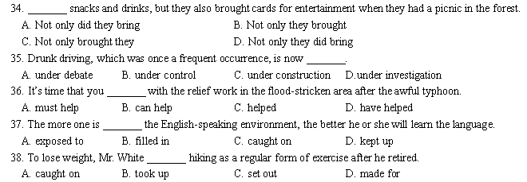39. — I was surprised to see wild flowers in Alaska.
— Many people think there is nothing there _______ ice and snow.
A. but for B. rather than C. apart from D. regardless of
40. — I just can’t stop worrying about the school results of the midterm examination.
— _______. There is nothing you can do now but study hard, keep calm and do your best.
A. Relax B. Go ahead C. Go for it D. Good luck
第二节：完形填空(共20小题；每小题1分，满分20分)
阅读下面短文，掌握其大意，然后从41-60题所给的四个选项（A、B、C和D）中，选出最佳选项。
There was a rich man who wanted to choose a husband for his only child from a great number of pursuers. The man 41 all the pursuers to a river and pointed to the crocodiles there, saying, “Anyone who can swim across the river safely will marry my 42 ” The pursuers looked at each other and no one 43 take action. At that moment, a man dived into the river and swam 44 a surprising speed to the other side. All the people there 45 him with a great sense of admiration for his courage. 46 , the man, after landing on the bank, shouted 47 , “who pushed me into the river just now?”
Maybe the man, 48 thinking about the whole 49 and the happy consequences of his act, will eventually be 50 to the one who pushed him into the river. In life it is fairly 51 for disadvantages to turn into advantages and misfortunes into fortunes! But many of us are 52 to realize the true 53 of our “rivals” (对手) to success. Generally speaking, many people would see the one who “pushes him into the river” as a rival. However, the one who “pushes him into the river” gives you a feeling of urgency and inspires your ambition and 54 to strive for success! You try your best to 55 your difficulties and progress to the next stage in life!
If a man does not have rivals, he 56 be satisfied with the present and will not try to improve his 57 . He would 58 in the face of difficulties and sink into laziness. Therefore, your rivals are not your enemies. Instead, they are good 59 ! In our lives, we need some rivals to “pushes him into the river,” leading us to strive ahead in difficulties and competitions. Thanks to our rivals, we can show our 60 to its best. Thanks to our rivals, we are able to make continuous progress while competing with them!
41. A. led B. walked C. drove D. brought
42. A. brother B. sister C. son D. daughter
43. A. could B. dared C. would D. must
44. A. at B. in C. for D. with
45. A. welcome B. observed C. applauded D. approved
46. A. But B. However C. Meanwhile D. Furthermore
47. A. happily B. surprisingly C. angrily D. desperately
48. A. unless B. before C. after D. while
49. A. process B. program C. result D. accident
50. A. close B. satisfied C. devoted D. grateful
51. A. general B. usual C. common D. ordinary
52. A. willing B. unwilling C. able D. unable
53. A. meaning B. answer C. tendency D. significance
54. A. demand B. desire C. deed D. defense
55. A. ignore B. overlook C. overcome D. meet
56. A. is bound to B. is meant to C. is intended to D. is fit to
57. A. contribution B. occasion C. situation D. ambition
58. A. hold out B. hold back C. hold on D. hold off
59. A. rivals B. competitors C. friends D. relatives
60. A. potential B. preference C. character D. knowledge
第三部分：阅读理解 (第一小节20小题，第二小节5小题；每小题2分，满分50分)
第一节：阅读下列材料，从每题所给的四个选项（A、B、C和D）中，选出最佳选项。
A
Big Brothers Big Sisters is based on the simplicity and power of friendship. It is a program which provides friendship and fun by matching vulnerable young people (ages 7-17) with a volunteer adult who can be both a role model and a supportive friend.
Volunteer tutors come from all walks of life—married, single, with or without children. Big Brothers and Big Sisters are not replacement parents or social workers. They are tutors: someone to trust, to have fun with, to talk and go to when needed.
A Big Sister and Little Sister will generally spend between one and four hours together three or four times each month for at least twelve months. They enjoy simple activities such as a picnic at a park, cooking, playing sport or going to a football match. These activities improve the friendship and help the young person develop positive self-respect, confidence and life direction.
Big Brothers Big Sisters organizations exist throughout the world. It is the large and most well-known provider of tutor services internationally and has been operating for 25 years.
Emily and Sarah have been matched since 2008. Emily is a 10-year-old girl who has experienced some difficulties being accepted by her schoolmates at school. “I was pretty sure there was something wrong with me.”
Emily’s mum came across Big Brothers Big Sisters and thought it would be of benefit to Emily by “providing different feedback (反馈) about herself other than just relying on schoolmates to measure her self-worth.”
Sarah wanted to get involved in a volunteer program. “I googled it and found out how to be a part of it. I thought it would be fun for me to get involved in making time to do something because sometimes it is all work and no play.”
Big Brothers Big Sisters has been of great benefit and enjoyment to both Emily and Sarah. They love and look forward to their time together and the partnership has certainly helped Emily be more comfortable in being the wonderful, happy and unique girl she is!
61. What is the aim of Big Brothers Big Sisters?
A. To offer students public services. B. To help students improve their grades.
C. To organize sport activities for young people. D. To provide partnership and fun for young people.
62. A volunteer is usually expected to work within a year for at least ________.
A. 24 hours B. 36 hours C. 48 hours D. 72 hours
63. According to Emily’s mother, this program may provide Emily with ________.
A. advice from her teachers B. a new way to judge her schoolmates
C. a new way to assess herself D. more comments from her schoolmates
64. Why did Sarah want to get involved in the program?
A. She used to be a volunteer. B. She felt a bit bored with her life.
C. She needed a part-time job. D. She wanted to get a challenging job.
65. According to the passage, “vulnerable young people” are probably those who are ________.
A. popular at school B. rather weak physically
C. confident in themselves D. easily hurt emotionally

B
Tayka Hotel De Sal
Where: Tahua, Bolivia
How much: About $95 a night
Why it’s cool: You’ve stayed at hotels made of brick or wood, but salt? That’s something few can claim. Tayka Hotel de Sal is made totally of salt—including the beds (though you’ll sleep on regular mattresses (床垫) and blankets). The hotel sits on the Salar de Uyuni, a prehistoric dried-up lake that’s the world’s biggest salt flat. Builders use the salt from the 4,633-square-mile flat to make the bricks, and glue them together with a paste of wet salt that hardens when it dries. When rain starts to dissolve the hotel, the owners just mix up more salt paste to strengthen the bricks.
Green Magic Nature Resort
Where: Vythiri, India
How much: About $240 a night
Why it’s cool: Ridding a pulley(滑轮)-operated lift 86 feet to your treetop room is just the start of your adventure. As you look out of your open window—there is no glass!—you watch monkeys and birds in the rain forest canopy. Later you might test your fear of heights by crossing the handmade rope bridge to the main part of the hotel, or just sit on your bamboo bed and read. You don’t even have to come down for breakfast—the hotel will send it up on the pulley-drawn “elevator”.
Dog Bark Park Inn B&B
Where: Cottonwood, Idaho
How much: $92 a night
Why it’s cool: This doghouse isn’t just for the family pet. Sweet Willy is a 30-foot-tall dog with guest rooms in his belly. Climb the wooden stairs beside his hind leg to enter the door in his side. You can relax in the main bedroom, go up a few steps of the loft in Willy’s head, or hang out inside his nose. Although you have a full private bathroom in your quarters, there is also a toilet in the 12-foot-tall fire hydrant outside.
Gamirasu Cave Hotel
Where: Ayvali, Turkey
How much: Between $130 and $475 a night.
Why it’s cool: This is caveman cool! Experience what it was like 5,000 years ago, when people lived in these mountain caves formed by volcanic ash. But your stay will be much more modern. Bathrooms and electricity provide what you expect from a modern hotel, and the white volcanic ash, called tufa, keeps the rooms cool, about 65℉in summer. (Don’t worry—there is heat in winter.)
66. What do we know about Tayka Hotel de Sal?
A. It is located on a prehistoric wet lake. B. It must be protected against rain.
C. Everything in the hotel is made of salt. D. You have to cross a rope bridge to the hotel.
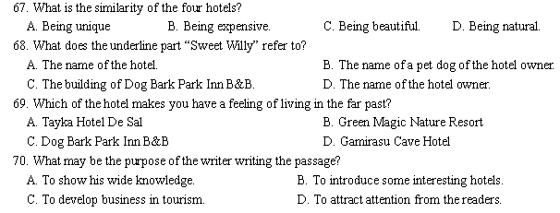
C
For those who make journeys across the world, the speed of travel today has turned the countries into a series of villages. Distances between them appear no greater to a modern traveler than those which once faced men as they walked from village to village. Jet planes fly people from one end of the earth to the other, allowing them a freedom of movement undreamt of a hundred years ago.
Yet some people wonder if the revolution in travel has gone too far. A price has been paid, they say, for the conquest (征服) of time and distance. Travel is something to be enjoyed, not endured (忍受). The boat offers leisure and time enough to appreciate the ever-changing sights and sounds of a journey. A journey by train also has a special charm about it. Lakes and forests and wild, open plains sweeping past your carriage window create a grand view in which time and distance mean nothing. On board a plane, however, there is just the blank blue of the sky filling the narrow windows of the airplane. The soft lighting, in-flight films and gentle music make up the only world you know, and the hours progress slowly.
Then there is the time spent being ‘processed’ at a modern airport. People are conveyed like robots along walkways; baggage is weighed, tickets produced, examined and produced yet again before the passengers move to another waiting area. Journeys by rail and sea take longer, yes, but the hours devoted to being ‘processed’ at departure and arrival in airports are luckily absent. No wonder, then, that the modern high-speed trains are winning back passengers from the airlines.
Man, however, is now a world traveler and cannot turn his back on the airplane. The working lives of too many people depend upon it; whole new industries have been built around its design and operation. The holiday-maker, too, with limited time to spend, patiently endures the busy airports and the limited space of the flight to gain those extra hours and even days, relaxing in the sun. Speed controls people’s lives; time saved, in work or play, is the important thing—or so we are told. Perhaps those first horsemen, riding free across the wild, open plains, were enjoying a better world than the one we know today. They could travel at will, and the clock was not their master.
71. What does the writer try to express in Paragraph 1?
A. Travel by plane has speeded up the growth of villages.
B. Man has been fond of traveling rather than staying in one place.
C. The speed of modern travel has made distances relatively short.
D. The freedom of movement has helped people realize their dreams.
72. How does the writer support the underlined statement in Paragraph 2?
A. By giving examples.
B. By giving instructions.
C. By analyzing cause and effect.
D. By following the order of time.
73. According to Paragraph 3, passengers are turning back to modern high-speed trains because ______.
A. they pay less for the tickets
B. they feel safer during the travel
C. they can enjoy higher speed of travel
D. they don’t have to waste time being ‘processed’
74. What does the last sentence of the passage mean?
A. They could travel with their master. B. They needed the clock to tell the time.
C. They preferred traveling on horseback. D. They could enjoy free and relaxing travel.

D
Poet Dean Young has dealt with impermanence (无常) a lot in his career, but it’s a particularly strong theme in Young’s latest collection, Fall Higher. The new collection was published in April, just days after the poet received a life-saving heart transplant (移植) after about a decade of living with a weakening heart condition.
Young, whose work is often frank and rich with twisted humor, tells NPR’s Renee Montagne that as he recovers from operation, he’s also slowly returning to his everyday writing habits.
“I’m getting back to it,” Young says, “not with the sort of concentration and sort of flame that I look forward to in the future, but I am blackening some pages.”
And on those blackened pages you’ll find poems like “How Grasp Green”, which carries themes of springtime and rebirth. It’s one of the first poems Young has written since his transplant.
It’s easy to spot clues (线索) to Young’s awful health situation in the lines of his poetry.
Fall Higher’s “Vintage” opens with “Because I will die soon, I fall asleep, during the lecture on the ongoing emergency.” And the poem “The Rhythms Pronounce Themselves Then Vanish”—published in The New Yorker in February—opens with the CT scan that revealed Young’s heart condition.
Hearts tend to come up a lot in poetry, and that’s especially true if Young’s work, which has clearly been influenced by the troubles of his own heart.
“A lot of times, it’s not just a metaphor (暗喻),” Young says. “For me, it’s an actual concern because I’ve been living with this disease for over 10 years. My father died of heart problems when he was 49, so it’s been a sort of shadowy concern for me my whole life.
But Young’s poems also deal with more abstract matters of the heart. He wrote Fall Higher’s, “Late Valentine” for his wife. “We’ve been married since late November and most of it has been spent in the hospital,” Young says of his marriage to poet Laurie Saurborn Young, who says “‘Late Valentine’ is very sweet.”
His work also touches on themes of randomness and fate—two factors that contributed to him getting a second chance in the form of transplanting a new heart from a 22-year-old student. “I just feel enormous gratitude,” he says of his donor (捐献者). “He gave me a heart so I’m still alive … I’m sure I’m going to think about this person for the rest of my life.”
75. The poetry collection Fall Higher .
A. was published in February B. is Young’s latest collection of poetry
C. makes darkness as its main theme D. was written after Young’s heart transplant
76. We can learn from the text that Young .
A. was born with heart disease
B. received a heart transplant in February
C. married a female poet after he wrote “late Valentine”
D. wrote a poem for his wife in his collection
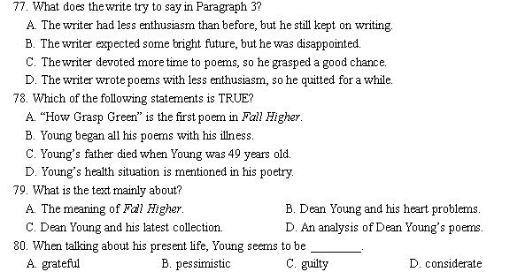
第二节：下面是一篇关于培养孩子创造性思维的文章，文章中有5处（第81~85题）需要添加小标题，请从以下选项中选出符合各段意思的小标题，并在答题卡上将该项涂黑，选项中一项为多余选项。
A. The Definition of Creativity
B. The Value of Creative Thinking
C. The Disadvantage of School Education
D. The Importance of Giving Children Choices
E. Creativity not Being Something Born With
F. Effective Ways to Develop Students’ Creativity

The Case for Creativity — Encouraging Children to Think
Creativity is the key to a brighter future, say education and business experts. Here is how schools and parents can encourage this vital skill in children.
81.
If Dick Drew had listened to his boss in 1925, we might not have a product that we now think of as practically essential: masking tape. Drew worked for the company, known as 3M. At work he developed a sticky-side substance strong enough to hold things together. But his boss told him not to pursue the idea. Finally, using his own time, Drew perfected the tape, which now is used everywhere by many people. And his former company learned from its mistake: Now 3M encourages people to spend 15 percent of their work time just thinking and developing new ideas. Experts say if we teach our children to think creatively, they will be better able to function in tomorrow’s society.
82.
Creativity is not a natural ability, nor is it necessarily a characteristic of high intelligence. Just because a person is highly intelligent does not mean that he uses it creatively. Creativity is the matter of using the resources one has to produce original ideas that are good for something.
83.
Unfortunately, schools have not tended to promote creativity. With strong emphasis on test scores and the development of reading, writing and mathematical skills, many educators sacrifice creativity for correct answers. The result is that children can give back information but can’t recognize ways to apply it to new situations. They may know their multiplication tables, for example, but they are unable to apply them to story problems.
84.
In some schools, however, educators are recognizing the problem and are trying their best to encourage creativity in their students. Some teachers are combining the basics with activities where the students must use their imagination. For example, instead of simply asking WHEN Columbus discovered the New World, teachers might ask students to think about what would have happened if his trip had taken him to New York first instead of to the Caribbean area. With that question, students would have to use what they know about Columbus, what they know about New York, and what they know about the Caribbean. Teachers feel that even if the answers seem silly, it’s OK, that sometimes being silly is an essential step toward creativity.
85.
From the earliest age, children should be allowed to make decisions and understand their consequences. Even if it’s choosing between two food items for lunch, decision-making helps thinking skills. As children grow older, parents should let their children decide how to use their time or spend their money but not automatically help them too much if they make the wrong decision. This may be confusing for the child, but that is all right. This is because one of the most important traits of creative people is a very strong motivation to make order out of confusion.

非选择题部分（共40分）
第四部分：写作（共两节，满分40分）
第一节：短文改错（共10小题；每小题1分，满分10分）
下面短文中有10处语言错误。请在有错误的地方增加、删除或修改某个单词。
增加：在缺词处加一个漏字符号（∧），并在其下面写上该加的词。
删除：把多余的词用斜线（\）划掉。
修改：在错的词下划一横线，并在该词下面写上修改后的词。
注意：1.每处错误及其修改均仅限一词；
2.只允许修改10处，多者（从第11处起）不计分。
例如：It was very nice to get your invitation to spend ∧ weekend with you. Luckily I was
the am
completely free then, so I’ll to say “yes”. I’ll arrive in Bristol at around 8 p.m. in Friday evening.
on
This morning on my way to school I was deep moved by what I saw outside a

My mother is a teacher work in a key high school. She is too busy that she often has to get up early and stay up late. In addition to this, she hardly has any times to take exercise. She has been on poor health for some time. My father and I are worried that she may fall ill if she works too hard. These days I’m thinking why to develop my mother’s interest in playing sports. Considered that today is Mother’s Day, I decided buy a pair of jogging shoes for her. I secret put them on the desk in her study. When my mother entered into her study this evening, she looked surprised, but she immediately realized my intention. She promises that she would go jogging every evening.
第二节：书面表达（满分30分）
在学校组织的“感动校园人物”评选活动中，你班经过讨论，决定推荐李华参加评选。请按以下要求写一篇100-120词的文章。内容包括：
1．推荐李华的理由；
2．列举1-2个事例。
注意：文章开头已经给出，不计入总词数。
After a heated discussion, our class has decided to recommend Li Hua as the Touching Figure on Campus.
_________________________________________________________________________________________________________________________________________________________________________________________________________________________________________________________________________________________________________________________________________________________________________________________________
2013学年第一学期温州十校联合体高三期中联考英语试卷答案

命题人：柳市中学 2013.11
审核学校: 温州八中

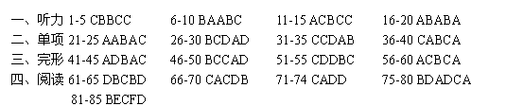
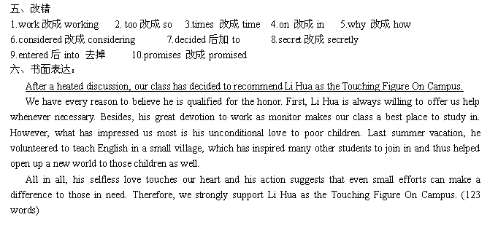
听力材料原文：
Text 1
W: Excuse me, where are women’s shoes?
M: They are on the third floor, next to the handbags.
W: Thank you.
Text 2
W: Mike, you don’t quite seem yourself today. You okay?
M: Well, I hardly slept last night. I’ve been studying for my exams these days.
Text 3
W: You mean Jack has stopped smoking, Frank? That’s amazing.
M: Yes, it’s really amazing. He used to be a chain smoker, you know.
W: What about you? Have you thought about quitting smoking?
Text 4
W: Summer vacation is coming. Have you already got any plan?
M: Not really. But I’m going to head down to Vancouver Island to visit my brother for a few days first. We haven’t seen each other for a couple of years. Then maybe go back home. I’m a little homesick.
Text 5
W: I feel scared of hosting the evening party. You know, this is the first time for me to host such an important party.
M: Don’t worry. Just be yourself and everything will be fine. I’m sure you can do quite well.
Text 6
W: Hello! Would you like to reserve a table, Sir?
M: Hello! I want to book a table for a Chinese dinner the day after tomorrow. Could you arrange it for me?
W: Certainly. What time?
M: At five o’clock. I’m afraid we’ll come a little late after five.
W: How many guests?
M: About ten. I have no idea how much it costs. What’s the price?
W: The price of a Chinese table of dishes ranges from $100 to $500, not including drinks.
M: I would prefer the highest price.
W: OK, are there any particular dishes you’d like to order?
M: No, I will leave it all to you. I think we would like to have typical Chinese dishes.
W: No problem.

Text 7
M: Hi, Linda.
W: Oh, hello, Dick. How are you?
M: I’m fine, but you look tired. Can you have a cup of coffee with me? You are always busy.
W: Yes. I’m always studying. But I can’t stop now.
M: Why not?
W: I should go home right away.
M: Oh, can’t you spare me a minute or two?
W: I can’t now. I have an exam tomorrow. I must study for it.
M: You’re taking too many courses this year.
W: I can handle all of them, but it doesn’t mean a lot of work.
M: It’s too much work! You may get sick.
W: I’m all right, but I really must hurry now.
M: Just one cup of coffee. Just ten minutes to relax.
W: Oh, all right! But I really shouldn’t

Text 8
W: Well, I think the meeting went well today.
M: Yes, it did. But it’s good to have a break from business.
W: So what do you do when you are not working?
M: Well, I do quite a lot of sports. I enjoy mountain biking and I’ve just taken up sailing.
W: Really? I didn’t know there was any water around here.
M: Well, there are a couple of lakes nearby. What about you?
W: Well, I’m not interested in sports. I love gardening. I love going to the cinema. And I’m a real bookworm.
M: What kind of things do you like reading?
W: Well, there’s nothing that beats a really good murder mystery.
M: You don’t look the type for that!
Text 9
M: So how is everything in the apartment? Is the bedroom air conditioner working well?
W: Well, it cools pretty well now, but it surely makes an awful lot of noise. It makes it hard to sleep sometimes.
M: Oh, really? I’ll have someone take a look at it. How about the refrigerator? You said it wasn’t cooling properly?
W: Oh, it’s working fine now, thanks.
M: Good. And is the washing machine OK?
W: Yes, since you had it fixed last year, I haven’t had any problems with the water leaking. I want to talk to you about the sofa, though. It’s really uncomfortable. Maybe it’s time to replace it. How old is it, anyway?
M: Well, I admit it’s pretty old. About 20 years, I guess. Maybe it is time to think about a new one. Is the TV set working on all the stations?
W: Not really. The reception is bad on some of the stations.
M: OK. I’ll have it checked out next week.

Text 10
Mrs. Wilson invited some friends for lunch. She was eager to try a new way of cooking a fish dish, and she was very pleased with herself when the dish was ready. Because the dish was hot, she put it near the window to cool for a few minutes. When she came back for it, she was surprised to find the neighbor’s cat by the dish. Fortunately, she came in time to stop the cat. That afternoon was a great success and they talked and laughed till four o’clock. At the end of the afternoon, when she was alone again, she felt tired but happy. She was sitting near the window when she was frightened to see her neighbor carrying the cat, dead. What had happened to her friend’s cat? She at once called the family doctor. He told her to phone each of her visitors to meet him. Just as she sat down, the telephone rang. It was her neighbor, “My cat was killed by a car.”

