2013年高考英语试题分类汇编之书面表达
【2013年高考陕西卷】书面表达（满分30分）
假定你是李华。请根据写作要点用英语写一篇周记，记述你周末帮助家人做家务的一次经历。
写作要点：1.做家务的理由；2.做家务的过程；3.你的感受。
注意：
1.短文词数不少于100；
2.开头部分已写好，不计入总词数；
3.不能使用真实姓名和学校名称。
I am an 18-year-old middle school student,
【参考范文】
I’m an 18-year old middle school student. I have been busy with my study and seldom helped my parents with the housework. Feeling quite sorry for that, I begin to think about what to do to help.
Last Sunday, when my parents went out shopping, I suddenly got an idea: why not give the rooms a thorough cleaning? Firstly I collected all the books, newspapers and other things scattered in the rooms and put them in place. Then I wiped the dust off all the furniture. After that, I swept and mopped the floors.
At this very moment, my parents came back and were quite surprised to see all the rooms tidy and floors shining. My mother gave me a hug and I could see satisfaction in her eyes. Tired as I was, I never felt so happy.
【2013•课标全国卷Ⅰ】书面表达(满分25分)
假定你是李华。请你给笔友Peter写封信，告诉他你叔叔李明将去他所在城市开会，带去他想要的那幅中国画，同时询问他是否可以接机。信中还需说明：
李明：高个子，戴眼镜
航班号：CA985
到达：8月6日上午11:30
注意：1. 词数100左右
2. 可以适当增加细节，以使行文连贯；
3. 开头语和介绍语已为你写好。
Dear Peter,
How are you doing?___________________________________________________
__________________________________________________________________________________________________________________________________________________
Looking forward to your reply.
Yours,
Li Hua
【参考范文】
Dear Peter,
How are you doing?
I’m writing to tell you that my uncle Li Ming is going to your city for a conference, and I’ve asked him to bring you the Chinese painting you’ve asked for before.
Also, I’d like you to do me a favor. Would you please meet my uncle at the airport and take him to his hotel since this is the first visit to the U.S.? Thank you in advance!
His flight number is CA985, and it will arrive at 11:30 am. August 6. My uncle is tall and he is wearing glasses. And he will be in blue jacket.
Looking forward to your reply.
Yours,
Li Hua

【2013·辽宁卷】书面表达（满分25分）
—个英文网站面向中学生征稿请你写一篇英语稿件，介绍“中秋节”及这个 节日里的主要活动。
- 写作要点：它是中国的传统节日之一；
- 家人团聚；
- 赏月、吃月饼；
- 还有旅游、访友等其他活动。

注意：1.词数100左右；
2. 可以适当增加细节，以使行文连贯；
3. 开头语已为你写好，不计人总词数。

参考词汇：中秋节 the Mid-Autumn Festival 农历 lunar calendar
赏月 enjoy the full moon 月饼 moon cake
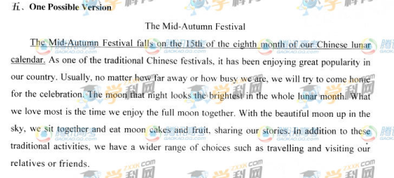
【2013·福建卷】书面表达(满分25分）
孩子的成长和教育是社会热议的话题，现今父母包揽一切、孩子过度依赖等现象十分严重。请阅读下面 的漫画，按要求用英文写一篇短文。
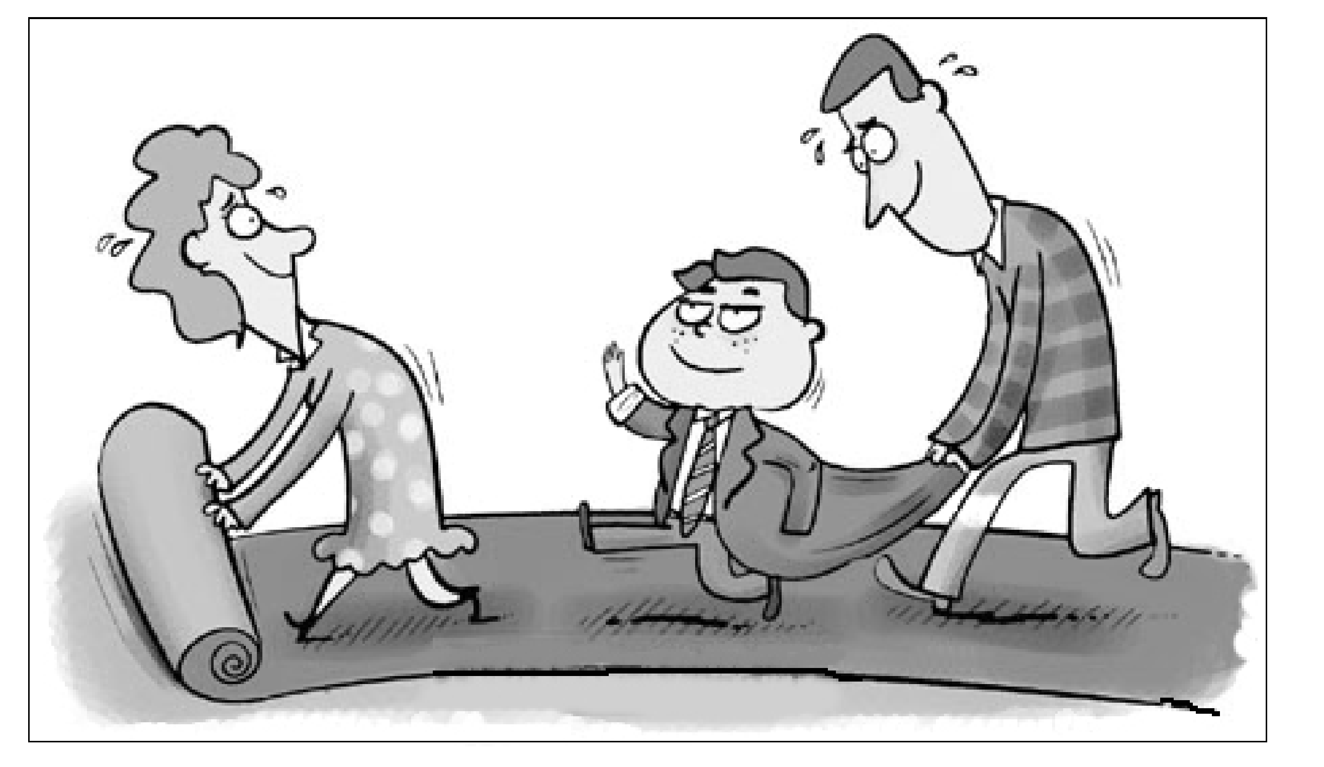

内容要求：
1.描述漫画内容；
2. 分析漫画所揭示的问题；
3. 提出你的看法。
注意：
1.短文开头已给出，不计入总词数；
2.考生可适当发挥，使文章内容充实、连贯；
3.词数120左右;
4. 文中不能出现考生的具体信息。
参考词汇:pave the way

From the picture, we can see a family of three walking on a long red carpet.
_______________________________

One possible version:
From the picture we can see a family of three walking on a long red carpet. The son , well dressed, waves proudly in the middle while the father behind bends forward to hold the jacket and the mother in front rolls out the carpet, sweating.
It shows a common phenomenon nowadays that children are the focus of families, shouldering the hope of their parents. Parents arrange everything for their children and spare no effort to pave the way for their success. As a consequence, children become so reliant on their parents that they have no independent thought or creative ideas.
Such a situation is of great concern. In my opinion, overprotection and too much care are extremely bad for children’s development. Instead of doing everything for them, parents should encourage their children to overcome difficulties and inspire them to develop by themselves. Only in this way can they grow up to be independent and become truly successful.
【2013·安徽卷】书面表达（满分25分）
假设你校英语社团举办以“讲求文明，从我做起”为主题的征文活动，请你以“On the Way to School”为题，写一篇英语短文。
内容主要包括：
1.遵守交通法规；
2.注意举止文明。
注意：1.词数120左右；
2.可以适当增加细节，以使行文连贯；
3.短文中不能出现与本人相关的信息；
4.短文的题目已为你拟好，不计入总词数
One possible version:
These days, breaking traffic rules and littering are not uncommon, causing serious harm to life and the environment. Changing this situation requires considerable effort on the part of everyone. As for me, it should start on the way to school.
I will keep traffic rules in mind all the way. If I ride a bicycle, I’ll always keep to the right and never cross a road until the traffic light turns green. If I walk, I’ll never forget to use the pedestrian crossing. Meanwhile, I’ll regard it as my duty to help keep our environment clean and healthy. Not only will I keep from littering and spitting anywhere, I will also help clean up the roadside litter whenever possible. I hope my behavior will make a difference.

【2013·北京卷】书面表达（共两节，15 分）
第一节 情景作文（20 分）
假设你是红星中学高三（1）班的学生李华，请按照以下四幅图的先后顺序，用英文写一篇周记。记述爸爸出 差期间，妈妈生病，你照顾她的过程。
注意： 1. 周记的开头已经为你写好。
2. 词数不少于 60.
Last Monday,

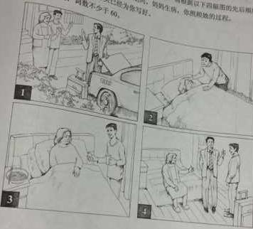

【参考范文】1
Last Monday, my father said goodbye to my mother and me and went on a business trip. He would be away for three days. Just the next morning I found my mother wasn’t feeling well. She had a cold. I immediately went to get her some medicine and then prepared some noodles for her. With my special care, my mother recovered quickly. When my father came back home, my mother told him what had happened. He praised me for what I had done.
I feel very happy that I have done something for my mother.
【参考范文】2
Last Monday, my father would be on a business trip for five days. Having gotten my promise of being great at home and taking care of my mother, he rest assured and put his luggage into the trunk of his car. Seeing my father’s driving away, my mother and I waved our hands and said goodbye to him. For a moment, I began to miss my father, wishing that he would be safe and well the next days.
I thought everything would go well, as this was not the first time that my father had been away for several days. Yet, unfortunately, my mother caught a cold the next morning. Looking at her pale face, I experienced high levels of anxiety. However, I told myself that I had to calm down and look after my mum, as I promised to my dad. The moment I got my mum to sleep, I put cold towel on her forehead, found pills in the medicine box, and made some noodles for her. Luckily, she waked up and felt better, after taking the pills and the noodles. That her fever was gone relieved and satisfied me a lot.
In the next four days, I was taking her body temperature twice a day, ensuring that she was completely well. To our delight, my dad went back home safely and healthily on Saturday. On hearing what I had done to my mum, he, as well as my mum, beamed at me and gave me a big thumb. Hearing their praises and seeing bright smiles on their faces, I really felt overjoyed and thrilled. Conceivably, taking care of my parents was, indeed and definitely, my mission and obligation.

第二节 开放作文（15 分） 请根据下面提示。写一篇作文。词数不少于 50.
You are discussing the following picture with your English friend Jim. Now you are telling him how you understand the picture and what makes you think so.
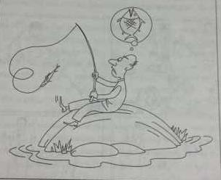

【参考范文】1
I think the picture is telling us that there is usually a difference between one’s dream and reality. People need to learn to face it. Everyone has his dream. However, it is not so easy for people to realize their dreams every time. Just like the man in the picture, instead of the big fish he wishes for, he actually catches a small one. In my opinion, people need to learn to accept the reality and keep on trying. With another try, they may gain what they dream of.
【参考范文】2
Hi, Jim, there is an interesting picture conveying a message vividly that a difference between reality and dream may as well be recognized in our life. Evidently, realizing this difference and trying to shorten this gap is the key to achieving our accomplishment, otherwise nothing will be gotten in the end.
In our daily life, some people are aware of their ability, making great efforts to improve themselves, while others ignore the disparity between their earnest wish and poorest actuality, doing nothing but complaining. Conceivably, the confused man in the picture is exactly the latter one. In this picture, a man is fishing on a big stone, waiting and waiting. However, the small fish he has caught is totally different from the big one he is longing for. Now, there are two options in front of him: face the reality and keep trying till get the dreamy fish, or drop his fishing rod and feel desperate. Apparently, he chooses the second one. Such a situation seems fairly common in our society. We are faced with this kind of intriguing question all the time, and every choice we make has great influence on our way to success. Making an accurate estimate of our realities and dreams, then sparing no efforts to approach the tip is the only option for us to make, provided that we are in great want of achieving our goals.
Based on the above statement, a conclusion will be arrived at that learning to accept the reality and adopting a positive attitude towards the dream is what we are supposed to do, when confronting our less-satisfying situation.
【2013·重庆卷】写作（共两个写作任务，满分35分）
写作一（满分15分）
请结合材料，按要求用英文写作。
A mother said, “My son is always on the phone, sleeping, out with friends, or in his room. He never has time to talk to me.”
【参考范文】
I must say that I have been behaving this way to some degree. Though I know Mum is the most important person in my world, I just can not do what she likes me to do. It seems that I quite often stay away from my dear mum in playing my phone, sleeping, hanging out with my friend, or just shutting out my mum in my room.
Having read about the above common complaint from so many mothers, I feel ashamed and guilty. From now on, I shall try my best to stay with my dear parents as often as possible. I must confess we young generation must realize that our parents care for us as well as hoping to share what we have been doing with them.
写作二（满分20分）
调查显示， 中国长江江豚(finless porpoise)受人类活动影响而濒临灭绝，目前总数不足100只。假设你是李华，现请用英文给WWF(世界自然保护基金组织)写一封信，请他们关注这一状况并提供帮助。内容应包括：
●说明写信目的
●简述江豚现状
●希望WWF如何帮助(比如资助江豚保护项目等)
●表示感谢并期望回复
注意：（1）词数不少于80；
（2）在答题卡上作答；
（3）书信格式及开头语已给出（不计入总词数）。
Dear Sir or Madam,
I’m a student from Chongqing, China. _________________________________
____________________________________________________________________
____________________________________________________________________
____________________________________________________________________

Yours sincerely,
Li Hua
【参考范文】
Dear Sir or Madam,
I’m a student from Chongqing, China. I’m writing this letter to you to report you the emergent situation of the Chinese Yangtze finless porpoise. Because of the human beings’ destructive influence, the number of this precious species has promptly dropped to less than 100.
As far as I know, your foundation can help those species that are at the edge of distinction, I’m writing this letter to you to ask for your generous donation to our project to protect this endangered species. If it is not too much inconvenient, would you please come to China to have a close observation of the poor porpoises and give us aid and direction to prevent them from dying out completely?
Thanks for reading my letter and anxiously anticipating to hear from you soon.
Yours sincerely,
Li Hua

【2013·全国大纲卷、新课标II】书面表达（满分25分）
假定你是李华，自制一些中国结（Chinese knot）。给开网店的美国朋友Tom写封信，请他代卖，要点包括：
1.外观（尺寸、颜色、材料）
2.象征意义
3.价格
注意：1.词数100左右；
2.可以适当增加细节，以使行文连贯；
3.开头语已为你写好。
【参考范文】
Dear tom,
How are you? I wonder if you could sell some Chinese knots for me. I made them myself with red silk threads, cloth and other materials. They look really beautiful in the shape of a diamond, about 5 inches long and 4 inches wide. In china, these knots stand for friendship, love and good luck. People can either give them as gifts to friends or hang them in their houses. They are only 12.99 US dollars each. If anyone wants to know more about the knots, let them write to me. Also, do let me know if you need further information. Thank you!
Li hua.
【2013·广东卷】写作（共两节，满分40分）
- 基础写作（共1小题；满分15分）
你接受了一项写作任务，要为英语校报写一篇时事快讯。
[写作内容]
请根据以下信息，写一篇关于移民火星的快讯
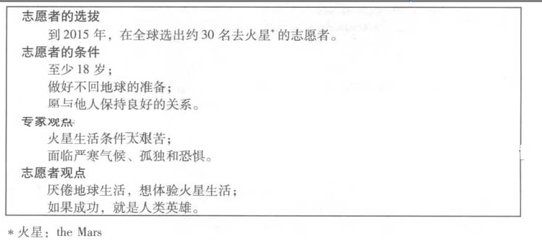
[写作要求]
只能用5个句子表达全部内容
[评分标准]、
句子结构准确，信息内容完整，篇章连贯。
第二节 读写任务（共1小题；满分25分）
阅读下面短文，然后按照要求写一篇150词左右的英语短文
To many people even the word “work” sounds unpleasant ,not necessarily because they are lazy. The same man, who dislikes his job in the factory or even in the office ,may work hard at the weekend ,painting the house or digging the garden.
What is the reason ,then ？In most cases ,it is because these people simply do not enjoy the
Job they are doing .It does not give them any real satisfaction .It may be quite easy ,like making up wooden boxes ,but it is very boring.Very often they are doing a job which is just a small part of
a much larger one ,such as attaching a door handle to a car .But the part they play in actually making the car is so small that they can never say :I have made something !
Yet in modern society somebody has to do ordinary jobs such as cleaning streets because this
Is the way society is organized ,No matter how ordinary a job is, it plays a part in society and therefore deserves our due respect. Society cannot function a single day without the “dull and boring” jobs.
[写作内容]
- 以约30个词概括上文的主要内容。
- 以约120个词谈谈你对平凡工作的想法，内容包括：
- 描述清洁工工作的艰辛；
- 假如没有清洁工，环境会变得如何？
- 你对平凡工作者的看法。
[写作要求]
- 作文中可以使用亲身经历或虚构的故事，也可以参照阅读材料的内容，但不得直接引用原文中的句子。
- 作文中不能出现真实姓名和学校名称。
[评分标准]
概括准确，语言规范，内容合适，语篇连贯。
【2013·湖北】
请根据以下提示，并结合事例，用英语写一篇短文。
We all know that “sticks and stones may break our bones”, but we should also be aware that words can hurt people, too.
注意：①无须写标题，不得照抄英语提示语；
②除诗歌外，文体不限；
③文中不得透露个人姓名和学校名称；
④词数为120左右。

【参考范文】
One possible version:
My classmate admires my fluent English very much and I usually feel encouraged by his compliments.
One day, when we learned the new word “eccentric” in class, we were asked to make a sentence with it. I volunteered to do it by saying “My deskmate is an eccentric boy whose clothes never fit him.” Hearing this, the whole class burst into laughter and my deskmate’s face turned red. After class, I learned from the teacher that my deskmate would have dropped out of school if he hadn’t been helped by others. My mindless words must have hurt him deeply.
Not until then did I realize words could be powerful in both positive and negative. We should avoid hurting others if we can’t always be encouraging when we speak.
【2013·江苏卷】书面表达
请根据你对以下两幅图的理解, 以“Actions Speak Louder than Words”为题, 用英语写一篇作文。
参考词汇: banner (横幅)
stump (树桩)
你的作文应包括以下内容:
1. 简要描述两幅图的内容;
2. 概述你对两幅图中不同做法的理解;
3. 举例说明两幅图对你的启示。
注意:
1. 可参照图片适当发挥;
2. 作文词数150 左右;
3. 作文中不得提及有关考生个人身份的任何信息,如校名、人名等。

Actions Speak Louder than Words

【参考范文】
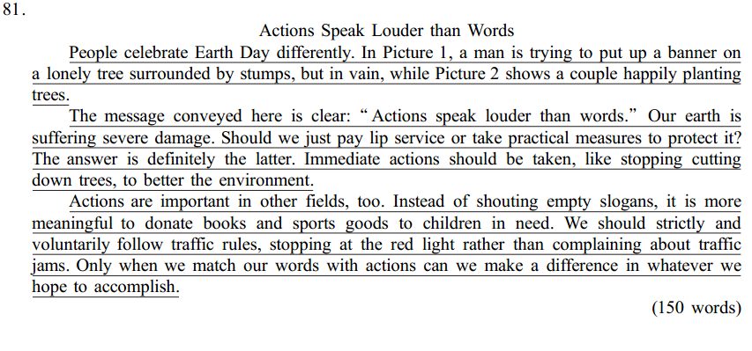
【2013·湖南卷】
Section C (25 marks)
Directions: Write an English composition according to the instructions given below.
请以下列词语为关键词写一篇英语短文。
matchwinnerloserresult

内容：
1．自己或他人的一次经历；
2．你的感受。
注意：
1．必须使用所给4个关键词；
2．词数不少于120个；
3．不能使用真实姓名和学校名称。

One possible Version
Last week, a football match was held between we Class One and Class Two.
The players from both sides are all excellent basketball players, so the match went on fiercely at first. At last the result is: the winner is Cass Two, and we were the loser.
We didn’t win the match, but we didn’t lose heart. One the one hand, we think that friendship comes first, and match comes second. On the other hand, since we all tried our best, we had no regret. In our life we may meet many failures, as long as we try our best, there’s no need feeling regret for these failures. What’ more， we should analyze the reasons of failure to get success for the next time.
In a word, success is important, so is failure, because it’s the mother of success.
【2013·山东卷】
写作（满分30分）
假如你是新华中学的学生李华，你的美国朋友Tom一周前给你发电子邮件，询问你暑假里的打算，但你因准备期末考试未能及时回复。请根据双下要点给他回封邮件：
- 未及时回信的原因；
- 你假期的打算（如做兼职、旅行、做志愿者等）
注意：1. 词数：120-150；
2 可适当增加细节，以使行文连贯。

【参考范文】
Dear Tom,
How are you doing? You asked me in your last letter about my plan for the coming summer vacation. I am sorry that I didn’t reply without delay. How I wish I would read and reply your email as soon as I received it. However, I was busy preparing for my final exam at that time, which is vital for me. As a result, I had no choice but to completely focus on my study, for which I am very sorry. I hope you can understand me.
During the holiday, I am going to do a part-time job. On the one hand, I can earn some money to reduce the burden of my family. On the other hand, I accumulate the social experience, which does good to my future life. At the same time, I will not forget to go over my lesson. I will spend a instructive holiday. How will you spend your holiday? I hope you have a good time.
These are my plan for the summer vacation. What’s yours? I am looking forward to your earliest reply.
Yours,
Lin Hua
【2013·四川卷】书面表达（共35分）
某中学生英文报近期开辟专栏，讨论学习习惯问题，请你结合自身学习实际，按一下提示，用英文为该专栏写一篇稿件。
- 说明学习习惯与学习效果之间的关系；
- 介绍一种好的学习习惯并提出养成该习惯的建议；
- 描述自己在学习习惯方面存在的某个问题并给出改进措施
注意：
- 词数120左右，开头语已为你写好
- 可以适当增加细节，以使行文连贯
- 文中不得透露个人姓名和学校名称
It’s useful and necessary to discuss learning habits._______________________________
____________________________________________________________________________________________________________________________________________________________________________________________________________________________________________________________________________________________________________________________
【参考范文】
It’s useful and necessary to discuss learning habits. As we all know, good learning habits can make your study go to succeed. As a student, we should pay more attentions to our habits which we develop in our study.
I’m sure “repeat” is a best habit. Do you develop the habit? If we want to improve our study, we should repeat what the teachers taught us again and again, and then we can understand or remember the knowledge which the teachers demand us to master. How to develop the habit? the first step, set a timetable, and stick to carry out the plan, don’t stop.
When I do my homework, I often make mistakes with carelessness, how to overcome the shortage? I think I should think about it over and over as long as I do my homework. And then I do it little by little. Maybe in this way I can correct my mistakes.

【2013·天津卷】书面表达
- 假设你是某大学的学生李津，你校英语俱乐部将选举新一届副主席，负责规划、组织俱乐部的相关活动，你欲参选，请按以下提示，写一篇竞选演讲稿。
- 个人的优势介绍（如性格、特长等）
- 组织校内的活动的设想（如举办讲座、英语晚会等）
- 组织校际交流活动的设想（如举办辩论赛、演讲比赛等）
- 表达竞选的愿望。
注意：
- 词数不少于100；
- 请勿提及真实学校姓名
- 可适当的加入细节，以使内容充实，行文连贯；
- 开头、结尾已给出，不计入总词数。
参考词汇：
副主席：vice president
竞选： run for
Good afternoon, my dear friends,
My name is Li Jin,

Thank you.
【2013·江西卷】
书面表达（满分25分）
星光中学（Xingguang High School）近期举行了一次登山活动。假定你是学校英语报记者，请写一篇短文，报道此次活动。内容包括：
1. 时间与地点：4月10日，大青山（Daqing Mountain）；
2. 活动的过程；
3. 你对于这次活动的评论。
注意： 1. 词数120左右。
2. 可适当增加细节，以使行文连贯。
【参考范文】
In order to encourage the students to take outdoor exercise, our school organized a mountain-climbing on April 10. Hundreds of us took part in it.
It was a nice day. At 8:00 am, we gathered at the foot of Daqing Moutain and set out for the top in high spirits. Al the way we were chatting, singing and laughing, enjoying the fresh air and the beautiful scenery. When some fell behind, others would come and offer help. About 2 hours later, we all reached the top. Bathed in sunshine, we jumped and cheered with joy.
The activity benefited us a lot. Not only did it get us close to nature and give us relaxation from heavy school work, it also promoted the friendship among us. What a wonderful time!
【2013浙江卷】
请以“One Thing I’m Proud of”为题，用英语写一篇100---120个词的短文，记述一件你自己认为得意的事情。要求如下：
1.记述事情的经过；
2.简要说明你感到得意的原因或从中得到的启示。
注意：文章的标题已给出，不计入词数。
One Thing I’m Proud of
____________________________________________________________________________________________________________________________________________________________________________________________________
【参考范文】




