2013年高考英语试题分类汇编之短文改错
[2013·新课标I] 短文改错（共10小题；每小题1分，满分10分）
假定英语课上老师要求同桌中间交换修改作文，请你修改你同桌写的以下作文。文中共有10处语言错误，每句中最多有两处，每处错误仅涉及一个单词的增加、删除或修改。
增加：把缺词处叫个娄子符号（∧），并在其下面写出该加的词。
删除： 把多余的词用斜线（\）划掉。
修改：在错的词下划一横线，并在该词下面写出修改后的词。

注意：1. 每处错误及其修改均仅限一词；
2. 只允许修改10处，多者（从第11处起）不计分。
I hardly remember my grandmother. She used to holding me on her knees and sing

old songs. I was only four when she passes away. She is just a distant memory for me

now.
I remember my grandfather very much. He was tall, with broad shoulder and a beard

that turned from black toward gray over the years. He had a deep voice, which set himself

apart from others in our small town, he was strong and powerful. In a fact, he even

scared my classmates away during they came over to play or do homework with me.

However, he was the gentlest man I have never known.

I hardly remember my grandmother. She used to holding me on her knees and sing
hold
old songs. I was only four when she passes away. She is just a distant memory for me
passed
now.
I remember my grandfather very much. He was tall, with broad shoulder and a beard
well/clearly shoulders
that turned from black toward gray over the years. He had a deep voice, which set himself
to/ into him
apart from others in our small town, ∧he was strong and powerful. In a fact, he even
and
scared my classmates away during they came over to play or do homework with me.
when
However, he was the gentlest man I have never known.
Ever
[2013·新课标II]短文改错（共10小题；每小题1分，满分10分）
假定英语课上老师要求同桌之间交换修改作文，请你修改你同桌写的以下作文。文中共有10处语言错误，每句中最多有两处，每处错误仅涉及一个单词的增加、删除或修改。
增加：把缺词处加一个漏符号（∧），并在其下面写出该加的词。
删除：把多余的词用斜线（\）划掉。
修改：在错的词下划一横线，并在该词下面写出修改后的词。

注意：1. 每处错误及其修改均仅限一词；
2. 只允许修改10处，多者（从第11处起）不计分。
The book I’m reading of talks about afternoon tea in Britain. It is said to have started in the early 1800’s. Have tea in the late afternoon provides a bridge between lunch and dinner, that might not be served until 8 o’clock at night. This custom soon becomes another meal of day. Interesting, it had a connection by the British porcelain(瓷器) industry. Tea in China was traditionally drank from cups without handles. When tea got popular in Britain, there was a crying need for good cup with handles to suit British habits. This made for the grow in the porcelain industry.
1.【答案】of---去掉
2. 【答案】have—having
3. 【答案】that—which
4. 【答案】becomes—became
5. 【答案】在day前加the
6. 【答案】interesting---interestingly
7. 【答案】by---with/to
8. 【答案】drank---drunk
9. 【答案】cup—cups
- 【答案】grow-growth
- 【2013·辽宁卷】

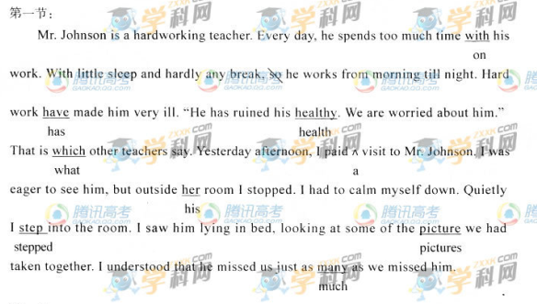
【2013·陕西卷】短文改错（共10小题，每小题1.5分，满分15分）
假定英语课上老师要求同桌之间交换修改作文，请你修改你同桌写的以下作文，文中共有10处语言错误，每句中最多有两处，错误涉及一个单词的增加、删除或修改。
增加：在缺词处加一个漏词符号（/\）,并在该句下面写出该加的词。
删除：把多余的词用斜线（\）划掉。
修改：在错的词下划一横线，并在该词下面写出修改后的词。
注意：1．每处错误及其修改均仅限一词；
2．只允许修改10处，多者（从第11处起）不计分。
My grandfather and I enjoy fishing.
One Sunday morning we go fishing at a lake. We took ours fishing poles and headed for the lake. As soon as we arrived, so we dropped the lines into the water. Before waiting for about half an hour, I was beginning to get impatiently. I wanted to give up, and my grandfather told me to wait a little longer. Finally, there were a sudden pull at the pole and fish was caught . Within the next few minute, my grandfather also caught a fish. Felt hungry, we built a fire by the lake and barbecued the fish. It was delicious.
- （第二段）第一句go→went。
- 第二句ours→our。
- 第三句so去掉。
- 第四句Before→After。
- 第四句impatiently→impatient。
- 第五句中and→but。
- 第六句were→was。
- 第六句中and ∧fish-a。
- 第七句minute→minutes。
- 第八句Felt→Feeling。

【2013·四川卷】短文改错（共10小题；每小题1.5分，满分15分）
下面短文中有10处语言错误。请在有错误的地方增加、删除或修改某个单词。
增加：在缺词处加一个漏字符号（∧），并在其下面写出该加的词。
删除：把多余的词用斜线（﹨）划掉。
修改：在错的词下划一横线，并在该词下面写出修改后的词。
注意：1. 每句不超过两个错误；
2. 每处错误及其修改均公限一词；
3. 只允许修改10处，多者（从第11处起）不计分。
Today we had a chemistry test. I found the test difficulty, but I tried hardly to do it. Suddenly Mary, my best friend, asking me to let her to copy my answers. After think for some time, I let her
copy my answers. But after the test, all of us were called to the teacher’s office. The teacher was
angry because we had same answers in the tests. We were warned not to cheat again so she would
need to see our parents. I was very upset. I didn’t cheat. I was just helping a friend. Why does she
punish me?
61. 【答案】difficulty--- difficult
62. 【答案】hardly--- hard。
63. 【答案】asking--- asked.
64. 【答案】第二个to去掉。
65. 【答案】think--- thinking.
66. 【答案】all---both.
- 【答案】same前加the.
- 【答案】tests--- test.
- 【答案】so---or.
70. 【答案】does---did.
【2013浙江卷】
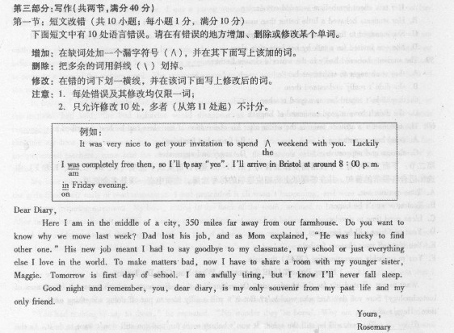
短文改错
1.【答案】far去掉。
2.【答案】move---moved。
3.【答案】other---another。
4.【答案】classmate---classmates。
5.【答案】or---and。
6.【答案】bad---worse。
7.【答案】is后添加the/my。
8.【答案】tiring---tired。
9.【答案】sleep---asleep。
10.【答案】is---are。

.

