浙江省2013年高考模拟冲刺（提优）测试一英语试题

第I卷 (共80分)
第一部分：英语知识运用（共两节，满分30分）
第一节：单项填空（共20小题；每小题0.5分，满分10分）
1. —Hello. Is Mary there, please?
—I’m sorry, she is not here right now. _______?
A. What do you want her for B. What do you want to say
C. Can I take a message D. Can you tell me something
2. For _____ person with reading habits, _____ printed page contains not only words but ideas, thoughts and feelings.
A. the; a B. the; the C. a; the D. a; a
3. —Can I have ________ apple?
—Oh, your sister has just had it.
A. another B. other C. one more D. the other
4. Joanna is no less hardworking than her twin sister, _______ she failed in the final exam.
A. but B. so C. or D. and
5. My husband________ a model plane the whole Sunday morning. I thought he would help do some washing.
A. has made B. made C. was making D. had made
6. Don't ______ to spring-clean the whole house just because my mother is coming---there's no need to do that.
A. undertake B. attempt C. bother D. hesitate
7. Will you please also state your earliest delivery date, your terms of payment, and discounts for
regular _______?
A. supplies B. sales C. purchases D. accounts
8. Some people have no idea that by helping a criminal they could ________with a prison sentence.
A. come up B. end up C. put up D. catch up
9. If you love someone, why ______ you chain him to your side, control his emotion, and even make him center on you?
A. must B. dare C. need D. will
10. Oh, boy, why are you just playing games all day? Can't you find something ______ doing at all?
A. practical B. valuab1e C. worth D. positive
11. ______ a piece of cheese cake my mum prepared---You won’t be disappointed!
A. Trying B. Tried C. To try D. Try
12. Children are excited about the approach of Christmas, _____ may bring great happiness to them.
A. it B. which C. what D. that
13. ________the letters there are answers written by people who are supposed to know how to solve such problems.
A. Along with B. Apart from C. According to D. Regardless of
14. Research shows that though students benefit from having parents involved at school, _____ happens at home matters much more.
A. which B. what C. that D. whether
15. Sometimes we just can’t understand why so many people fail to realize that wealth does not ______ bring happiness?
A. consequently B. automatically C. necessarily D. particularly
16. The young man has been trying everything in his power to please the director, ______ to get a role in the play.
A. hoped B. hoping C. to hope D. having hoped
17. They weighed the advantages of the operation ______ all the possible risks involved over and over again.
A. within B. except C. behind D. against
18. ________there are a large number of chemical factories, the air is likely to be polluted.
A. Where B. That C. Though D. As
19. ---So you know Catherine?
---Yes, it was last week_____ she came to visit my roommate Jane.
A. that B. when C. since D. before
20. —Will you complete the task in time?
—Surely, I will. _________.
A. Everything is possible B. But it’s too hard
C. No matter what will happen D. Though it’s a piece of cake
第二节：完形填空（共20小题；每小题1分，满分20分）
阅读下面短文，掌握其大意，然后从21~40各题所给的四个选项（A、B、C和D）中，选出最佳选项，并在答题纸上将该选项标号涂黑。
My sister and I have been a headache for my mother, because my father was in the army, he was not around too often. __21__, my mother brought us up almost single-handedly and it must have __22__ real strength of mind to bring up such naughty and stubborn children who got out from one trouble only to get into another.
Bonus and I weren’t scholars either. __23__, we hated studying from the very beginning. We were __24__ to spend time with our schoolbooks---out of the fear of Mum’s scolding. I almost did not make it to 10th grade. That entire summer Mum __25__ that I read my schoolbooks from the very first chapter till the last.
I left __26__ college at 18. In my second year of college, while I was studying for my final exams, I got a phone call from Mum __27__ my sister had failed her 9th grade exams. Mum was heartbroken. My mother was an English teacher in a famous school in the city and it was a(n) __28__ for her.
Then started another __29__ for my Mum. There always seemed to be people who would come and talk about how well their children were doing __30__ my mother would be having a tough time making sure we stayed on the right path. Mum was __31__ that we would do well for ourselves. She never let my sister and me __32__ that we had lost out on something and always told us: “Let this be a lesson. We are going to work really really hard...__33__ will change.”
Things did change, but very slowly and __34__, one little step at a time. Last year I finished with law school and started working. My mother’s belief in me __35__. And just a few days ago I got a phone from Bonus. She had __36__ the exam with honors and was __37__ to the best university in the country. I was in tears. Later that night I __38__ Mum: “Mum, your two little failures didn’t do as badly as everybody thought.” Mum __39__ and said: “You are my daughters and I knew you the best. I always knew that you would succeed. It was just a __40__ of time.”
21. A. However B. Thus C. Otherwise D. Besides
22. A. devoted B. spent C. taken D. wasted
23. A. In that case B. In this way
C. On the other hand D. On the contrary
24. A. pleased B. annoyed C. forced D. advised
25. A. demanded B. concluded C. promised D. mentioned
26. A. at B. for C. from D. after
27. A. announcing B. reading C. knowing D. saying
28. A. shame B. challenge C. pride D. honor
29. A. experiment B. research C. conflict D. trial
30. A. though B. while C. as D. unless
31. A. determined B. astonished C. satisfied D. concerned
32. A. predict B. imagine C. guess D. feel
33. A. Environment B. Society C. Circumstances D. Impressions
34. A. quickly B. extremely C. smoothly D. gradually
35. A. made up B. paid off C. took on D. burst out
36. A. attended B. received C. passed D. failed
37. A. accepted B. allowed C. admitted D. permitted
38. A. questioned B. convinced C. persuaded D. called
39. A. nodded B. laughed C. shouted D. joked
40. A. matter B. period C. waste D. length
第二部分：阅读理解（第一节20小题，第二节5小题；每小题2分，满分50分）
第一节：阅读下列材料，从每题所给的四个选项（A、B、C和D）中，选出最佳选项，并在答题纸上将该选项标号涂黑。
A
NEW YORK (AP) — The investigation into the disappearance of 6-year-old Etan Patz has gone through decades and countries, from basements to rooftops and seemingly everywhere in between.
No one has ever been charged criminally — and the little boy with sandy brown hair and a toothy grin was declared dead in 2001.
This week, the six-year-old boy who went missing from the Soho area of New York City in 1979 is back in the news. Police and the FBI are investigating a possible lead into the 33-year-old case of Etan Patz, the first missing child to appear on the side of a milk box.
The child disappeared on the way to school on the morning of May 25, 1979. It was the first time he was allowed to walk the two blocks to the bus stop alone.
A tip seemed to have led officials to the basement of a building on the corner of Prince and Wooster streets, about a block and a half from where Etan had lived with his family.
The name Etan Patz has become a hot topic on Twitter as people weigh in on the case. Shirley Brady noted: “As mom to a 6 years old in Soho, it’s still held out by locals as cautionary tale (警示故事).” Another wrote, “Boy who disappeared on his way to school in 1979 has been REOPENED! Crazy.” One wondered, “Why is FBI and NYPD searching for a kid that disappeared in 1979?”
Good question. This is a case that Stuart Gra Bois, as an assistant U.S. lawyer under Rudolph Giuliani, followed for years. It became the most famous missing-person case in New York City, turned a nationwide spotlight on missing children, and created headlines around the globe. No one was ever stated guilty of the crime.
The case led to the creation of National Missing Children’s Day, marked on May 25, the day the blond-haired, blue-eyed child went missing.
The case has even pointed to a suspect, charged with child molester (猥亵者) Julio Antonio Ramos, who is currently in prison. Patz’s babysitter had been dating the man, and Ramos did know the kid, but has denied taking him away.
New evidence in the case suggests another suspect who lived in the apartment at the time: a local handyman named Othniel Miller, who gave Etan $1 for helping him the night before the disappearance.
The man’s name had come up in an earlier investigation, but he was a friend of the Patz family, and the NYPD did not follow the lead.
Investigators plan to be at the site, 127 B Prince St., which is now a Lucky Brand jeans store, for the next two to three days to search for human remains. The Associated Press reports that the excavation (挖掘) has been the result of a recently ordered review of the case by Manhattan’s police.
41. We can learn from the first three paragraphs that ________.
A. The 6-year-old missing boy was found by the side of a milk box
B. Police and the FBI have not been following the case of Etan Patz for 33 years
C. The investigation into the disappearance of boy has worked fruitlessly for decades
D. Etan Patz went missing from the Soho area of New York city in 1979 and died in 2001
42. What does the underlined phrase “weigh in on the case” mean?
A. ignore the case B. feel stressed on the case
C. reopen the case D. begin to discuss the case
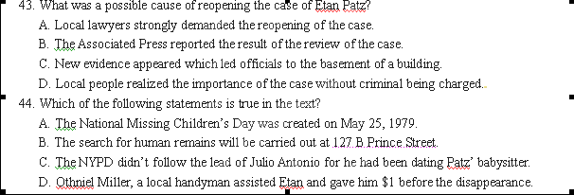
45. We can learn from the passage that ________.
A. People air the same view about the case on the Internet
B. People reject the reopening of the case of the missing boy
C. The missing-person case still has a long-lasting influence on people
D. Twitter is the only place for people to discuss about missing-person cases
B
Generic Name: ASPIRIN
Pronunciation: ['æspərin]
Why it is prescribed (开药方)：
- Aspirin relieves mild to moderate pain.
- It reduces fever, redness, and swelling.
- It prevents blood from clotting (凝结).
When it is to be taken:
- Aspirin is often taken without a prescription.
- Follow the instructions on the label and package.
- If your doctor prescribes aspirin for you, you will receive specific instructions for how often you should take it.
- Keep in touch with your doctor.
How it should be taken:
- Aspirin comes in the form of suppositories (栓剂), capsules, and regular, coated, extended-release, and chewable tablets.
- Regular, coated, and extended-release aspirin tablets and capsules should be swallowed with a full glass of water or milk after meals to avoid stomach upset.
- Chewable aspirin tablets may be chewed, crushed, dissolved in a liquid, or swallowed whole; a full glass of water, milk, or fruit juice should be drunk immediately after taking these tablets.
Special Instruction:
- Children should not take aspirin for fevers associated with flu or chickenpox (水痘) because such use has been linked with a serious illness known as Reye’s syndrome.
- Adults should not take aspirin for pain for more than 10 days (five days for children) without consulting a doctor.
- Aspirin should not be taken by adults or children for high fever, fever lasting longer than three days without a doctor’s supervision (监管).
- Do not give more than five doses (剂量) to a child in a 24-hour period unless directed to do so by a doctor.
- If you miss a dose, take the missed dose as soon as you remember it and resume the prescribed schedule.
Side Effects:
- Although side effects from aspirin are not common, they can occur.
- Nausea, vomiting, stomach pain, indigestion and heartburn are common. Take aspirin after meals, with a full glass of water or milk. If these effects continue, contact your doctor.
- Ringing in the ears, bloody or black stools (粪便), difficulty breathing, dizziness, mental confusion and sleepiness are rare. Stop taking the drug and contact your doctor.
Other Precautions:
- If you are pregnant or breast-feeding women, inform your doctor before taking aspirin.
- Do not take aspirin if you are within three months of delivery.
- Do not take aspirin if you are allergic (过敏) to it.
- If you have diabetes (糖尿病), regular use of eight or more regular strength aspirin tablets a day may affect test result.
- If you are taking large doses of aspirin on a long-term basis, avoid having alcoholic drinks because alcohol can increase stomach problems.
- To prevent an overdose of aspirin, read the labels before taking other pain relievers and cold products to be sure that they do not contain aspirin.
Storage Conditions:
- Store aspirin in a cool place or in a refrigerator.
- Throw away aspirin that smells strongly of vinegar.
- Keep this aspirin out of the reach of children.

46. Which of the following about Aspirin is correct?
A. It only comes in the form of regular tablets.
B. It should not be taken for more than 5 days for children.
C. It can be used to reduce fever and pain and prevent blood clotting.
D. It causes ringing in the ears or difficulty breathing after being taken
47. If you start taking aspirin, you should do all the following things EXCEPT ________.
A. keeping in touch with your doctor
B. taking aspirin tablets after meals to avoid stomach upset
C. drinking a full glass of juice immediately after taking chewable aspirin tablets
D. taking more than 8 regular strength aspirin a day while suffering from diabetes
48. The underlined word “resume” most probably means ________.
A. continue B. make up C. pause D. throw away
49. Which of the following might be a side effect caused by Aspirin?
A. blood clotting B. stomach upset C. lasting fever D. sight problem
50. Where can we probably come across such a text?
A. In a research paper. B. In the package of a medicine
C. In a medical textbook. D. In a scientific and technological magazine
C
As anyone who has tried to lose weight knows, realistic goal-setting generally produces the best results. That’s partly because most people who set realistic goals actually work more efficiently, and put more effort, to achieve those goals.
What’s far less understood by scientists, however, are the potentially harmful effects of goal-setting. Newspapers convey daily accounts of goal-setting widespread in industries and businesses up and down both Wall Street and Main Street, yet there has been surprisingly little research on how the long-advocated practice of setting goals may have contributed to the current economic crisis, and immoral behavior in general.
“Goals are widely used and promoted as having really beneficial effects. And yet, the same motivation that can push people to put more effort in a constructive way could also motivate people to be more likely to engage in immoral behaviors,” says Maurice Schweitzer, an associate professor at Penn’s Wharton School. His paper, titled “Goals Gone Wild: The Systematic Side Effects of Over-Praised Goal Setting,” appears in the February issue of the Academy of Management Perspectives.
“It turns out there’s no financial benefit to just having a goal---you just get a psychological benefit” Schweitzer says. “But in many cases, goals have financial rewards that make them more powerful.”
A major example Schweitzer and his colleagues give is the 2004 breakdown of energy-trading giant Enron( 德国安然公司), where managers used financial rewards to motivate salesmen to meet specific goals. The problem, Schweitzer says, is that the actual trades were not profitable.
Other studies have shown that burdening employees with unrealistic goals can force them to lie, cheat or steal. Such was the case in the early 1990s when Sears（西尔斯公司）placed a sales quota (销售限额) on its auto repair staff. It inspired employees to overcharge for work and to complete unnecessary repairs on a companywide basis.
Schweitzer admits his research runs counter to a very large body of literature that praises the many benefits of goal-setting. Advocates of the practice have argued with his team’s use of such evidence as news accounts to support his conclusion that goal-setting is widely over-praised.
In a rebuttal (反驳) paper, Dr. Edwin Locke writes: “Goal-setting is not going away. Organizations cannot grow without being focused on their desired end results any more than an individual can grow without goals to provide a sense of purpose.”
But Schweitzer argues the “evidence” linking goal-setting and harmful behavior should be studied to help draw attention to issues that deserve attention and further investigation. “Even a few negative effects could be so large that they outweigh many positive effects,” he says.
The debate is likely to get heated on in future papers, and the practice of setting goals no doubt will continue. For now, though, the lesson seems to be to put more thought into setting goals.
“Goal-setting does help motivate people. My idea would be to combine that with careful management, a strong organizational culture, and make sure the goals that you use are going to be constructive and not significantly harmful to the organization,” Schweitzer says.
51. What does Maurice Schweitzer want to show by mentioning the example of Enron?
A. Setting realistic goals can turn a failing business into success.
B. Businesses are likely to succeed without realistic goals.
C. Companies are certain to meet specific goals with financial rewards.
D. Goals with financial rewards have strong motivational power.
52. How did Sears’ goal-setting affect its employees?
A. They had to work more hours to increase their sales.
B. They competed with one another to attract more customers.
C. They turned to immoral practice to reach their goals.
D. They improved their customer service on a companywide basis.
53. The underlined words “runs counter to” (Paragraph 7) can be replaced by ________.
A. agrees with B. goes against C. fits in with D. applies to
54. What is Edwin Locke’s argument against Schweitzer?
A. The practice of setting goals only helps people to develop.
B. Goal-setting is of no use motivating people to accomplish their tasks.
C. The positive effects of goal-setting outweigh its negative effects.
D. Studying goal-setting can contribute to successful business practices.
55. According to the passage, the author tries to convey ___________.
A. the goals that most people set are unrealistic.
B. all people can improve their work quality by setting goals.
C. setting goals can provide people with a sense of purpose.
D. people should not ignore the negative effects of goal-setting.
D
Amy returned to her small apartment at midnight, exhausted. Pushing the key into the lock, she quietly opened the door so as not to wake her younger brothers. She stepped into the front room and froze. The apartment was a mess: plates of half-eaten food were scattered in front of the TV; toys littered the floor; clothes, shoes and homework were strewn everywhere. Amy’s eyes welled with tears. This is just way too much for me, she thought. Her worst fears began to race through her mind. Would the court（法院）tell her she couldn’t care for her family anymore? Would the kids go through the bitterness once more of being split up and sent away? She was so young, almost a child herself, and yet Amy knew everything depended on her. At that moment, she wondered if she would ever find the strength to see it through
Amy had been born dead. Doctors fought and saved this smaller twin of a drug-taking mother, and she’d had to fight for everything in life ever since. From earliest childhood, Amy took care of her younger brothers. Jan, their mother, only added to the family disorder and confusion. Sometimes they lived in apartments, sometimes in shelters.
One afternoon Amy was called to the high school, where a social worker was waiting for her. “We know your mother has been staying with you,” the social worker said. “We’re going to have to put you guys in foster （收养)）care.” “No! Don’t split us up!” the girl cried out. “Can’t you just leave it the way it is?” The social worker shook his head. Amy’s voice then rose like the howl of a lioness protecting her babies: “Why can’t I take them? I take care of them all the time anyway.” The social worker hesitated, and then said, “Maybe. Once you’re 18, you could apply to become their relative caretaker. Then you’d be their foster mother until we find a home where all of you can be together.” “I’ll do it,” Amy said.
One month later, Amy was named guardian（监护人）of her brothers for a six-month trial period. It was a remarkable victory for an 18-year-old girl. Her brothers didn’t make her task any easier in the months ahead. However，Amy’s efforts were rewarded when the court allowed her to continue as guardian. Amy’s relief at remaining the kids’ guardian was at risk of being taken away by the pressure she always felt to measure up. Social workers still looked regularly over her shoulder and asked the boys shameful questions: “Does she feed you? Does she ever try to harm you?” Then one day a visiting social worker came over. “We’d like to get the boys out of foster care and adopted into homes,” she said. Sensing that the family was about to be split apart yet again, Amy replied, “Fine, then. Call it adoption if you want, but they’re not going anywhere.” To her surprise, the social worker took her remark seriously. She explained that if Amy were to adopt the boys, they would become like any other family.
That night at dinner Amy told the boys about the idea. “Cool!” Joey said. He threw a piece of corn at Adam. His brother flicked it back, and pretty soon corn was flying. Amy rolled her eyes. They didn’t have far to go to be like any other family. As the proceedings（程序）ended, Amy thanked everyone. “No,” the judge responded, “thank you. You saved three kids. Not many family members would do what you’re doing, especially for this many children. I’m very proud of you.”
On a lazy spring day, in a modest suburban neighborhood, Amy stood in front of a neatly kept one-story house. She watched her brothers playing basketball, and heard the playful bark of their dog, Tahoe. The young lady had made good on her promise: they had rented a home, a real home, and the boys had gotten their dog. Amy continues to raise her family alone, but has begun taking courses in business management at a nearby community college. Eventually, she hopes to become a child psychologist.
56. Which of the following best describes Amy?
A. Crazy and tough. B. Firm and stubborn.
C. Enthusiastic and generous. D. Abnormal and aggressive.
57. What was bothering Amy most in the passage?
A. The mess in her apartment.
B. Her family being split up again.
C. Working hard to support the family.
D. Her young age to take care of her brothers.
58. From the Paragraph 3, we can learn that __________.
A. The social worker gave in to Amy.
B. The social worker tried to adopt Amy’s brothers.
C. Amy tried to apply for the guardian of the brothers.
D. Amy had no idea how to face her family being split up.
59. By saying “They didn’t have far to go to be like any other family”, the writer means________.
A. they will live in the same area as other families.
B. they made a deep impression on the neighborhood.
C. Amy is able to take good care of the family.
D. Amy and her brothers would be already just like a family.
60. The best title for this text would be___________.
A. Standing On Two Feet B. Growing Up Alone
C. A Lifelong Fight D. A Teen Hero
第二节：下面文章中有5处（第61~65题）需要添加小标题。请从以下选项（A、B、C、D、E和F）中选出符合各段意思的小标题，并在答题纸上将相应选项的标号涂黑。选项中有一项是多余选项。
A. Network.
B. Do things alone.
C. Become a local.
D. Join a gym or club.
E. Join a Business Group
F. Be polite to People You Meet
Moving to a new city can be both exciting and scary. Whether you are moving for a job, school or just to start over somewhere new, it can function as a fresh start. However, leaving behind old friends and finding new ones is not always easy. Maintaining a positive attitude and being open to new situations and people will make the adjustment easier.
61.________
Trying new things will always put you in the position to run into new people. However, chances are, if you are by yourself instead of with a group of friends, other people will be more comfortable approaching you because they are less likely to feel as though they are bothering you or intruding. Go for walks by yourself, read a book in the park or have dinner at a restaurant alone. Doing things alone can also make you appear confident and interesting to others.
62.________
Visit the same coffee shops or restaurants as often as possible. Talk to the employees and be friendly. Over time, the people that work there will recognize you and you can build relationships with them that way. This can also help you feel like you blend in and belong in your new neighborhood. Ask the employees for suggestions on things to do. They are great resources to find out the latest activities and events happening in your city, and they may even join you.
63.________
You will not meet new people sitting in your house, so you will want to put yourself in situations with other people. Joining a gym, club or other social group can be a low pressure way to meet new people who have the same interests as you. Moving to a new city is a great time to try a new activity you are interested in, such as yoga or martial arts.
64.________
If you moved for a job or school, you will be surrounded by new people. Even if they are not necessarily the type of people you would normally be friends with, try to keep an open mind. Common interests provide the start of many wonderful friendships. Your coworkers or fellow students will likely be able to introduce you to other people you may get along with as well.
65.________
Sites like Linked In and Yahoo offer several online forums (论坛) that can help expand networking opportunities. You could become friends with someone through one of the online discussions and then meet in person later. Linked In lists several groups it feels you might enjoy. Get involved with the groups that meet in person with things like business book groups, networking events, or social mixers. To join a Yahoo group, click on “groups,” then “business and finance.” Type in the name of your city in the search screen, and scroll through the list of local groups that appear.

第Ⅱ卷（共40分）
第三部分：写作（共两节，满分40分）
第一节：短文改错（共10小题；每小题1分，满分10分）
下面短文中有10处语言错误。请在有错误的地方增加、删除或修改某个单词。
增加：在缺词处加一个漏字符号（∧），并在其下面写上该加的词。
删除：把多余的词用斜线（\）划掉。
修改：在错的词下划一横线，并在该词下面写上修改后的词。
注意：1.每处错误及其修改均仅限一词。2.只允许修改10处，多者（从第11除起）不计分。
例如：
It was very nice to get your invitation to spend ∧weekend with you. Luckily I was
the am
completely free then, so I’ll to say “yes”, I’ll arrive in Bristol at around 8:00 p.m. in Friday
on
evening.

This morning I was riding a bicycle on my way to school while suddenly a shower of heavy rain began to pour down. The wind is blowing hard and the road became very slippery. Just then I saw an elderly woman walking with difficult in the street. She was on her way back to home after shopping, carried a large basket full of vegetables. Suddenly she fell down in the mud. And she was very worn out that she couldn’t get up. Seeing this, I immediate rode over to her and tried my best to support her up. Then I helped picking up the vegetables, and put them into her baskets. After that, I took off my raincoat, put on her and took her home.
第二节：书面表达（满分30分）
假定你是李华，你的英国笔友Helen正在写一篇关于各国中学生课外阅读情况的调查报告。她给你发了一封电子邮件，想了解相关情况。请你根据以下提示，给她回一封电子邮件。
1．你校学生课外阅读的现状；
2．原因分析；
3．你的看法。
注意： 1．根据所给提示，适当发挥, 要求内容充实，语意连贯。
2．词数120左右。开头和结尾已经写好，不计入总词数。
3．邮件中不得提及考生所在学校及本人姓名。
Dear Helen,
Thank you for your email. Now I would like to tell you something about the extracurricular reading in our school. ______________________________________________________________
________________________________________________________________________________________________________________________________________________________________
Best wishes!
Yours
Lihua

2013年浙江省高考模拟冲刺卷（提优卷）
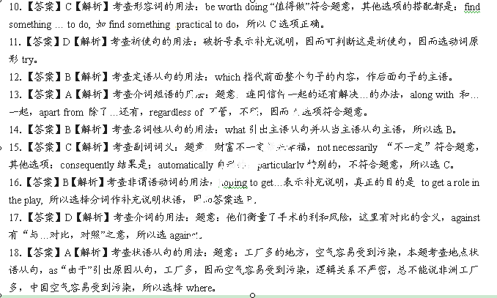 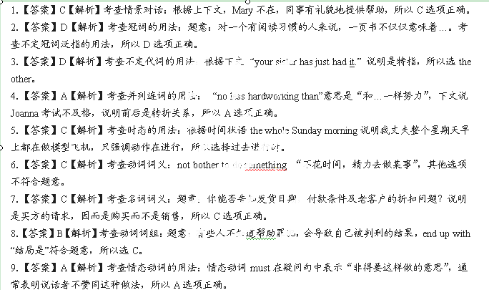英语（一）参考答案
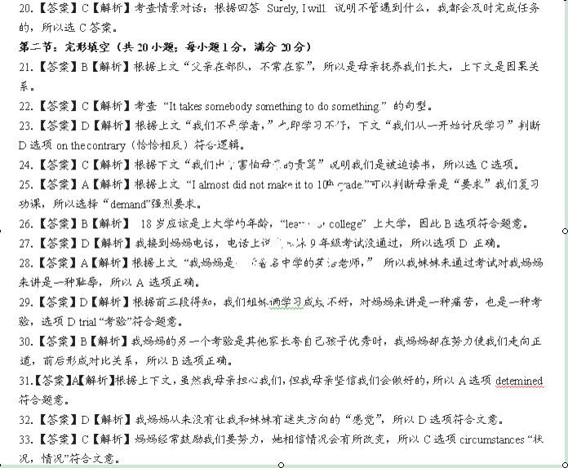
19．【答案】B【解析】考查强调句的省略用法：题意：是在她上星期来拜访我室友的时候我认识她的，last week后when所引出的是定语从句，完整的回答是： It was last week when she came to visit my roommate Jane that I got to know Catherine. 所以答案选B。
34．【答案】D【解析】根据上文slowly得知，这种变化是缓慢的而且是一步一步的，逐渐的，所以D选项符合题意。
35．【答案】B【解析】根据上下文判断，我母亲对我们的努力，信心最后终于得到回报，所以B选项 “pay off”（有回报）符合题意。
36．【答案】C【解析】根据下文 “with honors”可以判断我妹妹是通过了考试，所以C选项正确。
37．【答案】C【解析】我妹妹以优异成绩通过考试，所以被著名大学录取，Be admitted to(被…录取)符合上下文。
38．【答案】D【解析】晚上晚些时候，我打电话给我妈妈。所以D选项call符合题意。
39．【答案】B【解析】根据上文我打电话给妈妈，妈妈在电话那头笑了（因为女儿终于有出息了），所以B选项laugh符合题意，A选项nod “点头”在打电话情景中看不到。
40．【答案】A【解析】选项A “a matter of time” （时间的问题）符合题意，a period of time 和a length of time都是指一段时间。
第二部分：阅读理解（第一节20小题，第二节5小题；每小题2分，满分50分）
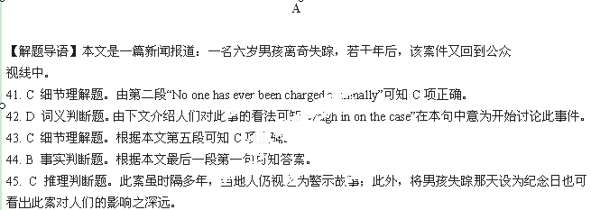B
【解题导语】本文是一则关于阿司匹林的药品说明书。
46. C 细节理解题。由该部分—“Why it is prescribed”可知C项正确。
47. D细节理解题。D项表述与原文“Other Precautions”中第四点不相符。
48. A 词义猜测题。本句中“resume”意为“继续”。
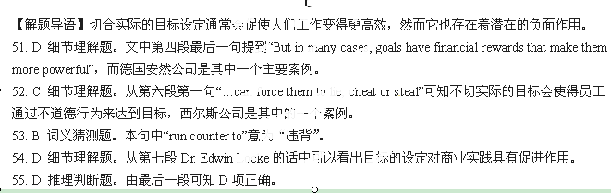49. B 细节判断题。根据“Side Effects”中第二点可以看出，胃部不适是服用阿司匹林常见的副作用。
50. B 推理判断题。本文是药品说明书的常见样式。
D
【解题导语】Amy，一位年仅十八岁的女孩，顽强地扛起了抚养家庭的重任。
56. B 推理判断题。通读文章可知，Amy是一位坚定且顽强的女孩。
57. B 细节理解题。根据文中第四段倒数第三句可知最使Amy担心的是她家人的再次分离。
58. A 推理判断题。从第三段这位社会工作者犹豫片刻而后说的话中可以看出他向Amy妥协。
59. D 句意理解题。该句意为他们很快就会成为一个家庭，无异于其他家庭。
60. D 标题归纳题。本文主要讲述的是Amy这位顽强少年的英雄事迹。
61-65 BCDAE

第一节：短文改错（共10小题；每小题1分，满分10分）
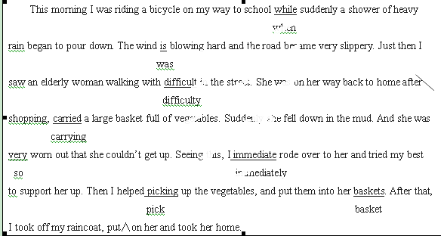
第二节：书面表达（满分30分）
