浙江省杭师大附中2012届高三第二次月考试题（英语）
第Ⅰ卷（共80分）
第一部分：英语知识运用（共两节，满分30）
第一节：单项填空（共20小题；每小题0.5分，满分10分）
1. — Our new house was completely in_______ mess after the party was over.
— Don’t worry. We can clean it by_______ means of our robot.
A. a; / B. the; the C. the; / D. a; the
2. It is very important for us to _______ between good and bad.
A. reject B. realize C. range D. distinguish
3. —Do you know if Terry will go camping this weekend?
—Terry？Never！She _______ tents and fresh air!
A. has hated B. hated C. will hate D. hates
4. _______cheating a second time，you will realize the value of honesty.
A. When catching B. When caught
C. When to catch D. When to be caught
5. —_______, sir?
—Yes，we’ ll have tomato soup，roast beef，potatoes and peas.
A. What would you buy B. What can I do for you
C. Ready to order now D. Do you enjoy your meal
6. Busy as the man is, he _______ every weekend to staying with his wife and children.
A. picks B. spends C. devotes D. takes
7. The singer sang one more song at the _______ of enthusiastic fans.
A. command B. recognition C. request D. service
8. — Has your brother returned from the USA yet?
— Yes, but he _______ here for only two days before his company sent him to Australia.
A. stayed B. has stayed C. will stay D. was staying
9. I want to say I love you, but I don’t know how to _______ it.
A. speak B. put C. get D. take
10. —Will you read me a story, Mummy?
—OK. You _______ have one if you go to bed as soon as possible.
A. might B. must C. shall D. could
11. Arriving at a bus stop _______ the vehicle pulling away just a few minutes ago is quite annoying.
A. to find B. finding C. found D. to be finding
12. If you are asking _______, in certain circumstances, I could reconsider your proposal, the answer is yes.
A. that B. whether C. how D. why
13. Between you and me, Peter is_______. He is out of breath while walking.
A. fatter than stronger B. no weaker than before
C. more fat than strong D. not so much fat as strong
14. — Mum, what is the point of having friends?
— Friends are always there for you when you’re feeling down.
—_______.
A. No problem B. Got it C. All right D. Good idea
15. I met Mr. Thompson during his stay in Beijing, _______ he attended an important international conference there.
A. when B. where C. in which D. which
16. — Do you still believe in love?
— Absolutely. It is not time, money, power or whatever but love _______ cures our pain.
A. who B. which C. that D. what
17. Written in a hurry, _______. How can it be satisfactory?
A. they found many mistakes in the report
B. Sam made lots of mistakes in the report
C. there are plenty of mistakes in the report
D. the report is full of mistakes
18. Nowadays, few people develop the habit of keeping a supply of oil-lamps in the house in case of power _______.
A. lack B. absence C. failure D. drop
19. A bit more effort, I think, ____ the problem could be settled.
A. and B. so C. or D. but
20. Because of the heavy snow, the village was not _______.
A. accessible B. affordable C. acceptable D. available
第二节：完形填空（共20小题；每小题1分，满分20分）
It was a cold winter’s night when I stopped for gas on my way home from work. I was tired and had a slight 21 .
I worked in a 22 doctor’s office and this was one of those days when the unexpected happened, making the schedule run 23 than usual. It seemed I was going to be late 24 home and my husband, being the 25 person, would be ready to pronounce me late once again. Maybe 26 I hurried, I could still make it home.
I was heading inside to 27 for my gas when I noticed an older couple at the counter. I heard them asking for 28 to the local hospital. It was the same hospital that I had just 29 a few minutes ago.
The young man at the counter was trying to be 30 in explaining how to get there, with two other people making 31 . One of them was 32 trying to give them a whole different route back. It was then that I walked over to the couple and said, “Would you like to follow me to the 33 ?”
A look of 34 crossed the woman’s face.
“I’m going right by there,” I said, which wasn’t a(an) 35 since I had just made up my mind to do 36 that.
I got in my car and began the journey back. I was trying to watch to be sure they were right 37 me. It took only fifteen minutes to get there as rush hour traffic was beginning to 38 . I felt better than I had all day and my headache was nearly gone.
Later, as I arrived home, my husband 39 , “So you aren’t ever late any more.”
I said, “Sometimes it’s 40 to be late.”
21. A. break B. fever C. cold D. headache
22. A. foreign B. common C. busy D. noisy
23. A. earlier B. later C. easier D. simpler
24. A. getting B. cooking C. calling D. working
25. A. tough B. punctual C. generous D. careful
26. A. as B. since C. while D. if
27. A. pay B. change C. wait D. search
28. A. opinions B. trouble C. directions D. money
29. A. reached B. visited C. called D. left
30. A. skilled B. helpful C. experienced D. active
31. A. comments B. promises C. jokes D. offers
32. A. only B. still C. even D. ever
33. A. station B. office C. hospital D. hotel
34. A. panic B. relief C. sadness D. peace
35. A. duty B. fact C. reason D. lie
36. A. partly B. properly C. exactly D. perfectly
37. A. across B. before C. beside D. behind
38. A. go up B. die down C. speed up D. turn down
39. A. teased B. shouted C. burst D. laughed
40. A. possible B. usual C. good D. safe
第二部分：阅读理解(第一节20小题，第二节5小题；每题2分，满分50分)
第一节：阅读下列短文，从每题所给的四个选项（A、B、C和D）中，选出最佳选项，并在答题纸上将该选项标号涂黑。

A
Roy wasn't the only one to receive his call-up（入伍）papers. Stephen Napier's call-up came at the beginning of February and he was pleased to find that he would be going into the Royal Air Force (RAF).
His father was not so pleased and made his feelings known as he and Stephen were on their daily walk. It was the first step in his plans for Stephen to take over the estate（地产）when the time came, and although Stephen was well aware of this, he could think of no reason not to accompany him.
“Thought you’d forgotten that nonsense. Still, I dare say I could pull a few strings to get you to the Army...”
“No, Father! I have told you I want to learn to fly. What chance would I have to do that in the Army? I'd be better off in the Navy——at least they've got the Fleet Air Arm. But I have been put in the RAF and that's where I want to be, so let’s leave it at that.” His face went red. Sent to his father's school and then to Cambridge, much to his satisfaction, he had never had to defend his own desires and his father was a hard man to oppose.
The father glared at Stephen, “No, I won't leave it at that. I want to know what other ridiculous ideas are in your head. For a start, what’s all this about America?”
“America?”
“Yes. All those books I saw in your room the other day. Brochures about emigration（移民）.”
The big, silvered head lowered, like that of a bull about to charge．“Don’t trouble to deny it. ”
“I won’t, Father. Some men at Cambridge have been talking about it. They want people like us here, mathematicians and scientists, for all kinds of research——the sort of research I could do．It would be a worthwhile life for me.”
The father responded exactly as his son had known he would. You've got a worthwhile life here！You’ve got an estate to run！”
“No, Father. You’ve got an estate to run. I never asked for it. Why not ask Baden to do this stuff? He perhaps can make a good job of it, but I... ”
“If he were here, I might think about this silly idea of yours——only think about it, mind you but...”
41. If Father wanted Stephen to take over the estate, the first thing he did would_______．
A .take a walk with Stephen as usual B. wait till his son graduated from Cambridge
C. persuade Stephen not to go into RAF D. send Stephen to the Army instead of RAF
42. Which statement is NOT true according to the passage?
A. Stephen preferred to go into the Navy rather than the Army.
B. Stephen also received his call-up papers as Roy.
C. The father didn't like Stephen's idea of going to America.
D. Stephen was eventually forced to stay to run the estate．
43. After reading this passage, we can infer that_______．
A. Stephen had never had to defend his desires before
B. Baden might be one of Stephen's family members
C. Stephen wanted to fly in RAF and become a pilot in America
D. if somebody took over the estate, Stephen could realize his dream
44. What do we learn from the underlined sentence?
A. It looked as if the father was angry when mentioning the brochures.
B. The father was very angry and wanted to beat his son Stephen．
C. Stephen was annoyed when his father referred to the brochures.
D. A big red bull was about to charge at Stephen.
45. Which would be the best title for this passage?
A. RAF——a better choice than the Army B. A talk between Father and Son
C. The dreams of a Cambridge student D. Conflict between Father and Son

B
Do you think it is ever a good idea for a teenager to have a credit card?
My kids watch closely as I swipe the card through the register. They’ve seen me do it hundreds, thousands of times. Cool. They are itching to swipe it through the machine themselves. When we walk out of the store with our groceries or pet food, or whatever, it’s almost as though money has not changed hands, painless, easy.
So it shouldn’t be shocking to discover that teenagers are becoming card carrying consumers in their own right. The question is, should they?
While some argue it’s best to teach kids how to use a credit card while still living under the family roof, not everyone agrees. Dave Ramsey, financial expert says getting a credit card for your teenager is actually, “an excellent way to teach him or her to be financially irresponsible. ”
Now parents are required to co-sign on credit cards for children under 21. “If their name is on the credit card, then the parent may say, ‘Hey, my name is on this. Don’t get me into trouble,” says Mary Beth Pinto, a marketing professor. “When parents were the co-obligors（共同借贷人），the children caused less debt. If the parents are the co-obligors, the tendency is that the parents were explaining how to use the cards.” Still, Pinto believes parents should start the process much earlier. “Yes, there has to be teaching going on and it has to start when they’re younger. You’re not going to get rid of credit cards. They are here to stay. You have to have them. You can’t fight progress,” Pinto said.
Ramsey, however, disagrees. “Throwing teens into a pool of （credit）sharks is a sure way to guarantee a life-time of heartache,” he said. “You can make online purchases and rent a car with a credit card. Of course, you must have money in your bank account before you can make a purchase with a credit card. But paying for things with money is what you are supposed to do. ”
46. The author mentioned her experience in Para 2 mainly to_______.
A. prove the convenience of using credit cards
B. tell what impression credit cards leave on kids
C. give advice on using credit cards wisely
D. explain the pleasure credit cards bring to customers
47. The underlined word in Para 2 can be replaced by _______.
A. eager B. afraid C. embarrassed D. thankful
48. What’s Ramsey’s attitude towards teens’ using credit cards?
A. He feels it is worth a try B. He is very supportive
C. He is strongly against it D. He considers it as a pleasant experience
49. Pinto will most likely agree that _______．
A. parents should let teens own their credit cards earlier
B. you shouldn’t be in control of credit cards
C. it is never good for anyone to get a credit card
D. learning to use credit cards is practical

C
Ideas about polite behavior are different from one culture to another. Some societies, such as America and Australia, for example, are mobile and very open. People here change jobs and move houses quite often. As a result, they have a lot of relationships that often last only a short time, and they need to get to know people quickly. So it’s normal to have friendly conversations with people that they have just met, and you can talk about things that other cultures would regard as personal.
On the other hand, there are more crowded and less mobile societies where long–term relationships are more important. A Malaysian or Mexican business person, for example, will want to get to know you very well before he or she feels happy to start business. But when you do get to know each other, the relationship becomes much deeper than it would in a mobile society.
To Americans, both Europeans and Asians seem cool and formal at first. On the other hand, as a passenger from a less mobile society puts it, it’s no fun spending several hours next to a stranger who wants to tell you all about his or her life and asks you all sorts of questions that you don’t want to answer.
Cross-cultural differences aren’t just a problem for travelers, but also for the flights that carry them. All flights want to provide the best service, but ideas about good service are different from place to place. This can be seen most clearly in the way that problems are dealt with.
Some societies have “universalist” cultures. These societies strongly respect rules, and they treat every person and situation in basically the same way. “Particularist” societies, on the other hand, also have rules, but they are less important than the society’s unwritten ideas about what is right or wrong for a particular situation or a particular person. So the normal rules are changed to fit the needs of the situation or the importance of the person.
This difference can cause problems. A traveler from a particularist society, India, is checking in for a flight in Germany, a country which has a universalist culture. The Indian traveler has too much luggage, but he explains that he has been away from home for a long time and the suitcases are full of presents for his family. He expects that the check–in official will understand his problem and will change the rules for him. The check–in official explains that if he was allowed to have too much luggage, it wouldn’t be fair to the other passengers. But the traveler thinks this is unfair, because the other passengers don’t have his problem.
50. Often moving from one place to another makes people like Americans and Australians _______.
A. like traveling better B. easy to communicate with
C. difficult to make real friends D. have a long–term relationship with their neighbors
51. People like Malaysians prefer to associate with those _______.
A. who will tell them everything of their own B. who want to do business with them
C. they know quite well D. who are good at talking
52. A person from a less mobile society will feel it _______ when a stranger keeps talking to him or her.
A. boring B. friendly C. normal D. rough
53. Which of the following is true about “particularist societies”?
A. There is no rule for people to obey.
B. People obey the society’s rules completely.
C. No one obeys the society’s rules though they have.
D. The society’s rules can be changed with different persons or situations.
54. The writer of the passage thinks that the Indian and the German have different ideas about rules because of different _______.
A. interests B. habits and customs C. cultures D. ways of life
D
Today, there’s hardly an aspect of our life that isn’t being upended by the tons of information available on the hundreds of millions of sites crowding the Internet, not to mention its ability to keep us in constant touch with each other via electronic mail. “If the automobile and aerospace technology had exploded at the same pace as computer and information technology,” says Microsoft, “a new car would cost about $ 2 and go 600 miles on a small quantity of gas. And you could buy a Boeing 747 for the cost of a pizza.”
Probably the biggest payoff, however, is the billions of dollars the Internet is saving companies in producing goods and serving for the needs of their customers. Nothing like it has been seen since the beginning of the Industrial Revolution, when power-driven machines began producing more in a day than men could turn out in nearly a year. “We view the growth of the Internet and e-commerce as a global trend,” says Merrill Lynch, “along the lines of printing press, the telephone, the computer, and electricity.”
You would be hard pressed to name something that isn’t available on the Internet. Consider: books, health care, movie tickets, construction materials, baby clothes, stocks, cattle feed, music, electronics, antiques, tools, real estate, toys, autographs of famous people, wine and airline tickets. And even after you’ve moved on to your final resting place, there’s no reason those you love can’t keep in touch. A company called FinalThoughts.com offers a place for you to store “afterlife e-mails” you can send to Heaven with the help of a “guardian angel”.
Kids today are so computer literate that it in fact ensures the United States will remain the unchallenged leader in cyberspace for the foreseeable(能预测的) future. Nearly all children in families with incomes of more than $75,000 a year have home computers, according to a study by the David and Lucile Packard Foundation. Youngsters from ages 2 to 17 at all income levels have computers, with 52% of those connected to the Internet. Most kids use computers to play games (some for 30 hours or more a week), and many teenage girls think nothing of rushing home from school to have e-mail chats with friends they have just left.
What’s clear is that, whether we like it or not, the Internet is an ever growing part of our lives and there is no turning back. “The Internet is just 20% invented,” says cyber pioneer Jake Winebaum. “The last 80% is happening now.”
55. What can we learn from the Microsoft’s remark?
A. Today’s cars and airplanes are extremely overpriced.
B. Information technology is developing at an amazing speed.
C. Information technology has reached the point where improvement is difficult.
D. There’s more competition in information technology industry than in car industry.
56. According to the author, the biggest benefit of the Internet is that_______.
A. it saves companies huge amounts of money
B. it speeds up profit making
C. it brings people incredible convenience
D. it provides easy access to information
57. The author gives the example of FinalThoughts.com to make the point that_______.
A. there are some genius ideas on the Internet
B. almost anything is available on the Internet
C. people can find good bargains on the Internet
D. some websites provide novel services to increase hits
58. What can we learn from the fourth paragraph?
A. There is a link between income and computer ownership.
B. Many American children don’t put computers to good use.
C. Studies show that boys are more computer literate than girls.
D. The U.S. will stay ahead in the information technology in years.
59. Which sentence has the phrase that possesses the same meaning as the one underlined in the fourth paragraph?
A. Some can tell you that he has changed their lives, while others think nothing of him.
B. Think nothing of it. It was my pleasure.
C. He thinks nothing of staying up all night in the Café bar.
D. He thinks nothing of the pain in his back for the moment.
60. What is the message the author intends to convey?
A. The Internet is going to get firm hold of our lives some day.
B. The Internet is going to influence our lives even more greatly.
C. We should have a positive attitude towards the changes the Internet brings.
D. Children should be well prepared for the challenges in the information age.
第二节：任务型阅读（共5小题；每小题2分，满分10分）
阅读下列材料，从所给的六个选项（A、B、C、D、E和F）中，选出符合各小题要求的最佳选项，并在答题卡上将该项涂黑。选项中有一项为多余选项。
首先请阅读下列住宿信息。
A
Location: Outside university
Room Type: Shared flat
Availability: From 1 Sept. 2010
Number of beds: 5 singles
Weekly Rent: ￡65
Notes: I vacancy, sharing with male undergraduates.
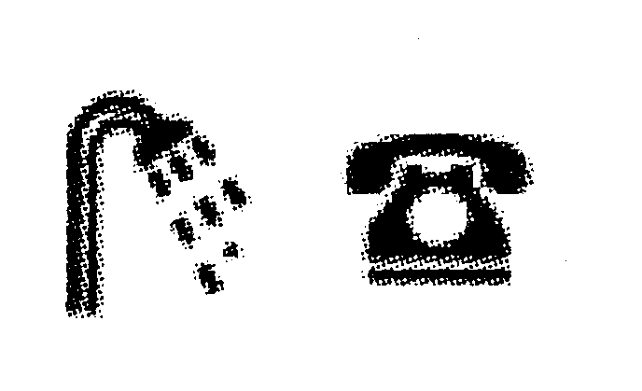

B
Location: Inside university
Room Type: Private flat
Availability: From 25 Aug. 2010
Number of beds: 1 double
Weekly Rent: ￡92.40
Notes: Full private shower, basic kitchen, furniture, bedding services and broadband Internet included.


C
Location: Outside university
Room Type: Private flat
Availability: From 1 Apr.2010
Number of beds:2 doubles
Weekly Rent:￡15.00
Notes: 1 double bedroom with lounge, kitchen, bathroom and WC. Sofa bed in lounge can be used as a second double bed. Includes free broadband Internet.


D
Location: Inside university
Room Type: Standard with washbasin
Availability: From 25 Sept. 2010
Number of beds:1 single
Weekly Rent:￡70.00
Notes: Private single bedroom. Also has public kitchen, bathrooms, WC and relaxing area with sofas that are shared by around 15 people.
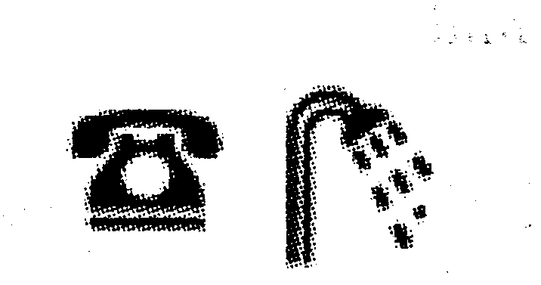
E
Location: Inside university
Room Type: Townhouse flats
Availability: From 25 Sept.2010
Number of beds:12 singles
Weekly Rent:￡35.00
Notes: 12 people share each house. These are brand new for 2008, and each house contains a good size public kitchen, living area with sofas and downstairs laundry. 


F
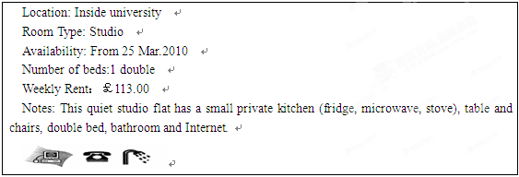
请阅读下列师生的信息，然后匹配与其需求相对应的住宿信息。
_____ 61. Robert Jones. Robert will be a guest teacher at the university beginning September 1. He has no car so needs accommodation that is very near work and that’s big enough for him and his wife. Privacy is important so he does not want to share things with others. As the university will pay his living expenses, money is no problem. 
_____ 62. Bill West. Bill will begin his undergraduate studies in the autumn term (September 2010). Bill is very sociable and is eager to live with others. He would prefer to stay in town rather than the university so he can experience more of what the city offers.
_____ 63. Shelia Budgie. Shelia, a postgraduate student from Australia, will come to the university at the beginning of April for 6 months’ study. She needs a very quiet, private place in the university where she can study in peace. As she loves to cook she also wants a place with a private kitchen.
_____ 64. Angelo Liokas. Angelo, a language student from Greece, arrives in October and wants to live in the university and share with other students so he can practice his English. As his money is very limited he needs an inexpensive room that has cooking and washing equipment available to him.
_____ 65. Linda Chan. Linda will finish her studies this spring and wants her family to come from China to attend her graduation ceremony. She needs a place that can accept the four family members planning to attend in April. They will also need Internet access to stay in touch with family members in China.

第II卷 （共40分）
第三部分 写作（共两节，满分40分）
- 短文改错（共10小题；每小题1分，满分10分）
下面短文中有10处语言错误。请在有错误的地方增加、删除或修改某个单词。
增加：在缺词处加一个漏字符号（∧），并在其下面写上该加的词。
删除：把多余的词用斜线（＼）划掉。
修改：在错的词下划一横线，并在该词下面写上修改后的词。
注意：1. 每次错误及其修改均仅限一词；2. 只允许修改10处，多者（从第11处起）不计分。
A lady once wrote a long story and sent to a famous editor．After a few week, the story was returned to her．The lady got very angrily．She wrote to the editor, “Dear sir, how do you know why the story is not good? You didn't read it．After I sent it to you, I pasted pages 21, 22 or 23 together．This was a test to see whether I would really read the story．When it came back, the pages still pasted together．Is this the way in that you read the stories that are sent to you?” The editor writes back, “Dear madam, at breakfast when I open an egg, I don't have to eat the whole egg in order to discover that it is bad．”

第二节：书面表达（满分30分）
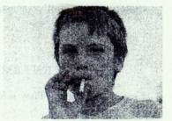
假如你是中学生宗华，你的美国朋友Jack给你的来信中寄来了一张自己的照片，请用英语给他写一封回信，内容如下：
1．表示惊讶；
2．介绍抽烟的危害；
3．给出戒烟的方法。

杭师大附中2011学年高三年级第二次月考
参考答案
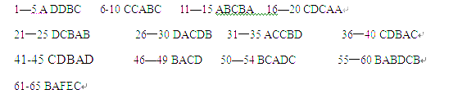
短文改错
1．to前面加it 2．week—weeks 3．angrily—angry 4．去掉why 或why—that 5．After—Before 6．or—and 7．I—you 8．still前加were
9．去掉in 或that—which 10．writes—wrote
