金华一中2010学年第一学期期中考试
高三英语

说明：本试卷分第一卷（选择题）和第二卷（非选择题）两部分，共120分。考试时间：120分钟。机读卡考号（9位数）：10003****（试场号座位号），科目：英语。请按规定填涂
第一部分 英语知识运用
第一节：单项填空（共40小题；满分20分）
从A、B、C、D四个选项中，选出可以填入空白处的最佳选项，并在机读卡上将该选项标号涂黑。
1. Mr. and Mrs. White are determined to give their children ____ first-rate education, though they are both out of ____ work now.
A．a, the B．the, the C．a, / D．the, /[来源:Z|xx|k.Com]
2. These seats are __________ for the elderly and disabled.
A. observed B. deserved C. preserved D. reserved
3. In order to prevent the disease ___________ to other districts, the authorized organization killed thousands and thousands of cows.
A. extending B. spreading C. expanding D. stretching
4. The home improvements have taken what little there is ______ my spare time.
A. from B. in C. of D. at
5. –I didn’t invite him to the party but he came anyway and got completely drunk.
--__________he hadn’t come! The party could have been a success.
A. How come B. Only if C. What if D. If only
6. –I hear that you will be on travel again.
--Yeah. My boss _______ for me to discuss business details with someone from another company.
A. asked B. arranged C. sent D. called
7. Nowadays, many people walk to work______ Copenhagen Conference calling for living a low—carbon lifestyle to cope with global warming.
A. in relation to B. in response to C. in addition to D. in opposition to
8. – Mary, I have got a new cellphone number!
-- Oh, hold on. I’ll put it down just _________.
A. in need B. in case C. in time D. in use
9. The 40-somethings found themselves in an embarrassing situation _____ rapid changes in all aspects of society.
A. as a consequence of B. in favor of C. for the purpose of D. by means of
10. –Have you finished your first paper?
--_________. Just half of it. How about you?
A. Not at all B. Not likely C. Not a bit D. Not yet.
11. –Let’s go Dutch for this supper, OK?
--No, _______ this time, as a reward for all your help.
A. it’s up to you B. it’s my treat C. let’s talk about it D. it doesn’t matter
12. In summer people often wear dark glasses as _________ against the bright sunshine.
A. permission B. protection C. prediction D. prevention
13. The present situation is very complex, so I think it will take me some time to ____its reality.
A. make up B. figure out C. look through D. put off
14. ___ you are familiar with the author’s ideas, try reading all the sections as quickly as you can.
A. Ever since B. Now that C. So that D. As long as
15. –Mr. Smith is no longer ________he used to be.
--So he is. Success and wealth have _________ his character.
A. what; trained B. who; transferred C. what; transformed D. who; transformed
16. Co-operation or teamwork, the importance of which is often ________, plays an important part in football matches.
A. stressed B. thought of C. paid much attention D. talked
17. Sometimes people have no belief ________ his choices about their eating habits.
A. on which to base B. which to base on C. to base on D. to be based on
18. Later in this chapter cases will be introduced to readers_________ consumer complaints have led to changes in the law.
A. where B. when C. who D. whose
19. When we got there, he was about to leave. So he only had time to explain _______ to us how he ________ our plan.
A. impatiently; like B. limitedly; thought about
C. carelessly; thought of D. roughly; found
21. Was it when you were attending high school _________you first listened to pop music?
A. when B. that C. which D. where
22. On March 14, violent crimes in Lhasa of Tibet broke out, _____ 13 innocent people and with more than 300 _____.
A. killed; injured B. killing; injured C. killed; injuring D. killing; injuring[来
23. The parents are ________ by law to send their children to school.
A. demanded B. required C. requested D. called
24. I was so excited at the news that I could hardly ________ my feelings in words.
A. carry B. convey C. talk D. communicate.
25.—I have some big news for you. You’ve been accepted as a member of our club.
--- __________That’s great!
A. Have I? B. Pardon? C. Congratulations! D. Good idea!
26. Peter was fired again. He really didn’t know _____ went wrong.
A. why B. what C. where D. that
27. __________twice a year, whether it is a car or bus or a truck, is the rule that every driver must obey in this city.
A．Examining B．Examined C．Being examined D．Having been examined
28. The driver got out of the car_______it caught fire.
A．directly B．that C．unless D．until
29.－Can I pay the bill by check?
－Sorry, sir. But it is the management rule of our hotel that payment ______ be made in cash.
A．shall B．need C．will D．can[来源:Z。xx。k.Com]
30. The scientists are able to ____________ accurately when the spaceship will reach the moon.
A．accumulate B．calculate C．appoint D．estimate
31.－You couldn’t have chosen a better way to solve the issue, I think.
－________________.
A．Well, nothing much B．Oh, don’t complain about it
C．Sorry, but I’ll find a better one D．Thanks a lot.
32. Now, thanks to the government’s quick reaction, thousands of children who would otherwise have died___________.
A. would be saved B. are saved
C. had been saved D. have been saved
33. She has waited for the guest for two hours and reached the ________ of her patience.
A. limit B. top C. point D. need
34. The traffic slowed down because of the heavy snow in Yushu County, presenting a new _____ to the discovery from the earthquake.
A. suffering B. disaster C. damage D. challenge
35. It was early in the morning and the traffic was _________.
A. fluent B. free C. light D. little
36. Don’t you know that the famous university is as a matter of fact ______ used to be a church?
A. where B. what C. which D. one
37. When I came to the cinema, the film had already been on. So I _______ my way to the seat.
A. went B. walked C. moved D. felt
- The waters off the Diaoyu islands, first _____ in Ming Dynasty, are our traditional fishing area.
A. discovered B. discovering C. being discovered D. having discovered
- “Stop thief! Stop thief!” But the thief was ________ by the crowd and we lost sight of it.
A. drowned B. swallowed C. caught D. stopped
- — Did you notice that guy almost hit a kid on a bicycle?
—No. I ______ the other way.
A. was looking B. looked C. have looked D. am looking
第二节：完形填空（共20小题；每小题1分，满分20分）
阅读下面短文，掌握其大意，然后从41–60各题所给的四个选项（A、B、C和D）中，选出最佳选项，并在机读卡上将该选项标号涂黑。
The letter was a great disappointment to me. It was from Holy Cross, the only school I really wanted to 41 . I scanned the page, “…. We had a great applicant pool this year. …We can’t offer spaces to 42 … and place you on our waiting list.”
“What does it say, honey?” my dad asked, his voice full of 43 for me.
“I didn’t get in, but I’m on the waiting list.”
“Well, at least it isn’t 44 ,” he said brightly.
“Yeah, but 45 , I don’t want to be on the waiting list; I want to be 46 . No one gets in off the waiting list. It’s a way of saying ‘Thanks for 47 ’.”
“Then let’s go out there and tell them so.”
“That sounds 48 , dad.” I said sadly, “It doesn’t work.”
Upset and annoyed, I 49 myself in my room. However，my father’s advice kept 50 in my head. I thought about it for a few days, finally coming to the 51 that he was right. And the next day I seated myself across from Mr. Luis Soto, my admissions officer.
“What can I do for you, Nacie?” he asked pleasantly.
“Well, sir, I am here to tell you that I love this school and would love a 52 to be here. I just wanted to tell you how much going here would 53 to me—it is my only dream college— and that I would use my time here to the best 54 . I wanted to let you know that if you gave me a chance and reconsidered my application, you wouldn’t 55 it.” The words had poured out 56 I could stop them or check their desperate tone.
Mr. Soto looked me over for a minute before he smiled broadly.
“OK, that is the kind of thing we love to hear. Congratulations, you’re in.”
It was so 57 and I asked, “I’m sorry?”
“We want people in the class who want to be here, who will 58 the best of this education. I’m glad you came to talk 59 to me. I’m happy to offer you a position in the Class of 2009.”
The whole experience taught me a lesson: if you truly want something, never, ever 60 .
41. A. attend B. study C. admit D. visit
42. A. everyone B. anyone C. someone D. no one
43. A. trust B. pity C. anxiety D. curiosity
44. A. admission B. imagination C. restriction D. rejection
45. A. ever B. again C. also D. still
46. A. recognized B. received C. accepted D. permitted
47. A. writing B. trying C. replying D. waiting
48. A. lame B. reasonable C. painful D. practical
49. A. enjoyed B. comforted C. stayed D. buried
50. A. saying B. ringing C. showing D. reminding
51. A. point B. conclusion C. agreement D. arrangement
52. A. chance B. motivation C. degree D. change
53. A. refer B. turn C. mean D. stick
54. A. contribution B. condition C. advantage D. result
55. A. suspect B. disappoint C. refuse D. regret
56. A. as B. when C. until D. before
57. A. unbelievable B. unforgettable C. unbearable D. favorable
58. A. take B. get C. make D. receive
59. A. patiently B. openly C. carefully D. calmly
60. A. get through B. give up C. keep on D. try out
第二部分：阅读理解（共20小题，每小题2分，满分40分）
阅读下列短文，从每题所给的四个选项（A、B、C和D）中，选出最佳选项，并在答题纸上将该选项标号涂黑。
A
Daniel stays home on workdays. He starts his personal computer in order to connect with the office which is about three hundred miles away in another city. After work, he puts on his headphones, watches a movie on his home video recorder, or plays baseball on the computer. On many days, Daniel doesn’t talk to any other human beings, and he doesn’t see any people except the ones on television. Daniel is imaginary, but his lifestyle is very possible. The inventions of modern technology seem to be cutting us off from contact with our fellow human beings.
The world of business is one area in which technology is separating us. Experts say, for example, that many people will soon be able to work at home. With access to a large central computer, employees such as office clerks, insurance agents, and accountants could do their jobs at display terminals (终端) in their own homes. They would never have to actually see the people they’re dealing with. In addition, the way employees are paid will change. Workers’ salaries will be automatically paid into their bank accounts, making paper checks unnecessary. No workers will stand in line to receive their pay or cash their checks. Personal banking will change, too. Customers will deal with machines to put in or take out money from their accounts. Many companies and consumers have already changed the way they sell or buy products. E-commerce, or business done on the Internet, is becoming more and more popular. This, therefore, makes it possible for people to do shopping without going out of their homes.
Another area that technology is changing is entertainment. Music, for example, was once a group experience. People listened to music at concert halls or in small social gatherings. For many people now, however, music is an individual experience. Walking along the street or sitting in their living-rooms, they wear headphones to build a wall of music around them. Movie entertainment is changing as well. Movies used to be social events. Now, fewer people are going out to see a movie. Many more are choosing to wait for a film to appear on television or are borrowing videotapes to watch at home. Instead of laughing with others, viewers watch movies in their own living-rooms.

61. After work, Daniel likes to ______.
A. listen to music at the concert hall B. watch a movie in his living-room
C. chat with his friends on the net D. play baseball with his workmates
62. The underlined sentence “Daniel is imaginary, but his lifestyle is very possible” means ______.
A. Daniel is a person full of imagination and he can make his life colorful.
B. Daniel is not a real person but the lifestyle of his kind does exist.
C. Daniel is only an ordinary person but he has his own way of living.
D. Daniel is a model who makes full use of modern technology in life.
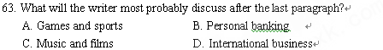
64. What is the main idea of the passage?
A. We may no longer need to communicate with other human beings.
B. Modern technology seems to be separating human beings.
C. We may no longer need to work in the office.
D. Modern technology makes it possible for us to work and entertain ourselves at home.
B
In November of 2007, NBC Universal launched（发起） its first official Green Week. Throughout the week, NBC Universal presented over 150 hours of environmentally themed content across multiple platforms.
Now, NBC Universal is proud to present Green Week 2009. With a new theme and message of "Green Your Routine," Here at NBC and NBC.com we celebrate our talent in the "The More You Know" PSA campaign, presenting green-themed tips in several of our daytime life, among several other features here on the "Green Your Routine" site.
Fashion & Beauty
Throw a clothes swap party! Dying for that sweater your friend wore the other day? Well, maybe she'll trade for that old T-shirt you have. Here's a website that helps you organize a swap party (www.swapstyle.com), or just plan your own!
Go natural with organic make-up. Applying unnatural products directly on your skin wasn't exactly what nature intended. Try switching to a line of organic make-up and cosmetics for a different way to bring out your natural beauty.
Home
Drop a brick in your toilet tank! Literally! According to the EPA, flushing（冲洗）makes up 30 percent of a household's water use (about three to six gallons per flush). By placing a brick in your toilet tank, you can help to conserve the amount of water used during each flush.
Work
Print smarter. Printing and copying can be one of the most costly operations in any office. To save on ink and paper costs, print double-sided and try to fit more than one page on a sheet. More printing tips can be found here: lifehacker.com
Turn off your computer. Do you leave your computer on overnight? If so, you're using up a good amount of electricity. When you can, try turning off your computer and the power strip it's connected to. If you can't, at least shut off your monitor.
Transportation
Organize a carpool. There are many benefits to carpooling. You save on gas, reduce wear and tear on your car, and you get to ride in the HOV lanes. Get connected with your neighbours and co-workers to start sharing rides and check out this website for more tips: www.erideshare.com.
Lose the car, get a bike. If you live close to where you work, try taking a bike instead of driving. You'll keep in shape and save on gas!
Every small step and effort makes a difference! Be sure to GREEN YOUR ROUTINE!
65．NBC Universal holds Green Week activities ___________.
A. in a university B. in a park C. in an office D. on the internet
66．This year, Green Week welcomes ____________.
A. advice on how to improve the website
B. suggestions about how to make their activities more interesting
C. tips on what to do to make our life greener
D. opinions on whether we should have campaigns
67．If you want to carpool with somebody, you can find more advice and information at______.
A. www.swapstyle.com B. www.erideshare.com
C. www. lifehacker.com D. www. NBC.com
68．Which is NOT recommended by Green Week this year?
A. Using things like cucumbers to beautify your skin.
B. Reducing the room of your toilet tank to save water when flushing.
C. Giving away your old clothes to those in need of them.
D. Printing and using computers in an economical way.
C[来源:学科网ZXXK]
Who’s in control of your life? Who is pulling your string? For the majority of us, it’s other people—society, colleagues, friends, family or our religious community. We learned this way of operating when we were very young, of course. We were brainwashed. We discovered that feeling important and feeling accepted was a nice experience and so we learned to do everything we could to make other people like us. As Oscar Wilde puts it, “Most people are other people. Their thoughts are someone else’s opinions, their lives a mimicry(模仿), their passions a quotation.”
So when people tell us how wonderful we are, it makes us feel good. We long for this good feeling like a drug. Therefore, we are so eager for the approval of others that we live unhappy and limited lives, failing to do the things we really want to. Just as drug addicts and alcoholics live worsened lives to keep getting their fix (一剂毒品). We worsen our own existence to get our own constant fix of approval.
But, just as with any drug, there is a price to pay. The price of the approval drug is freedom—the freedom to be ourselves. The truth is that we cannot control what other people think. People have their own agenda, and they come with their own baggage and, in the end, they're more interested in themselves than in you. Furthermore, if we try to live by the opinions of others, we will build our life on sinking sand. Everyone has a different way of thinking, and people change their opinions all the time. The person who tries to please everyone will only end up getting exhausted and probably pleasing no one in the process.
So how can we take back control? I think there’s only one way—make a conscious decision to stop caring what other people think. We should guide ourselves by means of a set of values---not values imposed（强加）from the outside by others, but innate values which come from within. If we are driven by these values and not by the changing opinions and value systems of others, we will live a more authentic, effective, purposeful and happy life.
69. What Oscar Wilde says implies that _____________.
A. we have thoughts similar to those of others
B. most people have a variety of thoughts
C. most people’s thoughts are controlled by others
D. other people’s thoughts are more important
70. What does the author try to argue in the third paragraph ?
A. We may lose ourselves to please others.
B. Changing opinions may cost us our freedom.
C. We need to pay for what we want to get.
D. The price of taking drugs is freedom.
71. In order to live a happy, effective and purposeful life, we should _________.
A. care about others’ opinions and change opinions all the time
B. guide ourselves by means of values from the outside
C. persuade others to accept our opinions
D. stick to our own values
72. It can be concluded from the passage that __________.
A. we shouldn’t care what others think B. it’s better to do what we like
C. we shouldn't change our own opinions D. it’s important to accept others’ opinions
D
An old problem is getting new attention in the United States—bullying．Recent cases included the tragic case of a fifteen-year-old girl whose family moved from Ireland．She hanged herself in Massachusetts in January following months of bullying．Her parents criticized her school for failing to protect her．Officials have brought criminal charges against several teenagers．
Judy Kuczynski is president of an anti-bullying group called Bully Police USA．Her daughter Tina was the victim of severe bullying starting in middle school in the state of Minnesota．Her said, “Our daughter was a very outgoing child．She was a bubbly personality, very involved in all kinds of things, had lots of friends．And over a period of time her grades fell completely．She started having health issues．She couldn't sleep．She wasn't eating．She had terrible stomach pains．She started clenching(咬紧) her jaw and grinding(磨,咬牙) her teeth at night．She didn't want to go to school.”
Bullying is defined as negative behavior repeated over time against the same person．It can involve physical violence．Or it can be verbal — for example, insults or threats．Spreading lies about someone or excluding a person from a group is known as social or relational bullying．
And now there is cyber bullying, which uses the Internet, e-mail or text messages．It has easy appeal for the bully because it does not involve face-to-face contact and it can be done at any time．
The first serious research studies into bullying were done in Norway in the late 1970s．The latest government study in the United States was released last year．It found that about one-third of students aged twelve to eighteen were bullied at school．
Susan Sweater is a psychologist at the University of Nebraska-Lincoln and co-director of the Bullying Research Network．She says schools should treat bullying as a mental health problem to get bullies and victims the help they need．She says bullying is connected to depression, anxiety and anti-social behavior, and bullies are often victims themselves．
73．Which of the following is NOT bullying?
A．To beat someone repeatedly． B．To call someone names．
C．To isolate someone from friends．
D．To refuse to help someone in need．
74．Why is cyber bullying appealing to the bully?
A．Because it can involve more people．
B．Because it can create worse effects．
C．Because it is more convenient． D．Because it can avoid cheating．
75．According to Susan Sweater, ．[来源:学科网ZXXK]
A．bullies are anti-social B．bullies should give victims help
C．students are not equally treated D．bullies themselves also need help
76．Which of the following can be the best title of the text?
A．How to wipe out bullying in schools.
B．Bullying has a negative influence on students in US.
C．Cyber bullying-Taking Off in Schools.
D．Girl's suicide in US brings fresh attention to bullying.
E
Birds that are half-asleep—with one brain hemisphere（半球）alert and the other sleeping—control which side of the brain remains awake, according to a new study of sleeping ducks．
Earlier studies have documented half-brain sleep in a wide range of birds．The brain hemispheres take turns sinking into the sleep stage characterized by slow brain waves．The eye controlled by the sleeping hemisphere keeps shut, while the wakeful hemisphere’s eye stays open and alert．Birds also can sleep with both hemispheres resting at once．
Decades of studies of bird groups led researchers to predict extra alertness in the end-of-the-row sleepers which tend to be attacked more easily．Sure enough, the end birds tended to watch carefully on the side away from their companions．Ducks in the inner spots showed no preference for gaze（注视）direction．
Also, birds napping at the end of the line depend on single-hemisphere sleep, rather than total relaxation, more often than inner ducks did．Turning 16 birds through the positions in a four-duck row, the researchers found that compared with 12 percent for birds in internal spots, outer birds half-asleep during some 32 percent of napping time．
“We believe this is the first evidence for an animal behaviorally controlling sleep and wakefulness at the same time in different regions of the brain,” the researchers say．
The results provide the best evidence for a long-standing assumption that single-hemisphere sleep evolved（发展）as creatures scanned for enemies．The preference for opening an eye on the lookout side could be widespread, he predicts．He’s seen it in a pair of birds napping side-by-side in the zoo and in a single pet bird sleeping by a mirror．The mirror-side eye closed as if the reflection were a companion and the other eye stayed open．
Useful as half-sleeping might be, it’s only been found in birds and such water animals as dolphins, whales, and seals．Perhaps keeping one side of the brain awake allows a sleeping animal to surface occasionally to avoid drowning．
Studies of birds may offer unique insights（深刻的理解）into sleep．Jerome M．Siegel of the UCLA says he wonders if birds’ half-brain sleep “is just the tip of the iceberg．” He supposes that more examples may turn up when we take a closer look at other species．
77．According to the passage, birds often half sleep because ______．
A．they have to watch out for possible attacks
B．their brain hemispheres take turns to rest
C．the two halves of their brain are differently structured
D．they have to constantly keep an eye on their companions
78．What is implied about the example of a bird’s sleeping in front of a mirror?
A．An imagined companion gives the bird a sense of security．
B．Birds prefer to sleep in pairs for the sake of their security．
C．The phenomenon of birds napping in pairs is widespread．
D．A single pet bird enjoys seeing its own reflection in the mirror．
79．While sleeping, some water animals tend to keep half awake in order to ______．
A．alert themselves to the approaching enemy
B．emerge（浮现）from water now and then to breathe
C．be sensitive to the ever-changing environment
D．avoid being swept away by rapid currents
80．By saying “just the tip of the iceberg”, Siegel suggests that ______．
A．half-brain sleep has something to do with icy weather
B．the mystery of half-brain sleep is close to being solved
C．most birds living in cold regions tend to be half sleepers
D．half-brain sleep may exist among other species
非选择题部分（共40分）
第三部分：写作(共两节，满分40分)
第一节：短文改错(共10小题；每小题l分，满分l0分)
下面短文中有10处语言错误。请在有错误的地方增加、删除或修改某个单词。
增加：在缺词处加一个漏字符号(∧)，并在其下面写上该加的词。
删除：把多余的词用斜线(＼)划掉。
修改：在错的词下划一横线，并在该词下面写上修改后的词。
注意：1．每处错误及其修改均仅限一词；
2．只允许修改l0处，多者(从第ll处起)不计分。
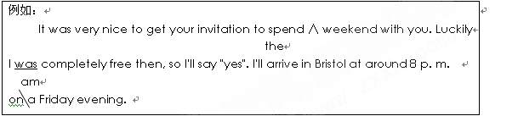Last weekend we went mountain-climbing. Even the heavy rain in the morning could not prevent us go. Setting off very early, we went along an extreme narrow road, all in high spirits. On every side of the road was green fields and some farm houses. We could hear the sound of the rain and our footsteps mixing with our laughter. At noon we reached the top of the mountain. That surprised us most there was the beauty of the scenes. After having short rest and sharing with the food we had brought, we started going down. It had rained even harder. We were wet to the skin, and we still sang and laughed happily.
第二节 书面表达（满分30分）
目前，一些诸如酱紫、神马、王道、BH和MS等的网络语言在青少年中极为盛行，并出现在家庭作业、报告，甚至考试的作文中。请你以Should Internet Slang Be Prohibited(禁止)为题，根据以下要点用英语写一篇短文。
部分同学认为网络语言：1.生动、时尚；2.充满幽默与智慧；3.更快捷。
另一些同学认为网络语言 ：1.缺乏思想性，太简单；2.很多人不能理解和接受；
你自己的观点
注意：（1）对所给要点，不要简单翻译，要有适当发挥。
（2）词数120左右；短文已写好的部分，不计入词数。
Should Internet Slang Be Prohibited?
At present, Internet Slang, such as "BH", "MS" has become popular among the teenagers.

参考答案


阅读理解
61-64BBAB
65-68 DCBC
69-72 CADA
73-76 DCDD
77-80 AABD

改错
1. go-going 2. extreme — extremely 3. every — each 或改为 either 4. was—were
5. mixing-mixed 6. That — What 7. /\short — a 8. 去掉 with 9. 去掉 第二个had
10. and — but
Should Internet Slang Be Prohibited?
At present, Internet Slang, such as "BH","MS", has become popular among the teenagers.
There are different opinions on Internet Slang. Some students think Internet Slang is vivid, fashionable and full of humor and intelligence. Besides, it makes chatting on the Internet quicker.
However, some other students think Internet Slang lacks depth of thought and is too simple. Besides, it is hard to understand and not accepted by most people. The words sometimes might make people confused, even resulting in misunderstanding.
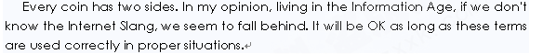

附件1：律师事务所反盗版维权声明
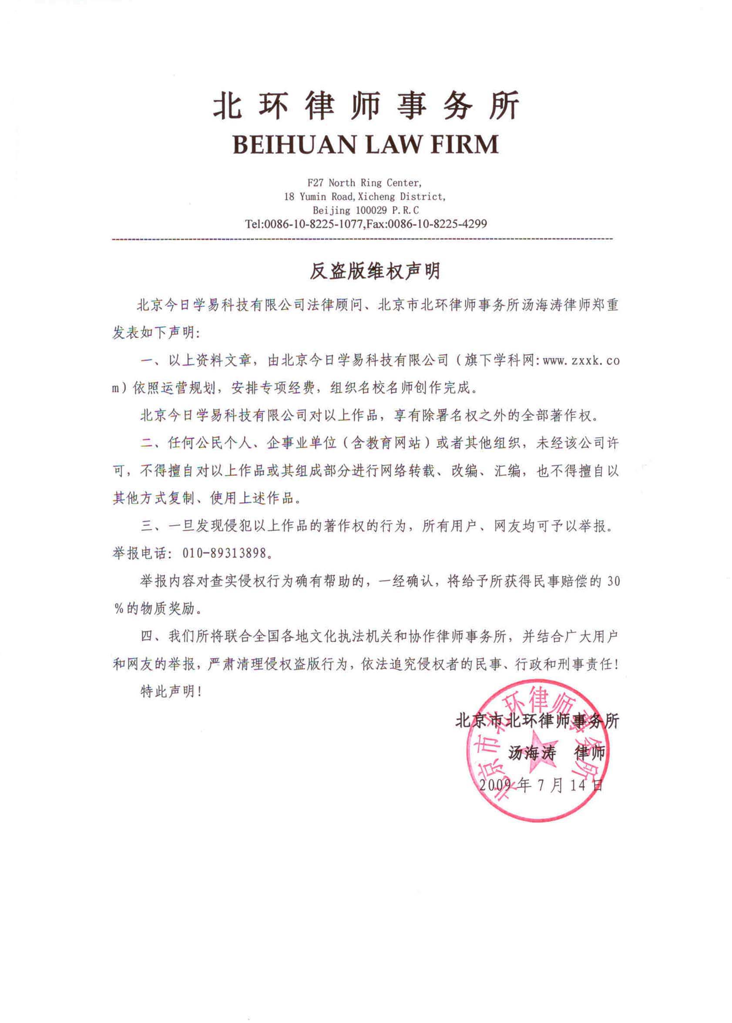
[来源:学科网ZXXK]

