2010高考真题精品解析—英语（浙江卷）
【名师简评】本套试卷难度适中，材料新颖，信息量大，是一套优秀的试题。单项填空的设题涉及各个方面，考查了，介词，连词，冠词，形容词，副词。着重考查了动词的时态，词义，还有高中的几个重点语法定语从句，名词从句，和虚拟语气。充分注重了语境化，词汇题具有一定难度。完形填空是记叙文，主要讲述作者小时候因家境贫寒，某一年不能收到圣诞礼物，但是三个好心人来到他家给他带来了圣诞礼物，让他有一种没被人遗忘的感觉。因此在作者长大之后也决定过一个有意义的圣诞节，作者召集他公司里40个人给125个孤儿开圣诞宴会，并给每个孤儿都准备了圣诞礼物。需要通过上下文语境选择。阅读理解题材广泛，有记叙文，说明文，调查报告，难度适中。改错从各方面来考察学生对英语的综合能力的掌握。书面表达相对来说难度适中，考生需审清题目，抓住要点进行写作，难度不大。

第一部分：英语知识运用(共两节，满分30分)
第一节：单项填空(共20小题；每小题0．5分，满分10分)
从A、B、c和D四个选项中，选出可以填入空白处的最佳选项，并在答题纸上将该选项标号涂黑。
1. -- How about camping this weekend, just for a change?
-- OK, __ you want.
A. whichever B. however C. whatever D. whoever
1.答案C
【解析】考查连词。句意：“---这个周末换换环境，去野营，怎么样？---好的，你想怎样就怎样”。 答句中谓语动词后缺少宾语，故由whatever引导，根据句意也可知此处表示“无论什么”，即C项正确。
2. Many lifestyle patterns do such __ great harm to health that they actually speed up __weakening of the
human body.
A. a; / B. /; the C. a; the D. /; /
2. 答案B
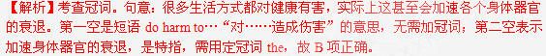3. The settlement is home to nearly 1,000 people, many of __ left their village homes for a better life in the city.
A. whom B. which C. them D. those
3. 答案A
【解析】考查定语从句中引导词的选择。句意：“这里将近是1000人的家园，他们中的很多都为了在城市里过上更好的日子而背井离乡”。此处考查的是“介词+which/whom”这种用法，此处先行词是people，故用whom，即A项正确。
4. The majority of people in the town strongly __ the plan to build a playground for children.
A. consider B. support C. confirm D. submit
4. 答案B
【解析】考查动词词义辨析。句意：城里的大多数人非常支持为孩子们建立一个操场的计划。由句意可知support“支持”符合题意。A项“考虑；认为”；C项“确认；批准”；D项“递交，服从”。
5. ff you plant watermelon seeds in the spring, you __ fresh watermelon in the fall.
A. eat B. would eat C. have eaten D. will be eating
5. 答案D
【解析】考查时态。句意：如果你在春天洒下西瓜种子，在秋天就可以吃到新鲜的西瓜了。此处是if引导的条件状语从句，实行“主将从现”原则，故选项中唯有D项正确，表示在秋天将可以吃到西瓜。
6. I have been convinced that the print media are usually more __ and more reliable than television.
A. accurate B. ridiculous C. urgent D. shallow
6. 答案A
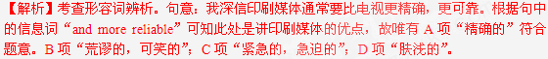7. I guess we've already talked about this before but I'll ask you again just __ .
A. by nature B. in return C. in case D. by chance
7. 答案C
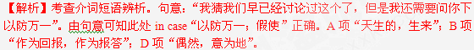8. The experiment shows that proper amounts of exercise, if __ regularly, can improve our health.
A. being carried out B. carrying out C. carried out D. to carry out
8. 答案C
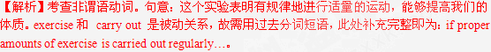9. It is uncertain __ side effect the medicine will bring about, although about two thousand patients have taken it.
A. that B. what C. how D. whether
9. 答案B
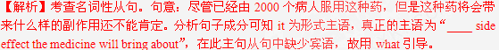10. Had I known about this computer program, a huge amount of time and energy __ .
A. would have been saved B. had been saved
C. will be saved D. was saved
10. 答案A
【解析】考查虚拟语气。句意：要是我早点了解计算机的程序，将会节约大量的时间和精力了。从句“had I known about…”补充完整为“if I had known about…”，表示对过去情况的虚拟，此处主句用would/could/might/should+ have done，故A项正确。
11. Do you think shopping online will __ take the place of shopping in stores?
A. especially B. frequently C. merely D. finally
11. 答案D
【解析】考查副词词义辨析。句意：你认为网上购物将最终替代在商店里购物吗？根据句意可知此处finally“最终，最后”正确。A项“尤其，特别”；B项“频繁地”；C项“仅仅，只不过”。
12. After that, he knew he could __ any emergency by doing what he could to the best of his ability.
A. get away with B. get on with C. get through D. get across
12. 答案C
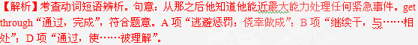13. -- Would she mind playing against her former teammates?
-- __ She is willing to play against any tough players.
A. I think so. B. I'm not surprised. C. Of course. D. Not likely!
13. 答案D
【解析】考查情景交际。根据答句中的“she is willing to play against any tough player”可知她不介意，且愿意与任何一个高超的对手对打，故D项“不可能”正确。A项“我认为如此”；B项“我一点也不惊讶”；C项“当然”。
14. __ that's important is that you are doing your best and moving in the right direction.
A. One B. All C. Everything D. Anything
14. 答案B
【解析】考查代词。句意：所有中重要的是你正在朝正确的方向努力。由句意可知all符合题意，此处是作主语，“that’s important”是定语从句修饰all。
15. For many years, people __ electric ears. However, making them has been more difficult than predicted.
A. had dreamed of B. have dreamed of C. dreamed of D. dream of
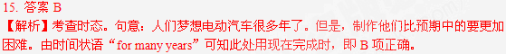16. The school advisers help you talk through your problems but they don't give you any direct __ .
A. solution B. target C. measure D. function
16. 答案A
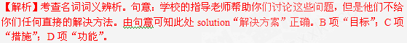17. "You __ have a wrong number," she said. "There's no one of that name here. "
A. need B. can C. must D. would
17. 答案C
【解析】考查情态动词。句意：“你肯定打错了，她说，这儿没有这个人”。根据“there’s no one of that name here”可知语气很肯定，所以此处表示肯定的推测，即must正确。
18. -- According to my grandma, it is a good idea to eat chicken soup when you have a cold.
-- __ , scientists agree with her.
A. Sooner or later B. Once in a while C. To be exact D. Believe it or not
18. 答案D
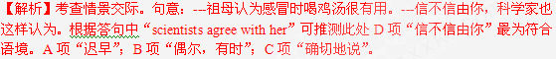19. Playing on a frozen sports field sounds like a lot of fun. Isn't it rather risky, __9
A. though B. also C. either D. too
19. 答案A
【解析】考查副词。句意：在一个冰冻的运动场上游戏听起来似乎很有乐趣。然而，这难道不是相当冒险吗？此处的though 为副词，“可是，虽然；然而；不过”的意思，符合题意。
20. The traffic rule says young children under the age of four and __ less than 40 pounds must be in a child
safety seat.
A. being weighed B. to weigh C. weighed D. weighing
20. 答案D
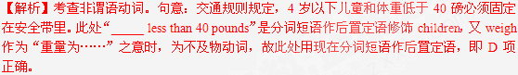第二节：完形填空(共20小题；每小题1分，满分20分)
阅读下面短文，掌握其大意，然后从21—40各题所给的四个选项(A、B、C和D)中，选出最佳选
项，并在答题纸上将该选项标号涂黑。
I will never forget the year I was about twelve years old. My mother told us that we would not be 21 Christmas gifts because there was not enough money. I felt sad and thought, "What would I say when the other kids asked what I'd 22 ?" Just when I started to 23 that there would not be a Christmas that year, three women 24 at our house with gifts for all of us. For me they brought a doll. I felt such a sense of 25 that I would no longer have to be embarrassed when I returned to school. I wasn't 26 . Somebody had thought 27 of me to bring me a gift.
Years later, when I stood in the kitchen of my new house, thinking how I wanted to make my 28 Christmas there special and memorable, I 29 remembered the women's visit. I decided that I wanted to create that same feeling of 30 for as many children as I could possibly reach.
So I 31 a plan and gathered forty people from my company to help. We gathered about 125 orphans (孤儿) at the Christmas party. For every child, we wrapped colorful packages filled with toys, clothes, and school supplies, 32 with a child's name. We wanted all of them to know they were. 33 . Before I called out their names and handed them their gifts, I 34 them that they couldn't open their presents 35 every child had come forward. Finally the 36 they had been waiting for came as I called out, "One, two, three. Open your presents!" As the children opened their packages, their faces beamed and their bright smiles 37 up the room. The 38 in the room was obvious, and 39 wasn't just about toys. It was a feeling — the feeling I knew 40 that Christmas so long ago when the women came to visit. I wasn't forgotten. Somebody thought of me. I matter.
21. A. sending B. receiving C. making D. exchanging
22. A. found B. prepared C. got D. expected
23. A. doubt B. hope C. suggest D. accept
24. A. broke in B. settled down C. turned up D. showed off
25. A. relief B. loss C. achievement D. justice
26. A. blamed B. loved C. forgotten D. affected
27. A. highly B. little C. poorly D. enough
28. A. present B. first C.. recent D. previous
29. A. hardly B. instantly C. regularly D. occasionally
30. A. strength B. independence C. importance D. safety
31. A. kept up with B. caught up with C. came up with D. put up with
32. A. none B. few C. some D. each
33. A. fine B. special C. helpful D. normal
34. A. reminded B. guaranteed C. convinced D. promised
35. A. after B. until C. when D. since
36. A. chance B. gift C. moment D. reward
37. A. lit B. took C. burned D. cheered
38. A. atmosphere B. sympathy C. calmness D. joy
39. A. it B. such C. something D. everybody
40. A. by B. till C. for D. from
【语篇解读】本文是一篇记叙文，主要讲述作者小时候因家境贫寒，某一年不能收到圣诞礼物，但是三个好心人来到他家给他带来了圣诞礼物，让他有一种没被人遗忘的感觉。因此在作者长大之后也决定过一个有意义的圣诞节，作者召集他公司里40个人给125个孤儿开圣诞宴会，并给每个孤儿都准备了圣诞礼物。
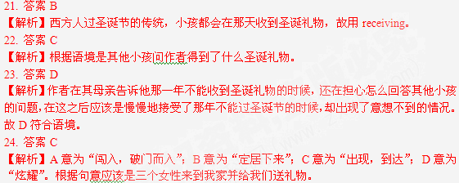25. 答案A
【解析】由I would no longer have to be embarrassed when I returned to school可断定作者在收到这三个女性送来的礼物之后有种轻松的感觉，因为不用担心怎么回答其他同学的问题了。
26. 答案C
【解析】由上文三个好心的女性来作者家并给他们带来了圣诞礼物可知，作者并没有被别人遗忘。
27. 答案D
【解析】根据上文three women turned up at our house with gifts for all of us可知别人充分的想到我的状况。
28. 答案B
【解析】由my new house 及下文可知这是作者安排的第一个特别的又值得纪念的圣诞节。
29. 答案B
【解析】A意为“几乎不”；B意为“立刻，马上”；C意为“定期地，有规律地”；D意为“偶尔地”。作者在考虑怎么制作一个既特别又具有纪念意义的圣诞节的同时，是立刻想到了小时候的那次很特别的圣诞节。
30. 答案C
【解析】由上文三个女性给作者带来礼物使作者有一种没被别人遗忘的感觉，说明作者在别人心目中还具有很重要的地位可知，作者也想让更多的小孩有他这样的很重要的感觉。
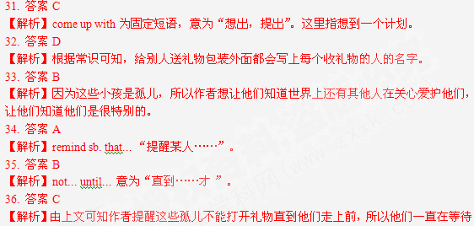打开礼物的这一刻。Moment意为“时刻，瞬间”。
37. 答案A
【解析】lit 为light的过去式，light up固定用法，意为“点燃，照亮”，句意为“孩子们的微笑照亮了整个房间。Take up 意为”占据，开始从事“；burn up 意为“烧完，烧光”；cheer up意为“使精神振作”。
38. 答案D
【解析】由前一句their faces beamed and their bright smiles 37 up the room可知孩子们都很快乐。
39. 答案A
【解析】由连词and可知，and之后句子为the joy wasn’t just about toys，前文已经出现了the joy，故为了避免重复用it代替。
40. 答案D
【解析】作者也有过这样快乐的感觉，而这感觉是来自于很久以前的一个圣诞节。故用from“来自于”符合句意。
第二部分：阅读理解(第一节20小题。第二节5小题；每小题2分，满分50分)
第一节：阅读下列短文，从每题所给的四个选项(A、B、C和D)中，选出最佳选项，并在答题纸上将该
选项标号涂黑。
A
When you are little, the whole world feels like a big playground. I was living in Conyers, Georgia the summer it all happened. I was a second grader, but my best friend Stephanie was only in the first grade. Both of our parents were at work and most of the time they let us go our own way.
It was a hot afternoon and we decided to have an adventure in Stephanie's basement. As I opened the basement door, before us lay the biggest room, full of amazing things like guns, dolls, and old clothes. I ran downstairs, and spotted a red steel can. It was paint. I looked beyond it and there lay even more paint in bright colors like purple, orange, blue and green.
"Stephanie, I just found us a project for the day. Get some paintbrushes. We are fixing to paint. " She screamed with excitement as I told her of my secret plans and immediately we got to work. We gathered all the brushes we could find and moved all of our materials to my yard. There on the road in front of my house, we painted big stripes ( 条纹) of colors across the pavement (人行道). Stripe by stripe, our colors turned into a beautiful rainbow. It was fantastic!
The sun was starting to sink. I saw a car in the distance and jumped up as I recognized the car. It was my mother. I couldn't wait to show her my masterpiece. The car pulled slowly into the driveway and from the look on my mother's face, I could tell that I was in deep trouble.
My mother shut the ear door and walked towards me. Her eyes glaring, she shouted, "What in the world were you thinking? I understood when you made castles out of leaves, and climbed the neighbors' trees, but this! Come inside right now !" I stood there glaring back at her for a minute, angry because she had insulted (侮辱) my art.
"Now go clean it up!" Mother and I began cleaning the road. Tears ran down my cheeks as I saw my beautiful rainbow turn into black cement.
Though years have now passed, I still wonder where my rainbow has gone. I wonder if, maybe when I get older, I can find my rainbow and never have to brush it away. I guess we all need some sort of rainbow to brighten our lives from time to time and to keep our hopes and dreams colorful.
41. What did the writer want to do when his mother came home?
A. To introduce Stephanie to her. B. To prevent her from seeing his painting.
C. To put the materials back in the yard. D. To show his artwork to her.
42. In his mother's eyes, the writer __ .
A. was a born artist B. always caused trouble
C. was a problem solver D. worked very hard
43. The underlined word "rainbow" in the last paragraph refers to __ .
A. the rainbow in the sky B. the stripes on the pavement
C. something imaginative and fun D. important lessons learned in childhood
44. It can be learned from the passage that parents should .
A. encourage children to paint
B. value friendship among children
C. discover the hidden talent in children
D. protect rather than destroy children's dreams
【语篇解读】本篇文章记叙文，作者小时候和他的好朋友在父母不在家的时候，根据孩子们自己的设想将地下室用各种各样的颜色刷成了心目中的“彩虹”，但却遭到了妈妈的批评，告诉我们父母应该保护孩子的梦想而不是破坏。
41. 答案D
【解析】细节推断题。根据文章第四段中的第四句话的I couldn’t wait to show her my masterpiece. 可知选D。
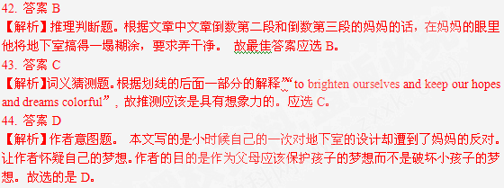B
Below is a housing guide for students going to London.
University accommodation（住所） office
Many university accommodation offices have their own list of registered landlords (房东). Others also provide information on accommodation agencies and other housing organizations. The advantage of using your university accommodation office is that you can get some support if you have 'a problem. The disadvantage is that they are unlikely to have enough registered landlords to house all their students.
Property papers: Loot and Renting
Loot is an important source (来源) of information about private housing for co-renters. The offers are from private landlords, agencies and individuals looking for other co-renters. They also have a website: www. loot. com. The advantage of using Loot is that there are some excellent bargains. The disadvantage is that there is no quality control over the offers.
Renting is another useful paper. The offers in this paper are mainly from accommodation agencies. Their website is at www. Renting.co. uk.
Accommodation agencies
The majority of rented accommodation in London is probably advertised through accommodation agencies. The advantage of using accommodation agencies is that you will have access to a large number of accommodations. A good agent will listen to your requirements and can save you time in looking for the right accommodation. The disadvantage is that they will make a range of charges to potential renters.
Noticeboards
Around the universities you will find a number of noticeboards where offers of accommodation will be posted. These will either be from landlords or from students. Some universities will also have online noticeboards where students can advertise to other students. Advertisements from students can be an excellent way to find accommodation. However, advertisements from landlords can be problematic.
Word of mouth
Some of the best housing in London is never advertised but is passed on from one group of students to another by word of mouth. It might be that you can find out about good offers from final year students. However, don't suppose that just because you have found out about housing from a friend it is necessarily, going to be better than that found through any other source.
Family
Faced with the very high rents charged in London, some students and their parents will consider buying as an alternative. In some cases this might be a good choice.
45. What is the advantage of using Loot?
A. It has more offers from accommodation agencies than Renting.
B. It gives you personal information about other co-renters.
C. Their website is designed mainly for students.
D. There are some good bargains.
46. A good agent can help you .
A. know more people
B. find cheap accommodation
C. get the right accommodation quickly
D. get free information about most accommodations
47. The information passed on by word of mouth is important because .
A. it is better than that found through any other source
B. it helps you find some of the best housing never advertised
C. the final year students always offer better information
D. the landlords have little valuable information
48. For students going to London for the first time, which of the following provides the most reliable information?
A. University accommodation offices.
B. Loot and Renting.
C. Noticeboards.
D. Family.
【语篇解读】本篇文章是说明文。告诉我们到伦敦去读书是如何找房子的一些指导。
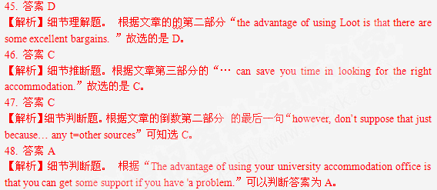C
The term “multitasking” originally referred to a computer's ability to carry out several tasks at one time. For many people, multitasking has become a way of life and even a key to success. In fact, some excellent mental aerobic exercises (大脑训练) involve engaging the brain in two or more challenging activities at a time. Although checking e-mail while talking on a phone and reading the newspaper may be second nature for some people, many times multitasking can make us less productive, rather than more. And studies show that too much multitasking can lead to increased stress, anxiety and memory loss.
In order to multitask, the brain uses an area known as the prefrontal cortex (前额叶脑皮层). Brain scans of volunteers performing multiple tasks together show that as they shift from task to task, this front part of the brain actually takes a moment of rest between tasks. You may have experienced a prefrontal cortex “moment of rest” yourself if you've ever dialed (拨电话) a phone number and suddenly forgotten who you called when the line is answered. What probably occurred is that between the dialing and the answering, your mind shifted to another thought or task, and then took that “moment” to come back. Research has also shown that for many volunteers, job efficiency (效率) declines while multitasking, as compared to when they perform only one task at a time.
Multitasking is easiest when at least one of the tasks is habitual, or requires little thought. Most people don' t find it difficult to eat and read the newspaper at the same time. However, when two or more attention-requiring tasks are attempted at one time, people sometimes make mistakes.
We often don't remember things as well when we're trying to manage several details at the same time. Without mental focus, we may not pay enough attention to new information coming in, so it never makes it into our memory stores. That is one of the main reasons we forget people's names—even sometimes right after they have introduced themselves. Multitasking can also affect our relationships. If someone checks their e-mail while on the phone with a friend, they may come off as absent-minded or disinterested. It can also cause that person to miss or overlook key information being passed on to them.
49. Why are some mental aerobic exercises designed to engage people in multitasking?
A. To make them more productive.
B. To reduce their stress and anxiety.
C. To develop their communication Skills.
D. To help them perform daily tasks more easily.
50. According to Paragraph 2, why may a person suddenly forget who he has called?
A. He may have his prefrontal cortex temporarily damaged.
B. He is probably interrupted by another task.
C. He is probably not very familiar with the person he has called.
D. He may need a rest between dialing and speaking.
51. People tend to make mistakes when .
A. they perform several challenging tasks at a time
B. new messages are processed one after another
C. their relationships with others are affected
D. the tasks require little thought
52. What is the main idea of the passage?
A. Multitasking has become a way of life.
B. Multitasking often leads to efficiency decline.
C. Multitasking exercises need to be improved.
D. Multitasking enables people to remember things better.
【语篇解读】本篇文章是一篇调查报告。讲的是任务多样化使得我们有生活压力，工作效率下降。
49. 答案A
【解析】根据文章的第一段的第四句“although…”可知应选A。
50. 答案B
【解析】细节判断题。根据文章第二段的倒数第二句“what probably occurred is that…”可推知选的是B。
51. 答案A
【解析】推理判断题。根据文章的第三段的最后一句“however, two or more attention …”可推知应选的是A。
52. 答案B
【解析】主旨大意题。 本文讲的是一篇调查报告。讲的是任务多样化使得我们有生活压力，工作效率下降。故选的是B。
D
My family and I lived across the street from Southway Park since I was four years old. Then just last year the city put a chain link fence around the park and started bulldozing (用推土机推平) the trees and grass to make way for a new apartment complex. When I saw the fence and bulldozers, I asked myself, “Why don't they just leave it alone?”
Looking back, I think what sentenced the park to oblivion (被遗忘) was the drought (旱灾) we had about four years ago. Up until then, Southway Park was a nice green park with plenty of trees and a public swimming pool. My friends and I rollerskated on the sidewalks, climbed the trees, and swam in the pool all the years I was growing up. The park was almost like my own yard. Then the summer I was fifteen the drought came and things changed.
There had been almost no rain at all that year. The city stopped watering the park grass. Within a few weeks I found myself living across the street from a huge brown desert. Leaves fell off the park trees, and pretty soon the trees started dying, too. Next, the park swimming pool was closed. The city cut down on the work force that kept the park, and pretty soon it just got too ugly and dirty to enjoy anymore.
As the drought lasted into the fall, the park got worse every month. The rubbish piled up or blew across the brown grass. Soon the only people in the park were beggars and other people down on their luck. People said drugs were being sold or traded there now. The park had gotten scary, and my mother told us kids not to go there anymore.
The drought finally ended and things seemed to get back to normal, that is, everything but the park. It had gotten into such bad shape that the city just let it stay that way. Then about six months ago I heard that the city was going to “redevelop” certain worn-out areas of the city. It turned out that the city had planned to get rid of the park, sell the land and let someone build rows of apartment buildings on it.
The chain-link fencing and the bulldozers did their work. Now we live across the street from six rows of apartment buildings. Each of them is three units high and stretches a block in each direction. The neighborhood has changed without the park. The streets I used to play in are jammed with cars now. Things will never be the same again. Sometimes I wonder, though, what changes another drought would make in the way things are today.
53. How did the writer feel when he saw the fence and bulldozers.'?
A．Scared. B. Confused. C. Upset. D. Curious.
54. Why was the writer told not to go to the park by his mother?
A．It was being rebuilt. B. It was dangerous.
C. It became crowded. D. It had turned into a desert.
55. According to the writer, what eventually brought about the disappearance of the park?
A. The drought. B. The crime.
C. The beggars and the rubbish. D. The decisions of the city.
56. The last sentence of the passage implies that if another drought came, .
A. the situation would be much worse
B. people would have to desert their homes
C. the city would be fully prepared in advance
D. the city would have to redevelop the neighborhood
【语篇解读】本篇文章是一篇夹叙夹议的文章，讲的是政府把我小时候住的地方推平了，让作者感到困惑。
53. 答案B
【解析】推理判断题。从整篇文章来看，作者对政府这种做法感到困惑。 故选的是B。
54. 答案B
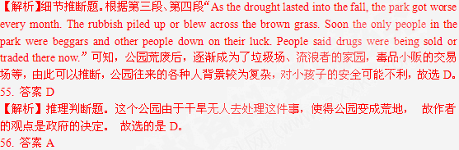【解析】推理判断题。从整篇文章可以知道，作者对政府的做法困惑不解，如果再有干旱，还是无人过问的话，情况和原来的一样，甚至更糟。 故最佳答案应选的是A。
E
I needed to buy a digital camera, one that was simply good at taking good snaps (快照), maybe occasionally for magazines. Being the cautious type, I fancied a reliable brand. So I went on the net, spent 15 minutes reading product reviews on good websites, wrote down the names of three top recommendations and headed for my nearest big friendly camera store. There in the cupboard was one of the cameras on my list. And it was on special offer. Oh joy. I pointed at it and asked an assistant, “Can I have one of those?” He looked perturbed (不安).“Do you want to try it first?" he said. It didn't quite sound like a question. "Do I need to?" I replied. "There's nothing wrong with it?" This made him look a bit insulted and I started to feel bad. "No, no. But you should try it," he said encouragingly." Compare it with the others. "
I looked across at the others: shelves of similar cameras placed along the wall, offering a wide range of slightly different prices and discounts, with each company selling a range of models based around the same basic box. With so many models to choose from, it seemed that I would have to spend hours weighing X against Y, always trying to take Z and possibly H into account at the same time. But when I had finished, I would still have only the same two certainties that I had entered the store with: first, soon after I carried my new camera out of the shop, it would be worth half what I paid for it; and second, my wonderful camera would very quickly be replaced by a new model.
But something in the human soul whispers that you can beat these traps by making the right choice, the clever choice, the wise choice. In the end, I agreed to try the model I had chosen. The assistant seemed a sincere man. So I let him take out my chosen camera from the cupboard, show how it took excellent pictures of my fellow shoppers... and when he started to introduce the special features, I interrupted to ask whether I needed to buy a carry-case and a memory card as well.
Why do we think that new options (选择) still offer us anything new? Perhaps it is because they offer an opportunity to avoid facing the fact that our real choices in this culture are far more limited than we would like to imagine.
57. The shop assistant insisted that the writer should __ .
A. try the camera to see if there was anything wrong with it
B. compare the camera he had chosen with the others
C. get more information about different companies
D. trust him and stop asking questions
58. What does the writer mean by "it would be worth half what I paid for it" (Paragraph 2) ?
A. He should get a 50% discount.
B. The price of the camera was unreasonably high.
C. The quality of the camera was not good.
D. The camera would soon fall in value.
59. The writer decided to try the model he had chosen because he __ .
A. knew very little about it
B. didn't trust the shop assistant
C. wanted to make sure the one he chose would be the best
D. had a special interest in taking pictures of his fellow shoppers
60. It can be inferred from the passage that in the writer's opinion, __
A. people waste too much money on cameras
B. cameras have become an important part of our daily life
C. we don't actually need so many choices when buying a product
D. famous companies care more about profit than quality
【文章大意】本篇文章是一篇记叙文。文章讲的是作者想买一个照相机。在营业员细节判断题的要求下进行比较最后选了自己认为最好的照相机。
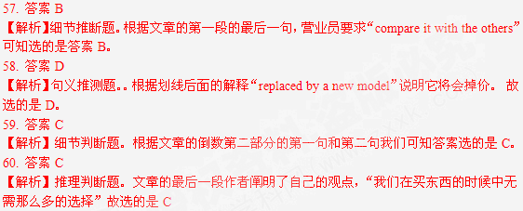第二节：Peter，Helen，Catherine，Elizabeth和Levin想根据各自在环保方面的兴趣(61—65)进行案例研究。阅读下面某杂志的专题报道摘要(A、B、C、D、E和F)，选出适合他们研究的最佳案例，并在答题纸上将相应选项的标号涂黑。选项中有一项是多余选项。
61. Peter: Reducing plastic and other wastes through DTY
62. Helen : Making use of the heavy traffic to produce electricity
63. Catherine: Building a community without private cars
64. Elizabeth: Building houses with recycled materials and energy-efficiency systems
65. Levin: Developing a new type of urban car which bums less gas
61.F【解析】F段讲的是通过自己动手做来减少塑料和废物的产生。和Peter的一致。
62. E【解析】E段利用拥挤的交通来发电。和Helen的一致。
63. A【解析】A段建立一个没有私家车的社会团体。和Catherin的一致。
65. C【解析】C段用能循环的材料和有效的能源来建房子。和Elixnbeth的一致。
65. D【解析】D段发展一种能节省燃烧气体的新型的城市车和Levin的一致。
A | B
Vauban  We know cars are terrible polluters, but would you give yours up? Vauban, a community in southwestem Germany, did just that, and its 5,000 citizens are doing fine. Most streets are free of vehicles, and there are generous green spaces and good public-transport links, including fast buses and bicycle paths. When,, people must drive, they can turn to car-sharing clubs. All the citizens had the chance to plan their own city," says Andreas Delleke, an energy expert, "and it's just how we wanted it to be. " | Denmark  During the period of gas shortage in the early, 70s, Denmark decided to become self-sufficient ( 自足). So they began a few projects making smart investments along the way.  On the island of Samsoe, local families, fishermen and farmers bought wind turbines (涡轮机],) to produce their own energy. Within seven years these turbines were completely paid for. And can you believe just one of wind turbines produces enough electricity for 600 households?
C | D
Trey Parker and Matt Stone  Trey Parker and Matt Stone, creators of South Park, have built a sustainable (可持续的) castle with outer siding and inner flooring of recycled wood, recycled carpeting, high-efficiency boiler systems.  "I think more and more today, people are willing to make a statement about the Earth and how they want to proteet it," Michael Rath, home designer and builder says. "For high-end homes in this valley, this is entirely consistent with what they cost. " | P-NUT  Who doesn't love the name P-NUT- short for Personal-Neo Urban Transport? It's Honda's latest attempt to create a tiny footprint for a new urban vehicle.  This little P-NUT is unique. With a central driving position, the car is designed to move in tight settings. The l 1-foot micro car will seat three with two rear-seat passengers behind the driver.  "The P-NUT conce, pt explores the packaging and design potential for a vehicle designed for the city lifestyle," said Dave Marek, a Honda design Spokesman.
E | F
Israel Company  Is it possible that annoying rash hour traffic could become a source of renewable energy?  Israel's Technion Institute of Technology claims that if we placed special generators ( 发电机 ) under roads, railways, and runways -- we could harvest enough energy to mass-produce electricity. A trial process has been used on a smaller scale, in dance clubs for instance, where the pounding feet of dancers light up the floor.  "We can produce electricity anywhere there is a busy road using energy that normally goes to waste," said Uri Amit, chairman of Israel's Technion . Institute Of Technology. | Coffee  Coffee. Some of us can't start our day without it, and we don't mind waiting 10 minutes in line for it.  Here is the most effective tip to make you a superstar in environment protection.  Get a coffee machine for your home or office, or persuade your company into buying one. ( Tell them it will improve productivity. ) Skip the coffee line on the way to work and make something that is better-tasting and much better for your wallet.  Plus, you Won't need those plastic cups or carrying cases that jnst get thrown away. Better yet, use your favorite travel mug.

非选择题部分(共40分)
第三部分：写作(共两节，满分40分)
第一节：短文改错(共10小题；每小题l分，满分l0分)
下面短文中有10处语言错误。请在有错误的地方增加、删除或修改某个单词。
增加：在缺词处加一个漏字符号(^)，并在其下面写上该加的词。删除：把多余的词用斜线(＼)划掉。
修改：在错的词下划一横线，并在该词下面写上修改后的词。注意：1．每处错误及其修改均仅限一词；
2．只允许修改l0处，多者(从第ll处起)不计分。
例如：
It was very nice to get your invitation to spend ∧ weekend with you. Luckily
the
I was completely free then, so I'll t0 say "yes". I'll arrive in Bristol at around 8 p. m. am
in Friday evening.
on
After shopping, Mother and I went to a restaurant for lunch". I notice Mother looking at a nearby table occupy by an elderly woman and young couple. They ate silently, and it was clearly that things were not going well. As we left, Mother stopped on their table. "Excuse me," she said, put her arm around the unhappy old woman. "You remind me so many of my mother. May I hug (拥抱) you?" The woman smiled happily as she accepted to it. Mter we left, I said, "That was
very nice of you, Mother. So I didn't think she looked like Grandma. " "Neither did me," said Mother cheerfully.
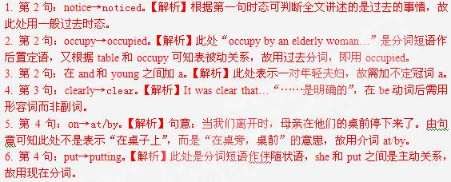7. 第5句：many→much。【解析】句意：你使我想起来很多关于我的母亲。此处表示泛指很多，故用so much修饰。
8. 第6句：划掉to。【解析】accept“接受”，是及物动词，后直接加宾语。
9. 第7句：So→ But。【解析】句意：妈妈，你真是太好了。但是我并不认为她像祖母。由句意可知此处表示转折关系，故用but。
10. 第8句：me→I。【解析】此处表示“我也这样认为”，表示情况和上句一样，且表示的是否定含义时，用“neither+助动词+主语”结构。
第二节：书面表达(满分30分)
最近，李越被评为你们班的“每周之星”。请你根据她的事迹(在上周六下午，不顾天气炎热，为班级选购歌咏比赛服装)，用英语为班级板报写一篇l00一120个词的短文。你的文章应包括下列要点：
1．李越的事迹及其对同学的影响； 2．你的评论。
注意：1．文章的标题和开头已给出(不计词数)。
2．参考词汇： singing contest 歌咏比赛
Costume 服装
Star Student of the Week
Li Yue has been awarded the title of "Star Student of the Week" for what she did for our class._________________________________________________________________________________________________________________________________________________________
【参考范文】
Star Student of the Week
Li Yue has been awarded the title of “Star Student of the Week” for what she did for our 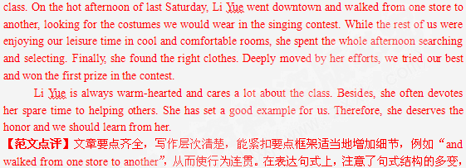以简单句为主，适当的运用并列句，还用到了限制性定语从句，如“we would wear in the singing contest”；在语法角度上，还用了非谓语动词作状语，如“ looking for the costumes...”“ Deeply moved by her efforts”； 同时还注重了连接过渡词及固定短语的使用，如“While”“devote … to ”等，从而显示出较强的语言运用能力。

英语参考题答案
第一部分
第一节（10分，每小题5分）
1. C 2. B 3. A 4. B 5. D 6. A 7. C
8. C 9. B 10. A 11. D 12. C 13. D 14. B
15. B 16. A 17. C 18. D 19. A 20. D
第二节(20分，每小题1分)
21. B 22. C 23. D 24. C 25. A 26. C 27. D 28. B 29. B 30. C 31. C 32. D 33. B 34. A 35. B 36. C 37. A 38. D 39. A 40. D
第二部分(50分,每小题2分)
41. D 42. B 43. C 44. D 45. D 46. C 47. B
48. A 49. A 50. B 51. A 52. B 53. C 54. B
55. D 56.A 57.B 58.D 59.C 60.C 61.F
62.E 63.A 64.C 65.D
第三部分
第一节(10分，每小题1分)
After shopping, Mother andI went to a restaurant for lunch. I notice Mother looking at a
noticed
nearby table occupy by an elderly woman and ∧ young couple. They ate silently, and it was clearly occupied a clear
that things were not going well. As we left, Mother stopped on their table. "Excuse me," she said,
by/at
put her arm around the unhappy old woman. "You remind me so many of my mother.
Putting much
May I hug (拥抱) you?" The woman smiled happily as she aocepted to it. After we left, I
＼
said, "That was very nice of you, Mother. So I didn't think she looked like Grandma. "
But
"Neither did me," said Mother cheerfully.
I
第二节(30分)
One possible student version
Star Student of the Week
Li Yue has been awarded the title of "Star Student of the Week" for what she did for our class. On the hot afternoon of last Saturday, Li Yue went downtown and walked from one store to another, looking for the costumes we would wear in the singing contest. While the rest of us were enjoying our leisure time in cool and comfortable rooms, she spent the whole afternoon searching and selecting. Finally, she found the right clothes. Deeply moved by her efforts, we tried our best and won the first prize in the contest.
Li Yue is always warm-hearted and cares a lot about the class. Besides, she often devotes her spare time to helping others. She has set a good example for us. Therefore, she deserves the honor and we should learn from her.

