衢州市2010年4月高三年级教学质量检测试卷
英 语
考生须知：
- 全卷分选择题（试卷I）、非选择（试卷II）和答题卷。考试结束后，将答题卡、答题卷上交。
- 试卷共12页，满分120分，考试时间 120分钟。
- 请将答案做在答题卡、答题卷的相应位置上，写在试卷上无效。

试卷 I
请用2B铅笔将答题卡上的准考证号和学科名称所对应的括号或方框涂黑，然后开始答题。
第一部分： 英语知识运用（共两节，满分30分）
- 单项填空（共20小题；每小题0.5分，满分10分）
从A、B、C、D四个选项中，选出可以填入空白处的最佳选项，并在答题卡上将该项涂黑。
1. —Excuse me, I don’t want to interrupt you but…
— .
A. You are welcome B. It’s okay C. I have no idea D. That’s right
2. Zhou Yang of China won women's 1500 meters short track speed skating gold medal at
Vancouver Olympic Winter Games on Saturday.
A. a ,the B. the ,the C. / ,the D. the ,/
3. flying is more expensive than land and sea travel, I went there by air to save time.
A. If B. As C. Even though D. In case
4. —What do you think of a bus tour in London?
—I think it would be great fun , but make sure you have a copy of the city’s travel with you .
A. check B. direction C. file D. brochure
5.Whenever he was asked why he was late for class, he would answer carefully, always the same thing.
A. saying B. said C. to say D. having said
6. I didn’t expect you to come so soon. How long did the journey ?
A. go B. cover C. make D. take
7. —I’m going to visit China next month.
— I wish I could go with you.
A. Congratulations! B. Sorry, I can’t go. C. Oh, how soon? D. Good for you!
8. The days are approaching the World Expo 2010 will be held in Shanghai.
A. that B. where C. when D. which
9. ideas and contents of the 60th national day, the great ceremony was very successful.
A. In terms of B. In favour of C. In charge of D. In memory of
10.—Did you make sense of what the man said just now?
—No, his meaning didn’t . Would you explain it to me?
A. get through B. get off C. get across D. get out
11. Next comes the question you want to put in the box?
A. that B. what C. where D. how
12. Mary control of herself while she about the traffic accident.
A. was losing; was asking B. lost; was being asked
C. has lost; was asked D. had lost; asked
13. —Hi, Johnson, any idea where Susan is ?
—It’s class time, so she in the classroom now.
A. can be B. must have been C. might have been D. must be
14. — I’m very busy now. Could I call you back after work?
— OK. I’ll wait for you.
A.Probably B. Occasionally C. Frequently D. Actually
15. Poverty is still killing people. , these small victories are a good start towards a better future.
A. Furthermore B. Therefore C. However D. Otherwise
16. — Where is your new home now?
—In the new developed zone. But I downtown for five years.
A. have lived B. had lived C. lived D. was living
17. It’s a pity that you leave so soon. It’s been so nice having you here.
A. should B. could C. can D. might
18.From the look on his face , I knew that the end had come, one way or .
A. another B. others C. other D. the others
19. You should write it in a style which is to your subject.
A. accurate B. attractive C. appropriate D. available
20.If you are unable to attend the interview, for reason, you should inform us immediately.
A. no matter what B. whatever
C. however D. no matter how
第二节：完形填空 （共20小题；每小题1分,满分20分）
阅读下面短文,掌握其大意,然后从21 – 40 各题所给的四个选项（A, B, C, 和D）中,选出最佳选项,并在答题纸上将该选项标号涂黑。
The Best Holiday
I was unbelievably proud of my nine-year-old daughter. Emily 21 to buy a mountain bike. she’d been saving her pocket money all year, 22 doing small jobs to earn extra money.
By Thanksgiving, she had collected only $49. I said, “ You 23 have your pick from my bicycle 24 .” “Thanks, Daddy. But your bikes are so old.” She was right. All my girls’ bikes were 1950s models, not the kind a kid today would 25 choose.
As Christmas 26 near, Emily and I went bike shopping. As we left one store, she 27 a Salvation Army volunteer standing next to a big pot. “Can we give something, Daddy ?” she asked. “Sorry, Em , I’m out of 28 .”
Throughout December, Emily continued to 29 hard. Then one day, she made a 30 announcement. “You know all the money I’ve been saving ?” she said hesitantly. “I’m going to give it to the poor people.” So one cold morning before Christmas, Emily handed her total savings of $ 58 to a volunteer who was really very 31 .
32 by Emily’s selflessness, I decided to contribute 33 of my old bicycles to a car dealer who was collecting used bikes for poor children. 34 I selected a shiny model from my collection, however, it seemed as if a second bike took on a glow(发光). Should I contribute two? No, one would be enough. But I couldn’t 35 the feeling that I should give a second bike. When I later 36 the bikes, the car dealer said, “You’re making two kids very 37 , sir. Here are your tickets. For each bicycle contributed, we’re 38 away one chance to win a girls’ mountain bike.”
Why wasn’t I surprised when that second ticket proved to be the 39 ? I like to think it was God’s way of 40 a little girl for a sacrifice beyond her years--- while giving her dad a lesson in the process.

21. A. promised | B. amazed | C. determined | D. organized
22. A.as well as | B. in addition | C. because of | D. except for
23. A. need | B. should | C. must | D. can
24. A. collection | B. contribution | C. shop | D. club
25. A. seldom | B. likely | C. slightly | D. merely
26. A. drew | B. became | C. went | D. pulled
27. A. observed | B. sensed | C. watched | D. noticed
28. A.charge | B. change | C. control | D. order
29. A.study | B.try | C. listen | D. work
30. A.disappointing disappointing | B. surprising | C. formal | D. public
31. A. agreeable | B. hopeful | C. thankful | D. pitiful
32. A. Moved | B. Shocked | C. Persuaded | D. Demanded
33. A. one | B. some | C. two | D. any
34. A. While | B. When | C. Because | D. Though
35. A. express | B. describe | C. explain | D. shake
36. A. returned | B. delivered | C. chose | D. shared
37. A. sweet | B. healthy | C. happy | D. fair
38. A. putting | B. giving | C. storing | D. signing
39. A. present | B. harvest | C. winner | D. chance
40. A. greeting | B. praising | C. sheltering | D. rewarding

第二部分 阅读理解（第一节20小题,第二节5小题；每小题2分,满分50分）
第一节 阅读下列短文,从每题所给的A、B、C、D四个选项中,选出最佳选项,并在答题卡上将该项涂黑。
A
Not long ago, I faced an enjoyable yet formidable(难以对付的) challenge. I was returning to my old neighborhood in the South Bronx to speak the students of my old school, Morris High. As we drove down streets where my friend Gene Norman and I used to race bicycles, I thought of the problems awaiting the kids living here, the drugs, the temptations, and the crime. What could I say to encourage them?
As we passed the hamburger place that I used to haunt, I remembered my growing-up years here, the joys, the sorrows, and the choices. Even then kids faced choices. There were drugs in my neighbourhood and a youngster could gain easy access to them if tempted. But in my family, the decision was simple: You just didn’t do it. We knew it was stupid and the most self-destructive thing you could do with the life God had given you.
At age of 17 I found a summer job in a local soft-drink bottling plant at 90 cents an hour. I was thrilled. On my first day of work, having joined the ranks of other newly hired teenagers, I was full of enthusiasm. The bottling machines caught my eye, but only the white boys worked there. I was hired as a porter and the foreman handed me a mop(拖把). I decided to be the best mop user there ever was. Right to left, left to right.
As our car rolled on, our driver’s voice broke my thought . “We are here, General.” I looked up at my old school; it hadn’t changed much. As I walked up its familiar stone steps I remembered racing up them to beat the bell. The setting for my talk to the student body was the gymnasium.
“I remember this place”, I told the students. “I remember it all. I remember running through Van Cortland Park with the track team, the victory I used to take each day from my home to Kelly Street to school.”
“I also remember, upon occasions, experiencing the feeling ‘you can’t make it’”, I continued. “But you can. When I was coming up, opportunities were limited. But now the opportunities are there to be anything you want to be. But wanting to be isn’t enough, dreaming about it isn’t enough. You’ve got to study for it, work for it, fight for it with all your heart energy and soul so that nothing will be denied you.
I wanted them to make the right choices, to work hard and not lose sight of a dream. And I wanted them to know that someone is always watching.
41.Why does the author say that he faced an enjoyable yet formidale challenge?Because__________
A.he was very much afraid of returning to his old neighborhood
B. his old neighborhood is problematic with drugs, temptation and crimes
C. he was going to make a speech to schoolboys and schoolgirls of Morris High
D. there are problems on the road his car was driven on and this worried him
42.The author thinks it was __________for kids to face choices when he was young.
A. very exciting B. only natural
C. very easy D. really a sad thing
43.According to the author, the stupid and the most self-destructive thing you could do with the life God
had given you is __________.
A. to get easy access to choices B. to hang around the hamburger place
C. to get addicted to drugs D. to resist the temptation of drugs
44.Which statement is TRUE according to the article?
A. The author went back to his old school as a general
B. The author was the best mop user there ever was
C. The author was very excited about his first job
D.The author believed that you can become anything you want

B
A special education teacher and former police officer was honored by President Barack Obama at the White House as the 2009 National Teacher of the Year for his innovative（创新的） approach, community focus, and teamwork with other teachers. “In a global economy where the greatest job qualification isn’t what you can do, but what you know, our teachers are the key to our nation’s success,”President Obama stated.
Mullen, a ninth-through twelfth-grade special education teacher at the ARCH School in
Connecticut,is the 59th National Teacher of the Year. Mullen's goal is to provide passion, professionalism(职业特质) ,and perseverance as an educator. “A teacher can receive no greater reward than the knowledge that he or she helped recover a lost student,” Mullen remarked. He will travel for one year as a full-time national and international spokesperson for education beginning June1,2009.
The National Teacher of the Year Program focuses public attention on teaching excellence and is the oldest and most famous national honors program for teachers. ‘ACEI is a proud participant in the selection process for the National Teacher of the Year, and we are pleased to see Anthony Mullen selected. Mr. Mullen is a dedicated individual who possesses a wealth of talents and skills as a teacher. His devotion to young people, however, reaches beyond the call of duty. Mr.Mullen extends himself to adviser and guides children who need to know that they are not forgotten and that they, too, are unique and special,” stated ACEI Executive Director Diane Whitehead.
ACEI is one of 15 national education organizations that select the National Teacher of the Year from among the state teachers of the year, including those representing the District of Columbia, the Department of Defense Education Activity,and five U. S. extra state departments.
45. What is the passage mainly about?
A. A White House ceremony.
B. An innovative teaching approach.
C. The 2009 National Teacher of the Year.
D. The national education organizations.
46. We can learn from the first paragraph Obama stresses __________.
A. teachers’ role B. community lives
C. teachers’ teamwork D. innovative approach
47. According to Mullen, his success as an educator lies in__________.
A. being a full-time national and international spokesperson
B. providing passion, perseverance and professionalism
C. helping those who can’t find their way home
D. helping the students achieve high scores
48. It can be inferred from the passage that __________.
A. the National Teacher of the Year Program hasn't been well-known
B. ACEI is the only organization in charge of selecting excellent teachers
C. Mullen is devoted to teaching the students for the call of duty
D. Mullen's success may be due to his previous work experience

C
World Footballer of the Year 2009
Football experts from the world have chosen Steven Gerrard, Lionel Messi, Cristiano Ronaldo, and Samuel Eto'o as the top footballers in the world. Now it's up to you to vote for the player you think is the king of World Football.
THE CANDIDATES
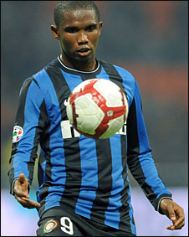
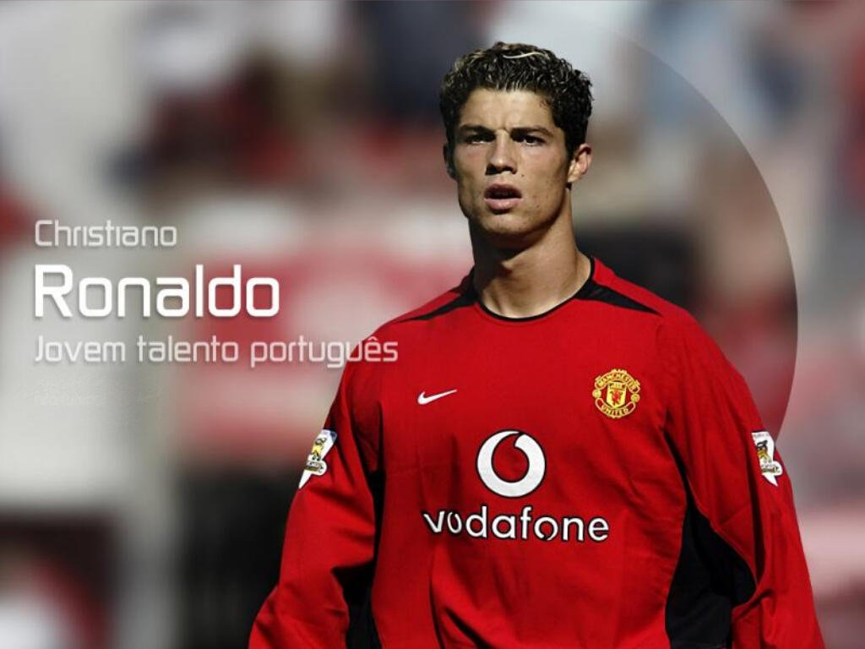
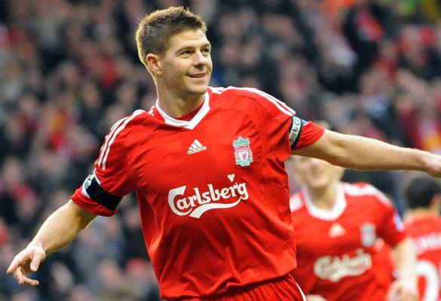
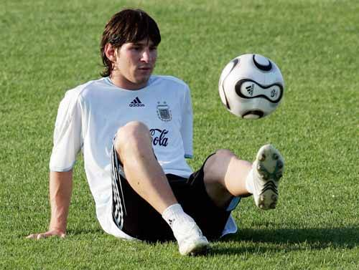
Samuel Eto'o
Eto'o ended the
2008-2009 season in
Spain with a record of
30 league goals in 36
games, as well as
another 6 in 12 games
in Europe as Barcelona famously won
both La Liga and the Champions League.
Cristiano Ronaldo
A Portuguese footballer plays for MU.
He plays primarily as
a right-winger. He has
also been used both in
a central attacking role
and as a second striker.
Steven Gerrard
The 28-year-old Anfield hero has scored 23 goals in all
competitions this
season, the best
record of his career,
and is leading
Liverpool’s
continuing challenge
to Premier League leaders Manchester United as the Reds bid to land their first league title for 19 years.

Lionel Messi
Messi is considered to be one of the best football players of his
generation, having
received several
Ballon d'Or and FIFA
World Player of the
Year nominations(提名)
by the age of 21. His playing style and ability have drawn comparisons to football legend Diego Maradona, who himself declared Messi his “successor”.

Vote Now
WHAT THE EXPERTS SAY
＊Why I'd vote for Gerrard
“Gerrard is clearly in his prime and quite rightly rated one of the finest midfield players of his generation.” says Steve Bates, chairman of the FWA.
＊Why I'd vote for Cristiano Ronaldo
Johan Cruyff points out Ronaldo is better than George Best and Denis Law, who were two brilliant and great players in the history of United.
＊Why I'd vote for Samuel Eto'o
Piers Edwards thinks the title of World footballer should go to Samuel Eto'o.
＊Why I'd vote for Messi
Messi’s individual brilliance and year-long persistence has impressed Diego Maradona.
49. The passage is mainly intended to __________.
A. invite readers to vote for the World Footballer of 2009
B. predict the results of the vote of the World Footballer of 2009
C. tell the outstanding performance of the candidates of the World Footballer of 2009
D. share with readers the experts’ opinions on the candidates of World Footballer of 2009
50.Which of the following descriptions about the footballers is RIGHT?
A. Ronaldo has primarily played as a second attacker.
B. Eto'o scored 42 goals in the 2008-2009 season altogether.
C. Diego Maradona believed that Messi could never match him in playing style.
D. Gerrard plays an important role in Liverpool’s challenge to Premier League leaders.
51. We can learn from the passage that Ballon d'Or is __________.
A. an activity about football B. an organization of football
C. a title for excellent footballers D. a team name of football
52. Diego Maradona is more likely to vote___________ to be the World Footballer of the Year.
A. Lionel Messi B. Cristiano Ronaldo
C. Samuel Eto'o D. Steven Gerrard

D
COPENHAGEN—The world is gathered in Copenhagen for the U.N. climate summit, but Denmark’s bicycle-friendly capital has also given its name to a movement of cities trying to find a kinder way to travel to and from work.
Nearly 40 percent of Copenhagen’s population cycle to work or school on ubiquitous（无处不在的） paved cycle paths. Many residents take to their bikes year-round, braving rain and snow through the winter in a city where the bicycles outnumber the people.
Amsterdam and Beijing too are known for their bicycles, but the Danish capital is where urban planners from around the world have been looking for ways to get their people out of cars and up onto bikes, an effort known as Copenhagenisation.
Klaus Bondam, Copenhagen’s technical and environmental chief, calls himself a “mega cyclist” and says the bike’s popularity stems partly from high taxes on cars which meant working-class Danes could not afford to drive in the 1930s and 1940s. “Today you’ll meet everybody on the bicycle lanes — women and men, rich and poor, old and young.” Bondam said.
The local government has during the last three years invested more than 250 million crowns ($49.42 million) in bicycle lanes and to make the traffic safer for bicyclists. Today around a third of the population drive cars to work or study, another third take public transport, while 37 percent cycle -- a figure the city aims to increase to 50 percent by 2015.
There are many benefits when citizens choose bicycles over cars: pollution and noise decline, public health improves, and more people on bikes or walking creates a sense of safety in the city. Fewer parked cars leaves more space for playgrounds, parks, shopping areas and other useful public places.
53. According to the first paragraph, Copenhagen is better known as ___________.
A. a city without cars B. a bicycle-friendly city
C. Denmark’s capital D. the U.N. climate summit
54. We can learn from the second and the third paragraph, __________.
A. there is no path for cars during rainy and snowy days
B. citizens are limited to have only one bike for each person
C. two-thirds of people in Copenhagen cycle to work or school
D. city planners try their best to encourage more citizens to ride bikes
55. Bikes are popular in Copenhagen partly because ___________.
A. the citizens are unable to afford to buy a car
B. the rich tend to keep fit by cycling to work
C. young people regard cycling a fashion to follow
D. high taxes were paid for cars in the 1930s and 1940s
56. We can learn from the passage that __________.
A. cars are forbidden to park in Copenhagen
B. more citizens tend to choose cars in Copenhagen
C. Copenhagen becomes a model for cities’ traffic
D. living standards in Copenhagen are greatly declining

E
When an ant dies, other ants take it out of the nest, often within an hour after its death. This behavior interests scientists and they wonder how ants know for sure—and so soon—that another ant is dead.
One scientist recently came up with a way to explain this ant behaviour. Dong-Hwan Choe is a biologist, a scientist who studies animals and plants. He found that ants have a chemical on the outside of their bodies that signals to other ants, “I'm dead—take me away” when it is dead.
But there's a question to answer: As we know, if an ant is dead, it stops moving. But when an ant is sleeping or knocked unconscious, it is also not moving. However, other ants don't move the living ant out of the nest. How do they know this ant is not dead? Choe found that ants have another chemical on their bodies, which tells nearby ants something like, “Wait—I'm not dead yet”when it is not dead. Choe suspects that when an ant dies, the chemical that says, “Wait I'm not dead yet”quickly goes away. When other ants detect the“dead”chemical without the“not dead yet”chemical, they move away the body.
To test his theory , Choe and his team put different chemicals on ants. When the scientists used the “I'm dead” chemical, other ants quickly moved the treated ant away. When the scientists used the“Wait—I'm not dead yet”chemical, other ants left the treated ant alone. Choe believes this behavior shows that the“not dead yet”chemical overrides the“dead” chemical when picked up by other ants. And that when an ant dies, the “not dead yet” chemical fades away. Other nearby ants then detect the remaining“dead”chemical and remove the body from the nest.
Understanding this behavior can help scientists figure out how to stop ants from invading new places and causing problems.
57. What is the function of the first paragraph?
A. Leading the following paragraphs.
B. Showing the main idea of the passage.
C. Introducing the background of the passage.
D. Giving a summary of the passage.
58. Which of the following has the closest meaning to the underlined word “overrides” in the fourth paragraph?
A.is weaker than B. is stronger than C. is better than D. is worse than
59. What can we learn from the passage?
A. Living ants can also be taken away when they are not moving.
B. When an ant dies, it can tell others using a certain chemical.
C. A living ant can pretend to be dead using a special chemical.
D. Ants often use chemicals to communicate with each other.
60. Which of the following descriptions about Dong-Hwan Choe is right?
A. Choe did this study in order to stop ants from invading new places.
B. Choe is a biologist who is only interested in animals, especially in ants.
C. Choe first came up with an idea to explain this ant behavior，and then did some tests to prove his theory.
D. Choe did the research on this ant behavior on his own

第二节 阅读下列材料,从所给的六个选项（A、B、C、D和E）中,选出符合各小题要求的最佳选项,并在答题卡上将该项涂黑。
Li Hua has just come back from the US and intends to give some of his relatives mentioned in 61-65 some DVDs as gifts．He brings back six DVDs（A-F）．After the description of each person, decide which DVD is the most suitable one for the people．There is one extra DVD, which you do not need to use．
_______61．Li Hua’s Grandfather is a fan of Jules Verne, the father of modern science fiction．He dreamed to be a hero and save people in trouble when he was young．Although he is old now, he will not miss a good science fiction movie．
_______62．Li Hua’s mother works in a primary school as an English teacher．She thought English learning should be interesting, and she often puts on some English movies in class, so students can not only learn the language but history and culture．Of course the language in the movie will not be difficult and it will be better if there is a beautiful English song in it．
_______63．Li Hua’s father is a history professor in a college．He is especially interested in the history of some foreign countries such as Egypt, Germany and the UK．Now he is preparing a lecture about the history of the UK and needs some materials．
_______64．Li Hua’s elder sister loves reading love stories ever since she was a middle school student．Now, she has just fallen in love with a good guy．They both love seeing good films, and now, of course, a film about love is their favorite．
_______65．Li Hua’s elder brother is a history lover under his father’s influence．He was fond of movies about wars in history．He has seen many movies about people struggling in Japanese or Nazis’ prisons, and he would like to see something different．
A．The League of Extraordinary Gentlemen
A hunter, a scientist, a vampire, an invisible man, an immortal, a spy, a beast…When a masked madman known as “The Fantom（幽灵）” tries to control the world, great adventurer Allan Quatermain sets up a team of superheroes, the likes of which mankind has never seen．Now, despite fighting their own personal demons and each other, they must join forces to save the world．
B．The Prince of Egypt
This cartoon movie attracted audiences the world over with its fantastic artistry, timeless story and powerful music．This masterpiece became one of the top animated films of all time．The extraordinary tale of two brothers---one born of royal blood, one an orphan with a secret past---is brought to life as never before, with unforgettable characters voiced by many stars．One of the two brothers becomes the ruler of the most powerful empire on earth, the other the chosen leader of his people．What they do will forever change their lives---and the world．
C．As Far As My Feet Will Carry Me
Based on the true story of Josef Martin Bauer’s best-selling novel, this powerful movie tells us the unbelievable journey of German soldier Clemens Forell in his dramatic escape from a Siberian（西伯利亚的） labor camp after World War II．Through the bitter cold of winter, deserted landscapes, and life－threatening adventures, Forell who was determined to return to his family makes his way, step by step, day by day, towards Persia and freedom．14,000 and 3 endless years of uncertainty later, he is finally about to reach his destination．
D．Braveheart
This Academy Award winning film, directed by Mel Gibson, tells the story of the great thirteenth century Scottish hero William Wallace, known to his countrymen as Braveheart．Gibson stars as Wallace, who leads the Scots to fight against the cruel English king Edward I after he suffers a personal tragedy at the hands of English soldiers．Willing to fight to the death for Scotland’s freedom, Wallace and his companions, whose faith in freedom is stronger than any English army, fight bravely with their enemy．
E．The wedding Planner
Mary Fiore is the wedding planner．She’s ambitious, hard-working, extremely organized, and she knows exactly what to do and say to make any wedding a fantastic event．But when Mary falls in love with a handsome doctor, her life is turned upside down---he’s the groom in the biggest wedding of her career! Will she help him marry his rich girlfriend, or will Mary finally get to be the bride herself? As this sweet romantic comedy proves, when it comes to love, you can never plan what’s going to happen．
F．Agent Cody
Frankie Muniz and Hilary Duff star in this “clever and lively action-adventure”（Los Angeles Times） about a junior CIA agent on a mission to save the world, stop the bad guys and win the girl’s heart…Catching your eye with cool tools, exciting special effects and the wonderful skateboard chase, Agent Cody Banks delivers great fun for the entire family．
试卷II
第三部分 写作（共两节,满分40分）
第一节 短文改错（共10小题；每小题1分,满分10分）
下面短文中有10处语言错误。请在有错误的地方增加、删除或修改某个单词。
增加：在缺词处加一个漏洞符号（/\）,并在其下面写上该加的词。
删除：把多余的词用斜线（\）划掉。
修改：在错的词下划一横线,并在该词下面写上修改后的词。
注意：1. 每处错误及其修改均仅限一词；
2. 只允许修改10处,多者（从第11处起）不计分。

例如：
It was very nice to get your invitation to spend ∧ weekend with you. Luckily I was completely
the am
free then, so I’ll to say “yes”. I’ll arrive in Bristol at around 8 p.m. in Friday evening.
on
Senior three student will face the question after they pass by the college entrance examination. Should I choose a good major and a good university ? Some students prefer to consider majors first so that they can learn what they are interested . It will also make it possibly for them to take their favorite jobs in the future. However, those who think differently believes that the environment is important to one’s development. They also believe that students graduate from leading universities are often more likely to find a good job. In my opinion , the best choice is to choose a good major at a good university. But if we can obtain both, the first thing to consider is a good major, because no matter where we study, they can still achieve a lot in the certain field if we try our best.

第二节 书面表达（满分30分）
下面的图表显示了某校高三学生周末放假的学习生活情况。
Ways to spend the weekend

根据上图信息，请以 “Ways to spend the weekend” 为题，用英语写一篇100—120个词的短文。 要求如下：
1. 简要描述图中的信息；
- 说明原因 （为了高效学习；锻炼身体；争分夺秒……）;
- 谈谈你的看法。
注意：文章标题和开头已给出（不计词数）

Ways to spend the weekend

As can be seen from the chart, __
______________________________________________________________________________________________________________________________________________________________________________________________________________________________________________________________________________________________________________________________________________________________________________________________________________________________________________________________________________________________________________________________________________________________________________________________________________________________________________________________________________________________________________________________________________________________________________________________________________________________________

衢州市2010年4月高三年级教学质量检测
英语参考答案

第一部分： 英语知识运用
第一节：单项选择（共20小题，每小题0.5分，满分10分）
1-5 BBCDA 6-10 DDCAC 11-15 BBDDC 16-20 CAACB
第二节：完形填空（共20小题，每小题1分，满分20分）
21—25 CADAB 26—30ADBDB 31—35 CAABD 36—40 BCBCD
第二部分：阅读理解（共25小题，每小题2分，满分50分）
41—44 CDCA 45-48 CABD 49-52 ADCA 53-56 BDDC 57-60 ABBC
61-65 ABDEC
第三部分：写作（共两节，满分40分）
第一节：短文改错（共10小题；每小题1分，满分10分）
Senior three student will face the question after they pass by the college entrance examination.
students
Should I choose a good major and a good university ? Some students prefer to consider majors first
or
so that they can learn what they are interested ∧. It will also make it possibly for them to take
in possible
their favorite jobs in the future. However, those who think differently believes that the
believe
environment is important to one’s development. They also believe that students graduate from
graduating或graduate前加who
leading universities are often more likely to find a good job. In my opinion , the best choice is to

choose a good major at a good university. But if we can obtain both, the first thing to consider is a
can’t 或后加not
good major, because no matter where we study, they can still achieve a lot in the certain field if
we a
we try our best.

第二节：书面表达（30分）
Ways to spend the weekend
As can be seen from the chart, senior three students have different ways to spend their weekends. Going back home and having a good rest is what most students would like to do, while 25% students choose to study at school during weekends. The least studnts , accounting for 15% , take outdoor activities to spend their weekends.
Various reasons are responsible for their different choices. Those who choose to go back home believe that a good rest does help them relax and work more efficiently during the school time. Outdoor-activity lovers hold the opinoin that taking exercise is a wonderful way to refresh themselves. However, a small number of students living far away from home tend to stay at school to save every minute to study.
Personally, despite the heavy study pressure, senior three year doesn’t necessarily mean studying all the time. Sometimes a good rest and proper exercise can be of vital importance.

