2009年普通高等学校夏季招生考试（北京卷）
英语
第Ⅰ卷(选择题 共115分)
第一部分：听力理解(共两节，30分)
第一节(共5小题；每小题1.5分，共7.5分)
听下面5段对话。每段对话后有一道小题，从每题所给的A、B、C三个选项中选出最佳选项。听完每段对话后，你将有10秒钟的时间来回答有关小题和阅读下一小题。每段对话你将听一遍。
例：What is the man going to read?
A．A newspaper.
B．A magazine.
C．A book.
答案是A。
1．How fast can the woman type?
A．15 words a minute.
B．45 words a minute.
C．80 words a minute.
2．Which program does the man like most?
A．Sports. B．History. C．News.
3．Which language does Mr.White speak well?
A．French. B．Spanish. C．Japanese.
4．What was in the woman's missing bag?
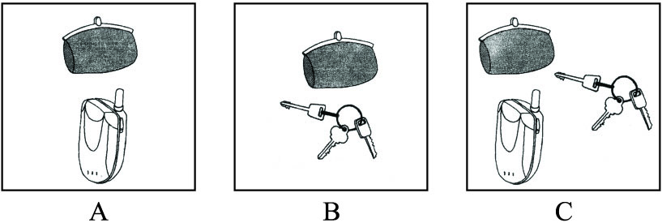
5．Where does the conversation probably take place?
A．In a classroom.
B．In a library.
C．In a bookstore.

第二节(共15小题；每小题1.5分，共22.5分)
听下面6段对话或独白。每段对话或独白后有几道小题，从每题所给的A、B、C三个选项中选出最佳选项。听每段对话或独白前，你将有5秒钟的时间阅读每小题。听完后，每小题将给出5秒钟的做答时间。每段对话或独白你将听两遍。
听第6段材料，回答第6至7题。
6．What's wrong with the man?
A．He has headaches.
B．He has a runny nose.
C．He has a temperature.
7．When did the problem begin?
A．Two weeks ago.
B．Two months ago.
C．Three months ago.

听第7段材料，回答第8至9题。
8．Why did the woman make the phone call?
A．To change her appointment.
B．To discuss a business plan.
C．To arrange an exhibition.
9．When are they going to meet?
A．Wednesday. B．Thursday. C．Friday.

听第8段材料，回答第10至11题。
10．What event will you take part in if you love to dance?
A．River Festival.
B．Youth Celebrations.
C．Songs of Summer.
11．What is the purpose of the announcement?
A．To introduce performers.
B．To introduce a program.
C．To introduce various countries.

听第9段材料，回答第12至14题。
12．How much are the double rooms?
A．From $180 to $240.
B．From $180 to $270.
C．From $270 to $330.
13．What is included in the price?
A．Service charge.
B．Breakfast.
C．Tax.
14．Why did the man make the phone call?
A．To ask for an extra bed.
C．To check the room rates.
C．To change his reservation.

听第10段材料，回答第15至17题。
15．What are the speakers talking about?
A．Picture books.
B．Reference books.
C．Cookbooks.
16．How much is Worldwide Fish?
A．￡12. B．￡15. C．￡17.
17．Which book does the woman decide to buy?
A．Something Fishy.
B．Worldwide Fish.
C．Tasty Fish.

听第11段材料，回答第18至20题。
18．What did Maria do right after graduation?
A．She entered politics.
B．She worked as a teacher.
C．She worked for her father.
19．Where did Maria set up her first coffee bar?
A．London.
B．Singapore.
C．New York.
20．How many coffee bars does she have now?
A．10. B．80. C．85.

第二部分：知识运用(共两节，45分)
第一节 单项填空(共15小题；每小题1分，共15分)
从每题所给的A、B、C、D四个选项中，选出可以填入空白处的最佳选项，并在答题卡上将该项涂黑。
例：It's so nice to hear from her again.______，we last met more than thirty years ago.
A．What's more B．That's to say
C．In other words D．Believe it or not
答案是D。
21．(2009北京，21)John plays basketball well，______ his favorite sport is badminton.
A．so B．or C．yet D．for
答案：C

22．(2009北京，22)You may use the room as you like______ you clean it up afterwards.
A．so far as B．so long as
C．in case D．even if
答案：B
23．(2009北京，23)Scientists have many theories about how the universe ______ into being.
A．came B．was coming
C．had come D．would come
答案：A
24．(2009北京，24)For breakfast he only drinks juice from fresh fruit______ on his own farm.
A．grown B．being grown
C．to be grown D．to grow
答案：A
25．(2009北京，25)One of the few things you ______ say about English people with certainty is that they talk a lot about the weather.
A．need B．must C．should D．can
答案：D
26．(2009北京，26)—What do you think of teaching，Bob?
—I find it fun and challenging.It is a job ______ you are doing something serious but interesting.
A．where B．which C．when D．that
答案：A
27．(2009北京，27)The way the guests ______ in the hotel influenced their evaluation of the service.
A．treated B．were treated
C．would treat D．would be treated
答案：B
28．(2009北京，28)All of them try to use the power of the workstation ______ information in a more effective way.
A．presenting B．presented
C being presented D．to present
答案：D
29．(2009北京，29)The wine industry in the area has developed in a special way，______little foreign ownership.
A．by B．of C．with D．from
答案：C
30．(2009北京，30)When I talked with my grandma on the phone，she sounded weak，but by the time we ______up，her voice had been full of life.
A．were hanging B．had hung
C．hung D．would hang
答案：C
31．(2009北京，31)At first he hated the new job but decided to give himself a few months to see______ it got any better.
A．when B．how C．why D．if
答案：D
32．(2009北京，32)John was given the same suitcase his father and grandfather ______ with them to school.
A．took B．had taken
C．were taking D．would take
答案：B
33．(2009北京，33)The biggest whale is ______ blue whale，which grows to be about 29 meters long—the height of ______ 9story building.
A．the；the B．a；a
C．a；the D．the；a
答案：D
34．(2009北京，34)______ twice，the postman refused to deliver our letters unless we chained our dog.
A．Being bitten B．Bitten
C．Having bitten D．To be bitten
答案：B
35．(2009北京，35)Being a parent is not always easy，and being the parent of a child with special needs often carries with______ extra stress.
A．it B．them C．one D．him
答案：A

第二节 完形填空(共20小题；每小题1.5分，共30分)
阅读下面短文，掌握其大意，从每题所给的A、B、C、D四个选项中，选出最佳选项，并在答题卡上将该项涂黑。
James's New Bicycle
James shook his money box again.Nothing！He carefully __36__the coins that lay on the bed.$24.52 was all that he had.The bicycle he wanted was at least $90！__37__on earth was he going to get the __38__ of the money?
He knew that his friends all had bicycles.It was __39__ to hang around with people when you were the only one without wheels.He thought about what he could do.There was no __40__ asking his parents，for he knew they had no money to __41__.
There was only one way to get money，and that was to __42__it.He would have to find a jod.__43__who would hire him and what could he do？He decided to ask Mr.Clay for advice，who usually had__44__ on most things.
“Well，you can start right here，”said Mr.Clay.“My windows need cleaning and my car needs washing.”
That was the __45__ of James's oddjob(零工) business.For three months he worked every day after finishing his homework.He was amazed by the__46__ of jobs that people found for him to do.He took dogs and babies for walks，cleared out cupboards，and mended books.He lost count of the__47__ of cars he washed and windows he cleaned，but the __48__ increased and he knew that he would soon have__49__for the bicycle he longed for.
The day __50__came when James counted his money and found $94.32.He__51__ no time and went down to the shop to pick up the bicycle he wanted.He rode__52__ home，looking forward to showing his new bicycle to his friends.It had been hard __53__ for the money，but James knew that he valued his bicycle far more __54__ he had bought it with his own money.He had __55__ what he thought was impossible，and that was worth even more than the bicycle.
36．A.cleaned B．covered C．counted D．checked
答案：C
37．A.How B．Why C．Who D．What
答案：A
38．A.amount B．part C．sum D．rest
答案：D
39．A.brave B．hard C．smart D．unfair
答案：B
40．A.point B．reason C．result D．right
答案：A
41．A.split B．spend C．spare D．save
答案：C
解析：句意参考40题。split“分开；裂开”；spend“花费”；save“节省”；spare“提供(时间、钱等)；拨出；匀出”。
42．A.borrow B．earn C．raise D．collect
答案：B
43．A.Or B．So C．For D．But
答案：D
44．A.decisions B．experience
C．opinions D．knowledge
答案：C
45．A.beginning B．introduction
C．requirement D．opening
答案：A
46．A.similarity B．quality
C．suitability D．variety
答案：D
47．A.brand B．number C．size D．type
答案：B
48．A.effort B．pressure C．money D．trouble
答案：C
49．A.all B．enough C．much D．some
答案：B
50．A.finally B．instantly
C．normally D．regularly
答案：A
51．A.gave B．left C．took D．wasted
答案：D
52．A.patiently B．proudly
C．silently D．tiredly
答案：B
53．A.applying B．asking
C．looking D．working
答案：D
54．A.since B．if C．than D．though
答案：A
55．A.deserved B．benefited
C．achieved D．learned
答案：C

第三部分：阅读理解(共20小题；每小题2分，共40分)
阅读下列短文，从每题所给的A、B、C、D四个选项中，选出最佳选项，并在答案卡上将该项涂黑。
A
How I Turned to Be Optimistic
I began to grow up that winter night when my parents and I were returning from my aunt's house，and my mother said that we might soon be leaving for America.We were on the bus then.I was crying，and some people on the bus were turning around to look at me.I remember that I could not bear the thought of never hearing again the radio program for school children to which I listened every morning.
I do not remember myself crying for this reason again.In fact，I think I cried very little when I was saying goodbye to my friends and relatives.When we were leaving I thought about all the places I was going to see—the strange and magical places I had known only from books and pictures.The country I was leaving never to come back was hardly in my head then.
The four years that followed taught me the importance of optimism，but the idea did not come to me at once.For the first two years in New York I was really lost—having to study in three schools as a result of family moves.I did not quite know what I was or what I should be.Mother remarried，and things became even more complex for me.Some time passed before my stepfather and I got used to each other.I was often sad，and saw no end to “the hard times.”
My responsibilities in the family increased a lot since I knew English better than everyone else at home.I wrote letters，filled out forms，translated at interviews with Immigration officers，took my grandparents to the doctor and translated there，and even discussed telephone bills with company representatives.
From my experiences I have learned one important rule：almost all common troubles eventually go away！Something good is certain to happen in the end when you do not give up，and just wait a little！I believe that my life will turn out all right，even though it will not be that easy.
56．How did the author get to know America?
A．From her relatives.
B．From her mother.
C．From books and pictures.
D．From radio programs.
答案：C
57．Upon leaving for America the author felt ______.
A．confused B．excited
C．worried D．amazed
答案：B
58．For the first two years in New York，the author______.
A．often lost her way
B．did not think about her future
C．studied in three different schools
D．got on well with her stepfather
答案：C
59．What can we learn about the author from Paragraph 4?
A．She worked as a translator.
B．She attended a lot of job interviews.
C．She paid telephone bills for her family.
D．She helped her family with her English.
答案：D
60．The author believes that______.
A．her future will be free from troubles
B．it is difficult to learn to become patient
C．there are more good things than bad things
D．good things will happen if one keeps trying
答案：D

B
Dear Friend，
The recent success of children's books has made the general public aware that there's a huge market out there.
And there's a growing need for new writers trained to create the $3 billion worth of children's books bought each year...plus stories and articles needed by over 650 publishers of magazines for children and teenagers.
Who are these needed writers？They're ordinary folks like you and me.
But am I good enough?
I was once where you might be now.My thoughts of writing had been pushed down by selfdoubt，and I didn't know where to turn for help.
Then，I accepted a free offer from the Institute to test my writing aptitude(潜能)，and it turned out to be the inspiration I needed.
The promise that paid off
The Institute made the same promise to me that they will make to you，if you show basic writing ability：
You will complete at least one manuscript(手稿)suitable to hand in to a publisher by the time you finish our course.
I really didn't expect any publication before I finished the course，but that happened.I sold three stories.And I soon discovered that was not unusual at the Institute.
Since graduation，I have authored 34 nationally published children's books and over 300 stories and articles.
Free test and brochure
We offer a free aptitude test and will send you a copy of our brochure describing our recognized homestudy courses on the basis of oneonone training.
Realize your writing dream today.There's nothing sadder than a dream delayed until it fades forever.
Sincerely，
Kristi
Kristi Holl，Instructor
Institute of Children's Literature
61．From the first three paragraphs，we learn that ______.
A．children's books are usually bestsellers
B．publishers are making $3 billion each year
C．magazines for teenagers have drawn public attention
D．there is a growing need for writers of children's books
答案：D
62．When finishing the course，you are promised to ______.
A．be a successful publisher
B．become a confident editor
C．finish one work for publication
D．get one story or article published
答案：C
63．Kristi Holl mentions her experience mainly to______.
A．prove she is a good instructor
B．promote the writing program
C．give her advice on course preparation
D．show she sold more stories than articles
答案：B

C
How Room Designs Affect Our Work and Feelings
Architects have long had the feeling that the places we live in can affect our thoughts，feelings and behaviors.But now scientists are giving this feeling an empirical(经验的，实证的)basis.They are discovering how to design spaces that promote creativity，keep people focused，and lead to relaxation.
Researches show that aspects of the physical environment can influence creativity.In 2007，Joan MeyersLevy at the University of Minnesota，reported that the height of a room's ceiling affects how people think.Her research indicates that higher ceilings encourage people to think more freely，which may lead them to make more abstract connections.Low ceilings，on the other hand，may inspire a more detailed outlook.
In addition to ceiling height，the view afforded by a building may influence an occupant's ability to concentrate.Nancy Wells and her colleagues at Cornell University found in their study that kids who experienced the greatest increase in greenness as a result of a family move made the most gains on a standard test of attention.
Using nature to improve focus of attention ought to pay off academically，and it seems to，according to a study led by C．Kenneth Tanner，head of the School Design & Planning Laboratory at the University of Georgia.Tanner and his team found that students in classrooms with unblocked views of at least 50 feet outside the window had higher scores on tests of vocabulary，language arts and maths than did students whose classrooms primarily overlooked roads and parking lots.
Recent study on room lighting design suggests that dim (暗淡的) light helps people to loosen up.If that is true generally，keeping the light low during dinner or at parties could increase relaxation.Researchers of Harvard Medical School also discovered that furniture with rounded edges could help visitors relax.
So far scientists have focused mainly on public buildings.“We have a very limited number of studies，so we're_almost_looking_at_the_problem_through_a_straw_(吸管)，” architect David Allison says.“How do you take answers to very specific questions and make broad，generalized use of them？That's what we're all struggling with.”
64．What does Joan MeyersLevy focus on in her research?
A．Light. B．Ceilings.
C．Windows. D．Furniture.
答案：B
65．The passage tells us that______.
A．the shape of furniture may affect people's feelings
B．lower ceilings may help improve students' creativity
C．children in a dim classroom may improve their grades
D．students in rooms with unblocked views may feel relaxed
答案：A
66．The underlined sentence in the last paragraph probably means that______.
A．the problem is not approached step by step
B．the researches so far have faults in themselves
C．the problem is too difficult for researchers to detect
D．research in this area is not enough to make generalized patterns
答案：D
67．Which of the following shows the organization of the passage?
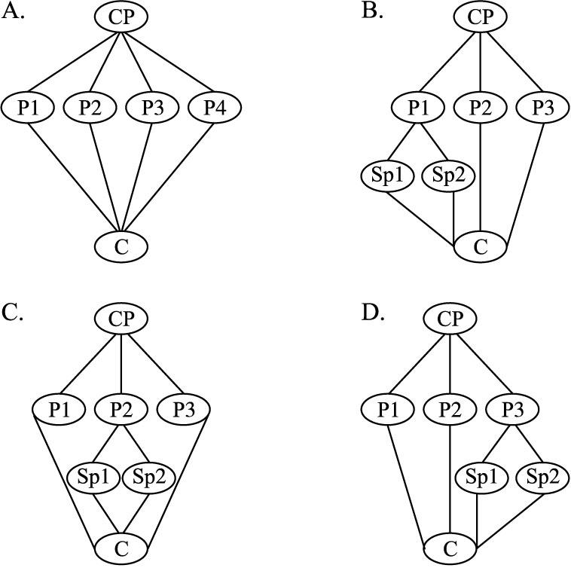
CP ：Central Point P：Point SP：Subpoint(次要点) C：Conclusion
答案：C

D
When students and parents are asked to rate subjects according to their importance，the arts are unavoidably at the bottom of the list Music is nice，people seem to say，but not important.Too often it is viewed as mere entertainment，but certainly not an education priority(优先)．This view is shortsighted.In fact，music education is beneficial and important for all students.
Music tells us who we are.Because music is an expression of the beings who create it，it reflects their thinking and values，as well as the social environment it came from.Rock music represents a lifestyle just as surely as does a Schubert song.The jazz influence that George Gershwin and other musicians introduced into their music is obviously American because it came from American musical traditions.Music expresses our character and values.It gives us identity as a society.
Music provides a kind of perception(感知)that cannot be acquired any other way.Science can explain how the sun rises and sets.The arts explore the emotive(情感的)meaning of the same phenomenon.We need every possible way to discover and respond to our world for one simple but powerful reason：No one way can get it all.
The arts are forms of thought as powerful in what they communicate as mathematical and scientific symbols.They are ways we human beings “talk” to each other.They are the language of civilization through which we express our fears，our curiosities，our hungers，our discoveries，our hopes.The arts are ways we give form to our ideas and imagination so that they can be shared with others.When we do not give children access to an important way of expressing themselves such as music，we take away from them the meanings that music expresses.
Science and technology do not tell us what it means to be human.The arts do.Music is an important way we express human suffering，celebration，the meaning and value of peace and love.
So music education is far more necessary than people seem to realize.
68．According to Paragraph 1，students______.
A．regard music as a way of entertainment
B．disagree with their parents on education
C．view music as an overlooked subject
D．prefer the arts to science
答案：A
69．In Paragraph 2，the author uses jazz as an example to ______.
A．compare it with rock music
B．show music identifies a society
C．introduce American musical traditions
D．prove music influences people's lifestyles
答案：B
70．According to the passage，the arts and science ______.
A．approach the world from different angles
B．explore different phenomena of the world
C．express people's feelings in different ways
D．explain what it means to be human differently
答案：A
71．What is the main idea of the passage?
A．Music education deserves more attention.
B．Music should be of top education priority.
C．Music is an effective communication tool.
D．Music education makes students more imaginative.
答案：A

E
Camping wild is a wonderful way to experience the natural world and，at its best，it makes little environmental influence.But with increasing numbers of people wanting to escape into the wilderness，it is becoming more and more important to camp unobtrusively(不引人注目地) and leave no mark.
Wild camping is not permitted in many places，particularly in crowded lowland Britain.Wherever you are，find out about organizations responsible for managing wild spaces，and contact them to find out their policy on camping and shelter building.For example，it is fine to camp wild in remote parts of Scotland，but in England you must ask the landowner's permission，except in national parks.
Camping is about having relaxation，sleeping outdoors，experiencing bad weather，and making do without modern conveniences.A busy，fullyequipped campsite (野营地) seems to go against this，so seek out smaller，more remote places with easy access to open spaces and perhaps beaches.Better still，find a campsite with no road access：walking in makes a real adventure.
Finding the right spot to camp is the first step to guaranteeing a good night's sleep.Choose a campsite with privacy and minimum influence on others and the environment.Try to use an area where people have obviously camped before rather than creating a new spot.When camping in woodland，avoid standing dead trees，which may fall on a windy night.Avoid animal runs and caves，and possible homes of biting insects.Make sure you have most protection on the windward side.If you make a fire，do so downwind of your shelter.Always consider what influence you might have on the natural world.Avoid damaging plants.A good campsite is found，not made—changing it should be unnecessary.
72．You needn't ask for permission when camping in ______.
A．national parks in England
B．most parts of Scotland
C．crowded lowland Britain
D．most parts of England
答案：A
73．The author thinks that a good campsite is one______.
A．with easy access
B．used previously
C．with modern conveniences
D．far away from beaches
答案：B
74．The last paragraph mainly deals with ______.
A．protecting animals
B．building a campfire
C．camping in woodland
D．finding a campsite with privacy
答案：C
75．The passage is mainly about______.
A．the protection of campsites
B．the importance of wild camping
C．the human influence on campsites
D．the dos and don'ts of wild camping
答案：D

第Ⅱ卷(共35分)

第四部分：书面表达(共两节，35分)
第一节 情景作文(20分)
假设你是红星中学高三一班的学生李华，为响应绿化祖国的号召，你班四月十二日去郊区植树。请根据以下四幅图的先后顺序，介绍植树活动的全过程，给某英文杂志的“绿色行动”专栏写一篇以“Green Action in Our Class”为题的英文稿件。
注意：词数不少于60。
提示词：郊区 suburbs
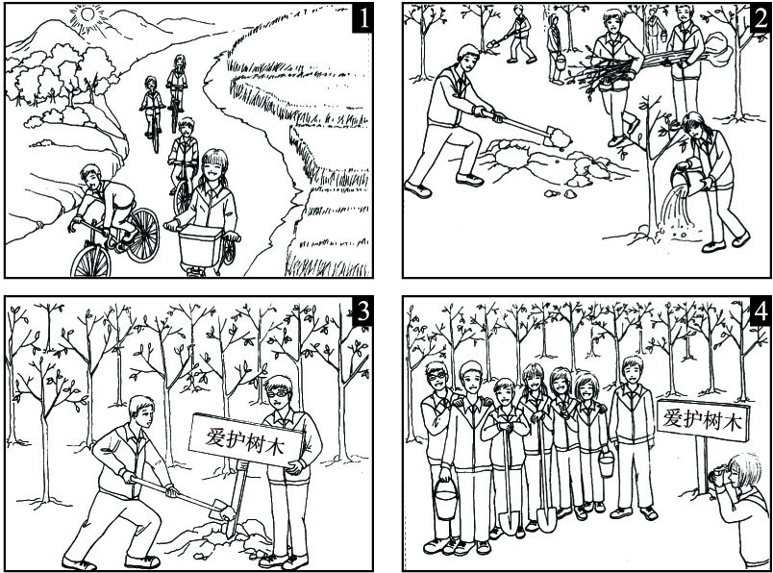
参考范文：
Green Action in Our Class
April 12 is memorable because our class had a meaningful experience on that day.In the morning，we bicycled to the suburbs to plant trees，talking and laughing all the way.Upon arrival，we began to work immediately.Some were digging holes.Some were carrying and planting young trees.Others were watering them.After getting the work done，we put up a board reminding people to protect the trees.Before leaving we took some photos to record our green action.Seeing the lines of trees，we all had a sense of achievement.We feel it's our duty to protect and beautify our environment.

第二节 开放作文(15分)
请根据下面提示，写一篇短文。词数不少于50。
In your spoken English class，your teacher shows you the following picture.You are asked to describe the picture and explain how you understand it.
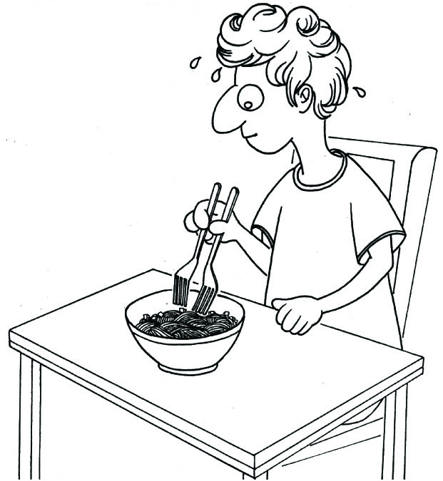
参考范文：
What an interesting picture！A Western young man，sitting at a table，is ready to eat a bowl of noodles.He is holding two forks the same way as we Chinese hold chopsticks.He is trying so hard to pick up the noodles that he is sweating a lot.At first glance，I think it's a bit funny，for we Chinese take for granted that chopsticks are the tools for eating noodles.The man in the picture is trying to copy us.Obviously he is doing it the hard way.Maybe using one fork will do a better job.In my opinion，we don't need to copy others' ways of thinking.Sometimes a simpler way of doing things may be a better way.

